`ytical

|  |  |  |  |
| --- | --- | --- | --- |
| Version: 1.0 |  | | |
| Author: Rohan W. Dalawai (I033153)  Bernd Goldfuss (D025385)  Milind Dumbre(C5303746)  Harish K. Rai  (I040970) |  | | |
| sap | Intelligent Returnable Packaging | | |
|  | | |
|  | **History** | | |
|  | Version  Enter the doc version | Date  Enter document version date 2008-04-04 | Status (Comments)  Draft, For Review, Released. |
|  | 1.0 | 8-Jan-2020 | In-progress |
|  |  |  |  |
|  |  |  |  |
|  |  |  |  |
|  |  |  |  |
|  |  |  |  |
|  |  |  |  |
|  |  |  |  |
|  |  |  |  |
|  |  |  |  |
|  |  |  |  |
|  |  |  |  |
|  |  |  |  |

How to Use this Template

**Delete square brackets and blue sample text (style “Explanation”) after reading.**

To update the table of contents and various automatic fields, maintain them in File → Properties → Summary **AND** Custom, mark them (entire text plus headers and footers) and press <F9>.

**Do not delete** non-applicable and optional sections, but mark them with **“Not relevant”** and give a brief explanation, why they are not relevant.

If appropriate, insert graphics to explain complex models or dependencies. Specify the exact source (server, directory) of the graphics so that the knowledge management team can use it.

Table of Contents

1 Business Context and Scope 8

1.1 Business Context 8

1.1.1 Supplier Owns the Returnable Packaging 9

1.1.2 OEM Owns the Returnable Packaging 10

1.1.3 Vendor Owns the Returnable Packaging 11

1.1.3.1 Vendor Ships the container to Supplier 11

1.1.3.2 OEM Ships the container to Supplier owned by Vendor 12

1.1.4 Business Impact 13

1.2 Customer Wants 13

1.3 Technical Context 14

1.3.1 Deployment Options 14

1.3.2 Solution Model 14

1.4 Business Role 16

1.5 User Stories for Intelligent Returnable Packaging 17

1.5.1 Summary/Overview of Returnable Materials (Not Serialized & Ownership is Unknown): 17

1.5.1.1 User Story: As a Shipping Specialist, I want to be able to track the returnable materials at the inventory level without knowing the ownership. 17

1.5.1.2 User Story: As a Shipping Specialist, I want to be able to track the empty returnable materials in the inventory without knowing the ownership. 17

1.5.1.3 User Story: As a Shipping Specialist, I want to be able to track the returnable materials which are in outbound transit without knowing the ownership. 17

1.5.1.4 User Story: As a Shipping Specialist, I want to be able to track the returnable materials which are in inbound transit without knowing the ownership. 17

1.5.1.5 User Story: As a Shipping Specialist, I want to be able to post and send accounts for outgoing returnables to suppliers/OEM without knowing the ownership. 17

1.5.1.6 User Story: As a Shipping Specialist, I want to be able to manually adjust the accounts for returnables without knowing the ownership. 17

1.5.1.7 User Story: As a Shipping Specialist, I want to be able to track the accounts on a Monthly / Weekly / Day basis without knowing the ownership. 17

1.5.1.8 User Story: As a Shipping Specialist, I want to be able to receive and match the account statement with supplier without knowing the ownership. 17

1.5.2 Summary/Overview of Returnable Materials (Not Serialized & Ownership is known): 18

1.5.2.1 User Story: As a Shipping Specialist, I want to be able to track the returnable materials at the inventory level knowing the ownership. 18

1.5.2.2 User Story: As a Shipping Specialist, I want to be able to track the empty returnable materials in the inventory knowing the ownership. 18

1.5.2.3 User Story: As a Shipping Specialist, I want to be able to track the returnable materials which are in outbound transit knowing the ownership. 18

1.5.2.4 User Story: As a Shipping Specialist, I want to be able to track the returnable materials which are in inbound transit knowing the ownership. 18

1.5.2.5 User Story: As a Shipping Specialist, I want to be able to create Accounts for posting returnable packaging. 18

1.5.2.6 User Story: As a Shipping Specialist, I want to be able to post and send accounts for outgoing returnables to suppliers/OEM knowing the ownership. 18

1.5.2.7 User Story: As a Shipping Specialist, I want to be able to manually adjust the accounts for returnables for which the ownership is known. 18

1.5.2.8 User Story: As a Shipping Specialist, I want to be able to track the accounts on a Monthly / Weekly / Day basis knowing the ownership. 18

1.5.2.9 User Story: As a Shipping Specialist, I want to be able to receive and match the account statement with supplier knowing the ownership. 18

1.5.2.10 User Story: As a Shipping Specialist, I want to be able to pay for the returnables used 18

1.5.3 Specialized Tracking of Returnable Materials (Serialized): 18

1.5.3.1 User Story: As a Shipping Specialist, I want to be able to track a specific returnable material which is serialized at the inventory level knowing the ownership. 18

1.5.3.2 User Story: As a Shipping Specialist, I want to be able to track the location of a specific returnable material which is serialized at the and the ownership is known. 18

1.5.4 Vendor Owned Returnable Materials: 18

1.5.4.1 User Story: As a Packaging Manager, I want to be able to track returnable materials by the vendor. 18

1.5.4.2 User Story: As a Packaging Manager, I want to be able to see the rental cost overview for a vendor 18

1.5.4.3 User Story: As a Packaging Manager, I want to be able to maintain the vendor master data and the respective renting type. 18

1.5.4.4 User Story: As a Packaging Manager, I want to be able to check and approve the rental invoice from OEM/Vendor. 18

1.5.5 Planning & Forecasting 19

1.5.5.1 User Story: As a Packaging Manager, I want to be able to know the future consumption of returnable material based on the future forecast. 19

1.5.5.2 User Story: As a Packaging Manager, I want to be able to know my consumption and automatically re-order the returnable containers. 19

1.6 Scope of this SRS – High-Level Requirements 20

1.6.1 Realtime Inventory Reporting 20

1.6.2 Management Dashboard 21

1.6.3 IOT/RFID/GPC based Container Tracking 21

1.6.4 Accounting 21

1.6.4.1 Account Statement Matching 21

1.6.5 Serialization of Returnable 21

1.6.6 Planning & Forecasting 21

1.6.7 View & Perform activities on a mobile device 22

1.6.8 ERP Integration 22

1.6.9 Integration to Vendor Portal 22

1.6.10 Output management 23

1.6.11 Alert / Reminder Framework 23

1.6.12 Rental and payments 23

1.7 Analytical Reports 24

1.8 Software Requirements 26

1.9 Software Delivery 28

1.10 Out of Scope 29

1.11 References 29

1.11.1 SAP-Internal References 29

1.11.2 Project Documents SCDP Co-Innovation EWM in S/4HANA 2020 29

1.12 Integration in the application environment 29

1.13 Reuse of existing components 29

1.14 Deviations and constraints 29

1.15 Miscellaneous/Comments 29

2 Organization 29

3 Glossary 30

4 Detailed Software Requirements 31

4.1 Overview of Software Requirements 31

4.1.1 List of planned IRP Applications 31

4.2 Logical data model 32

4.2.1 Common Data Models 32

4.2.1.1 Address Table 32

4.2.2 Organizational Data Models 32

4.2.2.1 Company code 32

4.2.2.2 Plant 33

4.2.2.3 Storage location 33

4.2.2.4 Sales Org 33

4.2.2.5 Sales Division 34

4.2.2.6 Distribution Channel 34

4.2.3 Master Data Models 34

4.2.3.1 Material Master 34

4.2.3.2 Business Partner (Customer) 35

4.2.3.3 Business Partner (Vendor) 35

4.3 Roles and User Stories 36

4.3.1 Business Role: Packaging Manager: 36

4.3.2 User Story – Import Organization Structure 36

4.3.3 User Story – Import Material Master 39

4.3.3.1 Material Master General Data 39

4.3.3.2 Material Master Plant Data 40

4.3.3.3 Material Master Sales Data 40

4.3.4 User Story –Import Business Partner 41

4.3.5 User Story – Manage Returnable Packaging Account 42

4.3.5.1 Returnable packaging account: 42

4.3.5.2 FIORI application for ‘Manage Returnable Packaging Account’ 42

4.3.5.3 Prerequisites for creating returnable packaging account: 42

4.3.5.4 FIORI tile for ‘Manage Returnable Packaging Account’ application 43

4.3.5.5 Filters for returnable accounts list page 43

4.3.5.6 Returnable accounts list page 45

4.3.5.7 Navigation to other applications 48

4.3.5.8 Returnable Packaging Account Creation 48

4.3.5.9 Copy Account Functionality 54

4.3.5.10 F4 Help for Manage Account Application 56

4.3.5.11 Statuses for returnable account 58

4.3.5.12 Number range for returnable packaging account 58

~~4.3.5.13~~ ~~Ownership in returnable account~~ 59

4.3.5.14 Change History of Returnable account 59

4.3.5.15 Returnable Packaging Account Update 59

4.3.5.16 Business validations 60

4.3.5.17 Account balance update in Returnable Packaging account 61

4.3.6 User Story – Manage Posting Documents 62

4.3.6.1 Search list of posting documents based on the filter on ‘Manage Posting Documents’ application landing page 63

4.3.6.2 Manual Posting 66

4.3.6.3 Status network for posting document 68

4.3.6.4 Change History of Returnable account 79

4.3.6.5 Number range for returnable packaging account 80

4.3.6.6 F4 Help for Manage Account Application 80

4.3.6.7 Business validations 82

4.3.6.8 Automatic Posting 82

4.3.6.9 Reprocessing of posted documents in errors 83

4.3.7 User Story – Track Returnable Quantity 83

4.3.8 User Story- Send the Outbound/Inbound Account Statements 83

4.3.9 User Story – Match the inbound / outbound account statement 85

4.3.10 User Story – Receive and Match the Returnable Account Statement 85

4.3.11 User Story – Perform Goods Issue or Goods Receipt 85

4.3.12 User Story – Identify the Empty Containers vs the full containers 85

4.3.13 User Story – Track the Returnable Packaging by Serial Numbers 85

4.3.14 User Story – Track the exact location (IOT/GPS Enabled) of the Returnable packages. 85

4.3.15 User Story- Manage Scrapping 85

4.3.16 User Story – Plan and Forecast the Packaging Material 85

4.3.17 User Story – Verify the Rental invoice 86

4.3.18 User Story – Returnable Packaging Material - Overview 86

4.3.19 User Story – Real time Returnable Packaging monitor 89

4.3.20 User Story –Manage Account Posting Types 89

4.3.21 User Story – Assign Posting Type to Movement Type 93

4.3.22 User Story – Automatic Posting 98

4.3.22.1 Introduction 98

4.3.22.2 Prerequisites 98

4.3.22.3 Schematic process flow for automatic postings 98

4.3.22.4 Processes not covered as part of automatic posting 98

4.3.22.5 Additional fields requirement for Automatic posting document 99

Field mapping 100

4.3.22.6 Odata API to be used from SAP S4HANA system for automatic postings 104

4.3.22.7 Odata API to transfer CPI payload to IRP 104

4.3.22.8 Logic for Automatic Material Document Posting 104

4.3.22.9 Account balance update in Returnable Packaging account 105

4.3.22.10 Reprocessing of documents in error 106

4.3.22.11 Automatic posting document number range 106

4.3.22.12 Business validations 106

4.3.23 User Story –Define Number Ranges 107

4.3.23.1 Create a new Number Range 107

4.3.23.2 Search and View details of a Number range 108

4.3.23.3 Activate and Deactivate 109

4.3.23.4 Track change history 109

4.3.23.5 Business Validations 109

4.3.24 User Story – Change history log 110

4.3.24.1 Introduction 110

4.3.24.2 Prerequisites 110

4.3.24.3 Applications for maintaining Change log 110

4.4 S/4HANA CE 111

4.4.1 Scope Items 111

4.4.2 Best Practice Content 111

4.4.3 Planned IRP UIs 111

4.4.4 Planned Transactions/Apps 111

4.4.5 Identity and Access Management (IAM) 112

4.4.6 Feature Toggling 112

4.5 User Interfaces 112

4.6 Software Requirements for technical Interfaces 112

4.7 Non-Functional Requirements 112

4.7.1 System Landscape and Deployment Options 112

4.7.2 Performance 113

4.7.3 Extensibility 113

4.7.4 Authorization and Roles 113

4.7.5 Processing Status, Application Logs, Change Documents 115

4.7.6 Documentation 115

4.8 Test Requirements 115

4.8.1 Test Landscape and Setup 115

4.8.2 Test Strategy 115

4.9 Business validations 115

4.10 Exception Handling 117

4.10.1 Error handling for integration scenario’s 117

4.10.1.1 Filters to be maintained for CPI Integration 118

4.10.1.2 Externalization parameters to be maintained for CPI integration 118

4.10.1.3 Validations before file upload 119

4.10.1.4 Data attributes validation 119

4.10.1.5 Data validation for dates 119

4.10.1.6 Error handling after file upload 119

5 Appendices 122

# Business Context and Scope

This document describes the requirements for **Intelligent Returnable Packaging**. Returnable Packaging (aka Reusable Packaging) is a system of reusing racks, pallets, containers that move products safely and efficiently throughout the supply chain.

The requirements are described from **Returnable Packaging** supply-to-line point of view.

## Business Context

Returnable packaging is a process of reusing the returnable containers. In this process the supplier delivers the requested components by OEM in a containers, racks, or pallets and after the consumption of components by OEM in the production supply line, the OEM’s returns the containers back to supplier. The type of containers used might differs for different components.

For e.g. nut and blots are delivered in the containers, front suspension is delivered in pallets, Mirrors are delivered in boxes.

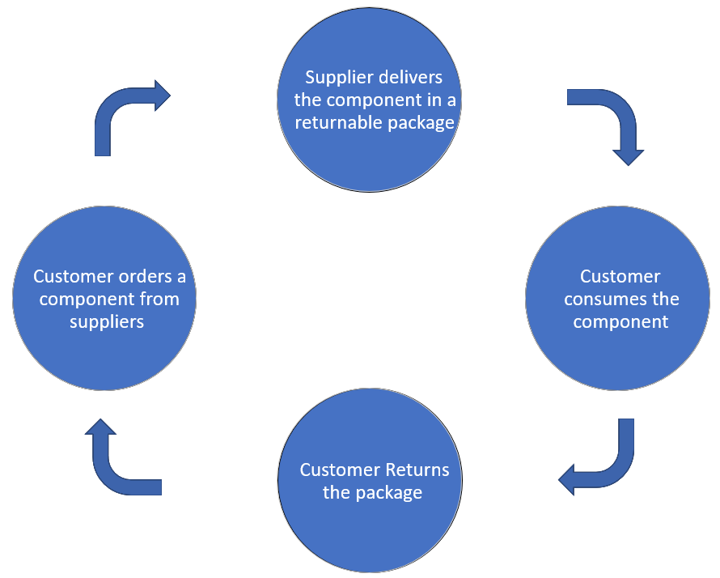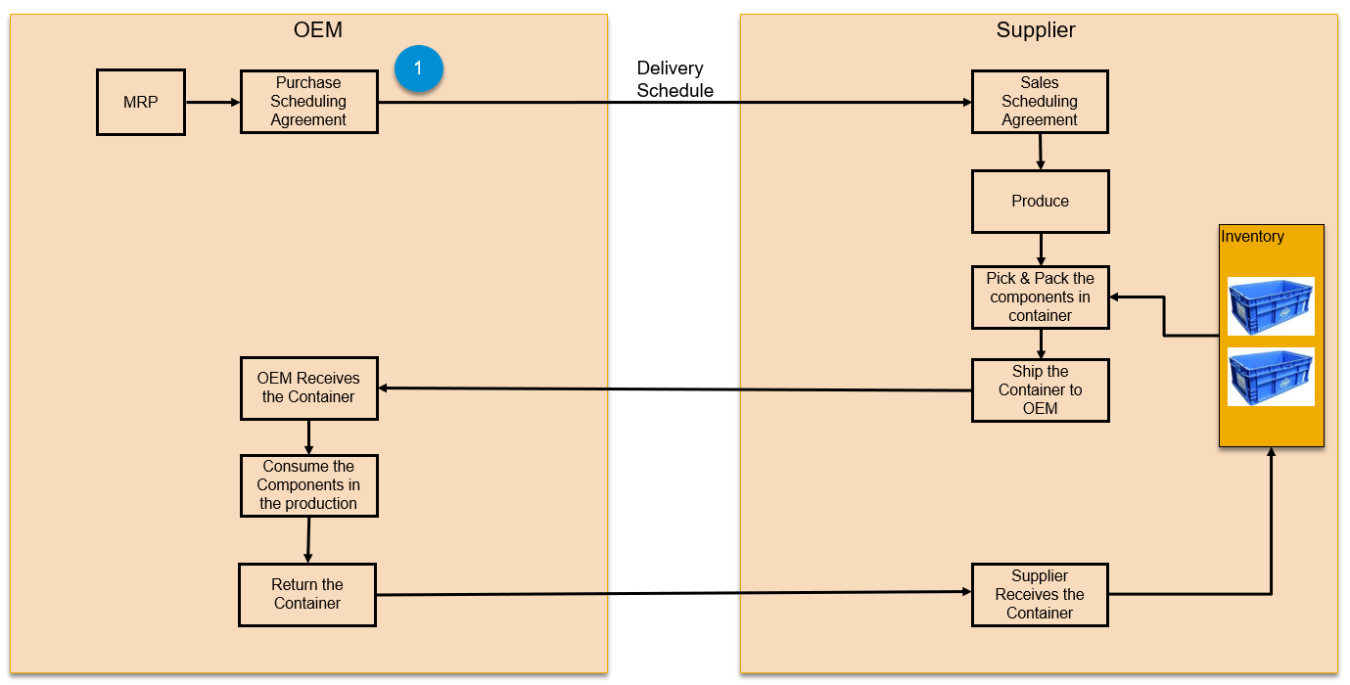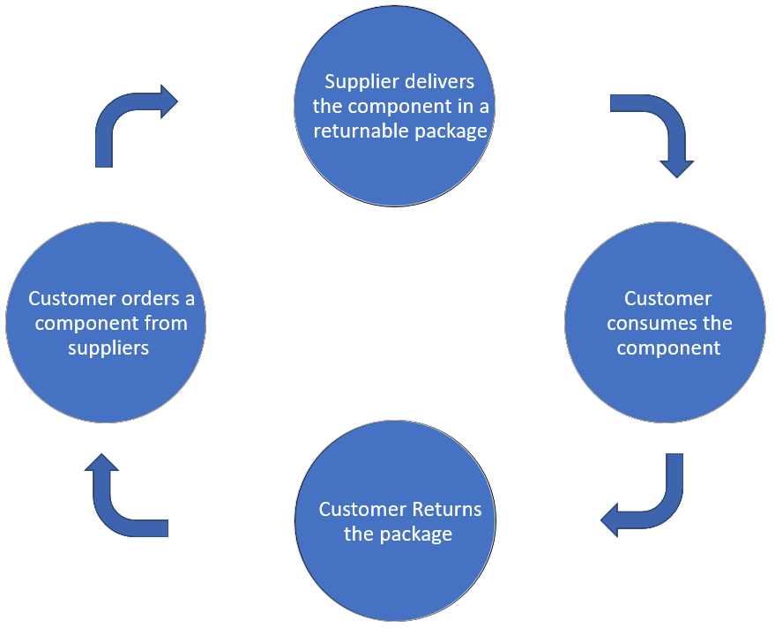

Figure 1 – Reusing of containers for shipment

For e.g. in the below process, the OEM is requesting for an engine from supplier by sending the delivery schedule. The supplier on receiving the order, produces the engine and ships the engine to OEM in a returnable container, the OEM consumes the engine and returns the returnable container to supplier.

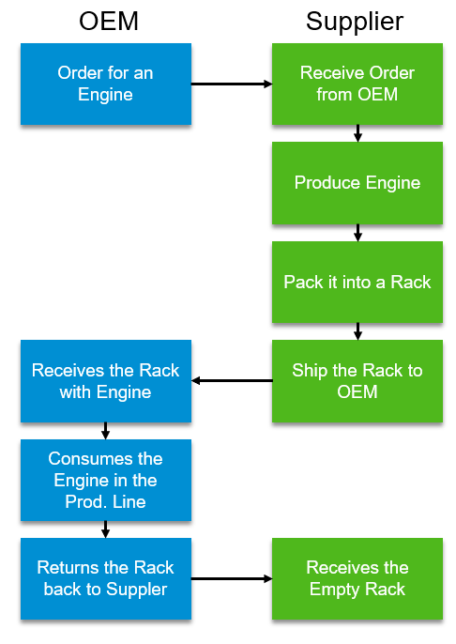

**Figure 2 – Returnable Containers for Engines**

There is multiple different scenario in this process when it comes to the ownership of the returnable packaging containers.

1. Supplier Owns the returnable packaging.
2. OEM Owns the returnable packaging.
3. Ownership of the returnable packaging is unknown.
4. Vendor Owns the returnable packaging.



### Supplier Owns the Returnable Packaging

In this scenario, the supplier’s gets an order form the OEM and the supplier ships the requested component in the container/pallet/rack owned by him and the OEM returns the containers once the component is consumed in the production line.

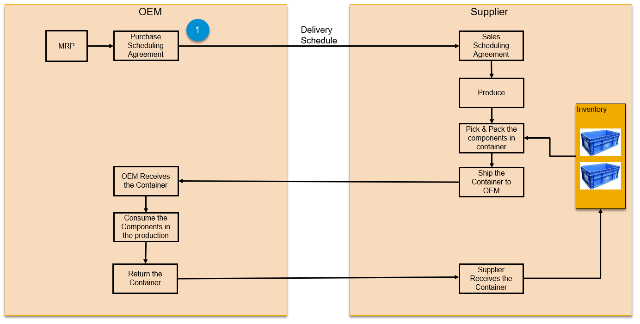

**Figure 3 – Supplier Owns the returnable packaging**

### OEM Owns the Returnable Packaging

In this scenario, the OEM owns the returnable packaging material in which the suppliers deliver the requested components. In this scenario, the OEM charges rent for the containers supplied to suppliers for shipping the requested components.

Once the contract between the supplier and the OEM is in place, based on the demand forecast from OEM, the supplier requests for (n) number of containers to ship the components from OEM.

Supplier ships the requested component in the containers owned by OEM.

At regular frequency (15 days or 1 month….), OEM calculates the rentals and sends an invoice to supplier.

There are diverse ways, rentals are charged:

1. Rentals are charged only if the supplier keeps the container for more than (n) days. For e.g. 5 Days. (This is a common scenario of charging rentals)
2. Fixed Rentals based on the qty of containers shipped to suppliers to deliver the components.
3. Rentals are charged only if the qty requested by the supplier goes beyond a certain limit. For e.g. No rentals will be charged for the first 200 containers shipped to the supplier and anything beyond 200 will be charged.

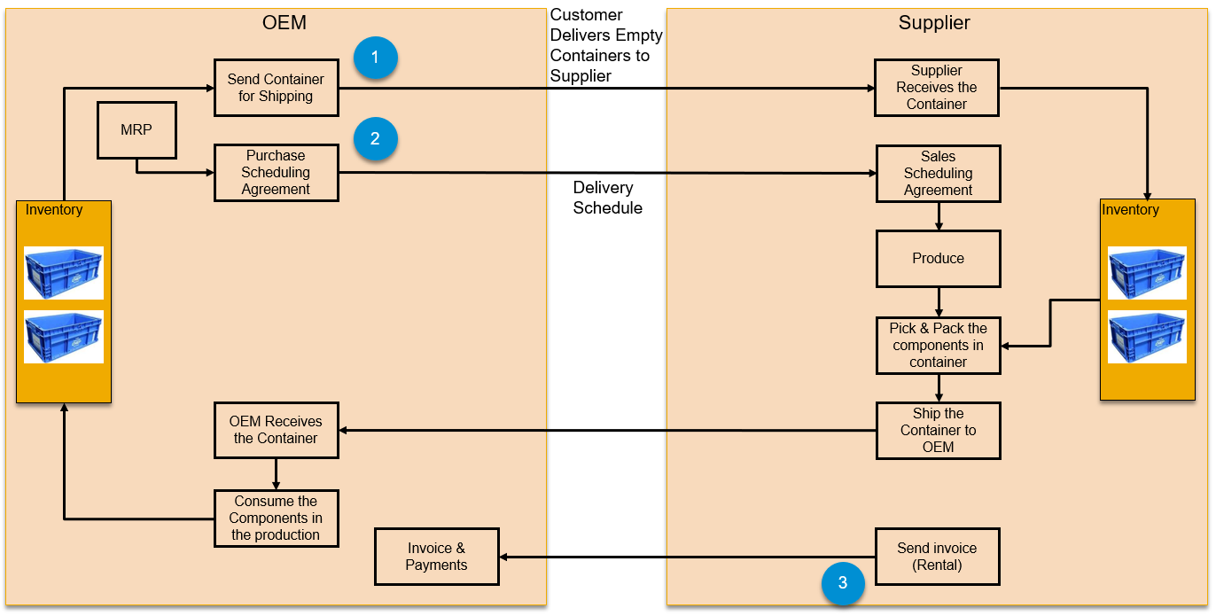

**Figure 4 – OEM Owns the returnable packaging**

*The above process is the same for unknown returnable packaging material ownership, but the rental process is excluded.

### Vendor Owns the Returnable Packaging

There are 2 flavors to vendor owning the returnable packaging based on from whom the suppliers get the containers for shipment i.e. from Vendor directly or from OEM.

#### Vendor Ships the container to Supplier

In this scenario, vendor owns the returnable packaging material which is used to ship the components from supplier to OEM.

In this case, OEM will identify a vendor based on the containers required to ship the components, for some of the component’s OEM gets the containers custom made based on their requirements. For e.g. the container or pallet to hold an engine differs for different OEM’s. the pallet to ship BMW engine cannot be used for other OEM’s.

Once the contract between the supplier and the OEM is in place, based on the demand forecast from OEM, the supplier requests for (n) number of containers to ship the components from **Vendor designated by OEM.**

Based on the delivery schedule or Just-in-Time calls, Supplier ships the requested component in the containers owned by vendor.

At regular frequency (15 days or 1 month….), vendor calculates the rentals and sends an invoice to supplier.

**This scenario is widely followed across OEM’s and suppliers.**

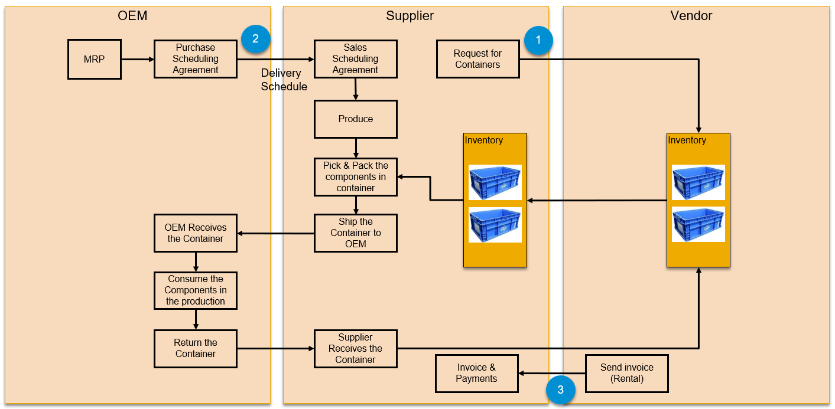

**Figure 5 – Vendor Owns the returnable packaging – Scenario 1**

#### OEM Ships the container to Supplier owned by Vendor

This scenario is not widely used across OEM and suppliers, were in the vendor ships the containers to OEM and in-turn the OEM sends the containers to supplier for shipping the components.

Vendor Ships the container to Supplier Vendor Ships the container to Supplier

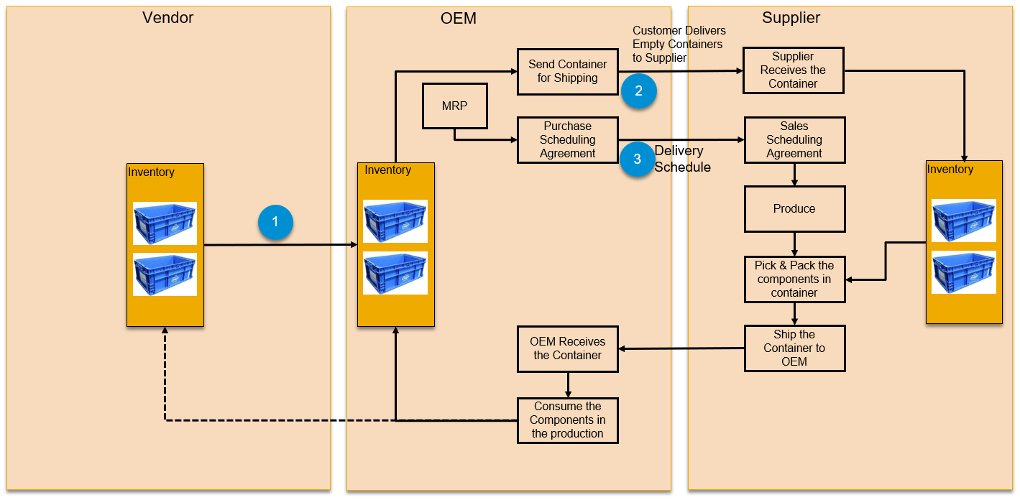

**Figure 6 – Vendor Owns the returnable packaging – Scenario 2**

### Business Impact

In the current returnable packaging process, thefts and damages to the containers is a common & a very frequent concern as it has a direct impact on the cost and a significant impact on the delivery.

* The cost of replacing “lost” reusable packaging and pallets in the North American auto industry is around **$750 million** per year.
* The automotive sector loses 15 **to 20 percent** of its pallets and lids annually, according to Deloitte
* Delay or shortage of containers can **disrupt production**, causing expensive downtime and downstream ripple effects
* Delay or shortage of containers can **delay order processing and delivery**, resulting in **increased labor for assembly** and shipping at the warehouse and stocking at stores, **additional freight charges**, and potentially lost sales at retail
* The risk of reusable container shortage can cause companies to increase their pool to a larger size than should be necessary to ensure they do not run out

## Customer Wants

In the current SAP ERP solution, only the Accounting functionality is available for Returnable Packaging using which the customer can manage accounts, post account (EDI/Output management), match account statement.

Due to lot of new scenario in the process i.e. vendor ownership, payment options and forecast and planning, customers are requesting for the below new features to run their packaging returnable process end-to-end efficiently.

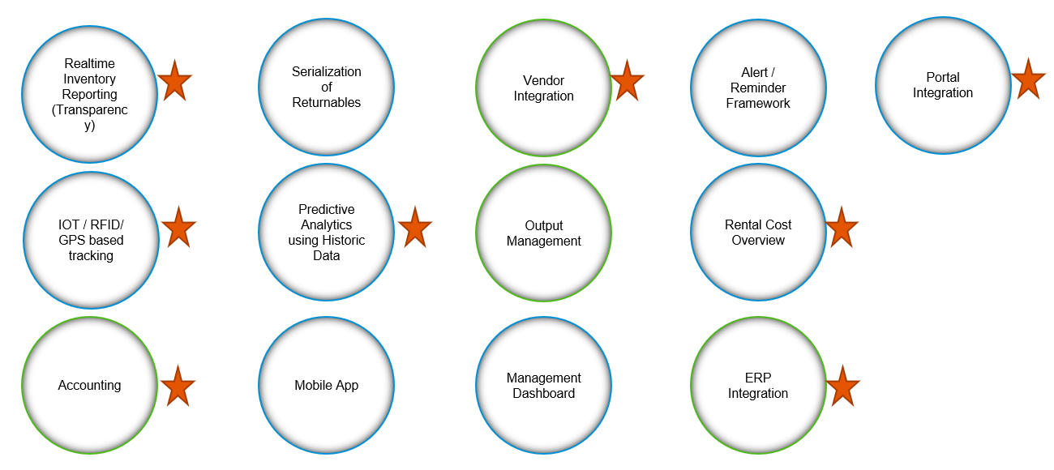

The following are the new functionalities customers are looking in the new solution:

1. Realtime Inventory Reporting
2. Management Dashboard
3. IOT/RFID/GPC based Container Tracking
4. Accounting
5. Serialization of Returnable
6. Planning & Forecasting
7. View & Perform activities on a mobile device
8. ERP Integration
9. Integration to Vendor Portal
10. Output management
11. Alert / Reminder Framework
12. Rental and payments

## Technical Context

### Deployment Options

The Intelligent Returnable Packaging would be available on SAP Cloud Platform and this would be positioned for S/4Hana Cloud and S/4Hana On-Premise customers. Moving the returnable solution on SCP provides us the following benefits:

1. Unified Data Model for OEM, Supplier and Vendor, which brings in more transparency in the process and provides real time reporting.
2. IOT & Blockchain services are readily available
3. Positioned on any ERP system across industries
4. Integration

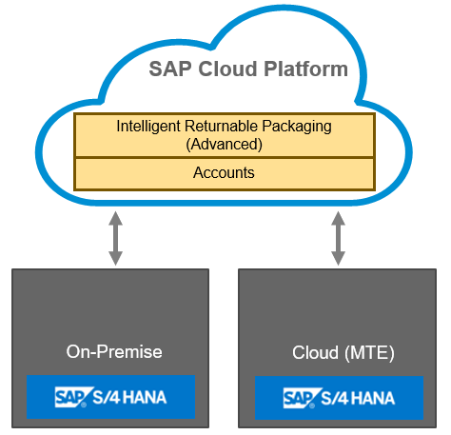

### Solution Model

The Intelligent Returnable Packaging is a component on SAP CLOUD platform which allows companies to manage their returnable packaging material effective with more transparency and it caters to multiple industries i.e. Automotive Industry, Mill products, Aerospace, Brewery….

ODATA API’s would be available using which the Intelligent Returnable Packaging solution can be integrated with any ERP / Vendor system.

Intelligent Returnable Packaging will be out of the box integrated with S/4Hana OP and S/4Hana Cloud solutions. Customers would be able to run hybrid scenario, where in they can connect to existing on-premise solution.

IOT and Block chain services on SCP would be used for individual container tracking and to bring in more transparency in the complete process.

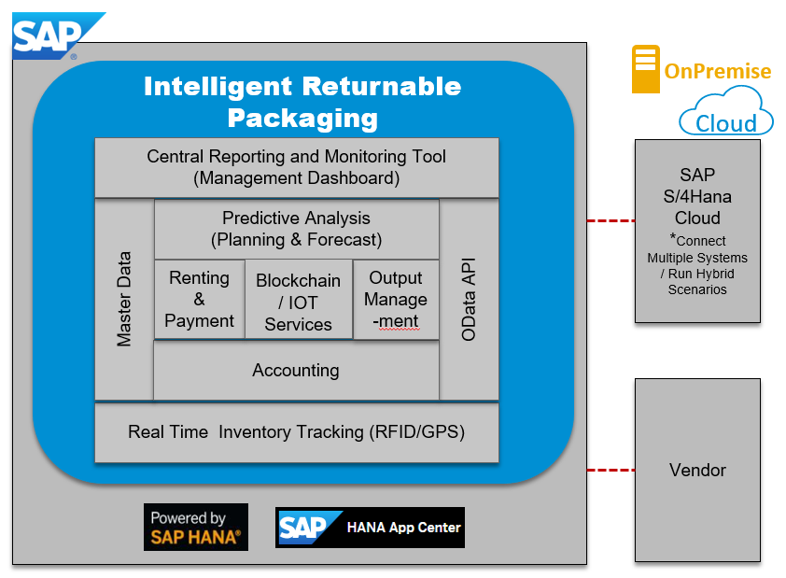

Figure 7 – Conceptual Solution Model – Intelligent Returnable Packaging

For discussion about the architecture of the integration, see details in ACD **(To be linked with ACD)** and later in SDD.

## Business Role

The following are the business role & responsibility of parties involved in returnable packaging process:

1. **Packaging Manager:**

Packaging Manager is responsible for:

* Managing Accounts
* Planning & Forecasting for returnable materials
* Requesting/reordering of containers from Vendor/OEM
* Goods Receipt the returnable materials from Vendor/OEM
* Account posting
* Match Account Statements
* Manually Adjust Posting
* Track & View Inventory for returnable
* Verify and Approve rental invoice from Vendor/OEM
  1. **Shipping Specialist:**

Shipping Specialist handles the creation of the outbound delivery, Goods issue, and Goods Receipt of returnable packaging materials.

1. **IT/Configuration Business Expert:**

IT/Configuration Business Expert handles all the configuration required to run the packaging process end-to-end.

1. **Order Manager (Optional):**

Order Manager is responsible for Track & View Inventory for returnable packaging material

1. **Billing Clerk:**

Billing Clerk handles receiving invoice and to handle the payment process.

## User Stories for Intelligent Returnable Packaging

### Summary/Overview of Returnable Materials (Not Serialized & Ownership is Unknown):

#### User Story: As a Shipping Specialist, I want to be able to track the returnable materials at the inventory level without knowing the ownership.

#### User Story: As a Shipping Specialist, I want to be able to track the empty returnable materials in the inventory without knowing the ownership.

#### User Story: As a Shipping Specialist, I want to be able to track the returnable materials which are in outbound transit without knowing the ownership.

#### User Story: As a Shipping Specialist, I want to be able to track the returnable materials which are in inbound transit without knowing the ownership.

#### User Story: As a Shipping Specialist, I want to be able to post and send accounts for outgoing returnables to suppliers/OEM without knowing the ownership.

#### User Story: As a Shipping Specialist, I want to be able to manually adjust the accounts for returnables without knowing the ownership.

#### User Story: As a Shipping Specialist, I want to be able to track the accounts on a Monthly / Weekly / Day basis without knowing the ownership.

#### User Story: As a Shipping Specialist, I want to be able to receive and match the account statement with supplier without knowing the ownership.

### Summary/Overview of Returnable Materials (Not Serialized & Ownership is known):

#### User Story: As a Shipping Specialist, I want to be able to track the returnable materials at the inventory level knowing the ownership.

#### User Story: As a Shipping Specialist, I want to be able to track the empty returnable materials in the inventory knowing the ownership.

#### User Story: As a Shipping Specialist, I want to be able to track the returnable materials which are in outbound transit knowing the ownership.

#### User Story: As a Shipping Specialist, I want to be able to track the returnable materials which are in inbound transit knowing the ownership.

#### User Story: As a Shipping Specialist, I want to be able to create Accounts for posting returnable packaging.

#### User Story: As a Shipping Specialist, I want to be able to post and send accounts for outgoing returnables to suppliers/OEM knowing the ownership.

#### User Story: As a Shipping Specialist, I want to be able to manually adjust the accounts for returnables for which the ownership is known.

#### User Story: As a Shipping Specialist, I want to be able to track the accounts on a Monthly / Weekly / Day basis knowing the ownership.

#### User Story: As a Shipping Specialist, I want to be able to receive and match the account statement with supplier knowing the ownership.

#### User Story: As a Shipping Specialist, I want to be able to pay for the returnables used

### Specialized Tracking of Returnable Materials (Serialized):

#### User Story: As a Shipping Specialist, I want to be able to track a specific returnable material which is serialized at the inventory level knowing the ownership.

#### User Story: As a Shipping Specialist, I want to be able to track the location of a specific returnable material which is serialized at the and the ownership is known.

### Vendor Owned Returnable Materials:

#### User Story: As a Packaging Manager, I want to be able to track returnable materials by the vendor.

#### User Story: As a Packaging Manager, I want to be able to see the rental cost overview for a vendor

#### User Story: As a Packaging Manager, I want to be able to maintain the vendor master data and the respective renting type.

#### User Story: As a Packaging Manager, I want to be able to check and approve the rental invoice from OEM/Vendor.

### Planning & Forecasting

#### User Story: As a Packaging Manager, I want to be able to know the future consumption of returnable material based on the future forecast.

#### User Story: As a Packaging Manager, I want to be able to know my consumption and automatically re-order the returnable containers.

## Scope of this SRS – High-Level Requirements

The detailed process of returnable packaging was in the customer is owning the containers is depicted below:

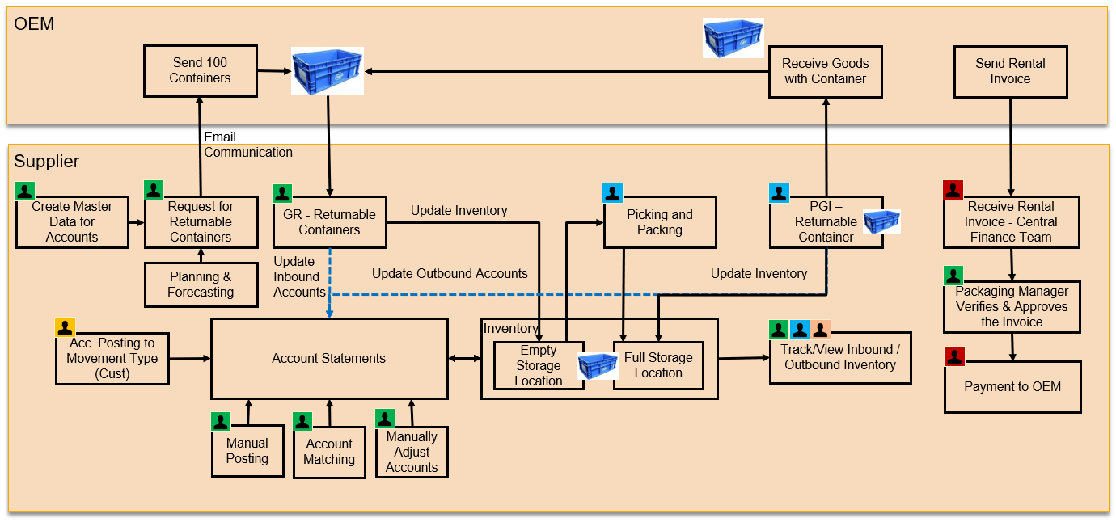

The detailed process of returnable packaging was in the vendor is owning the containers is depicted below:

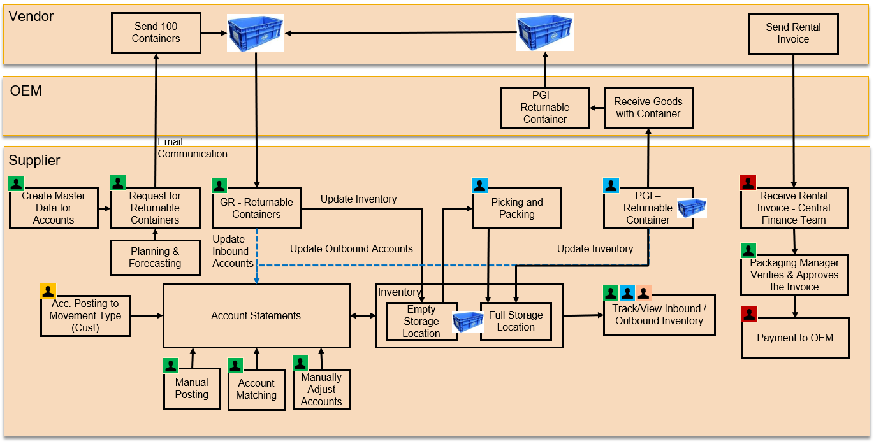

### Realtime Inventory Reporting

### Management Dashboard

### IOT/RFID/GPC based Container Tracking

### Accounting

#### Account Statement Matching

**Current Process:**

The account matching is done manually by supplier currently by logging into vendor/OEM portals and this is one of the major pain points described by customers as they must download the statement in a pdf format and login into vendor/OEM system and manually compare the statements line-by-line based on delivery note number.

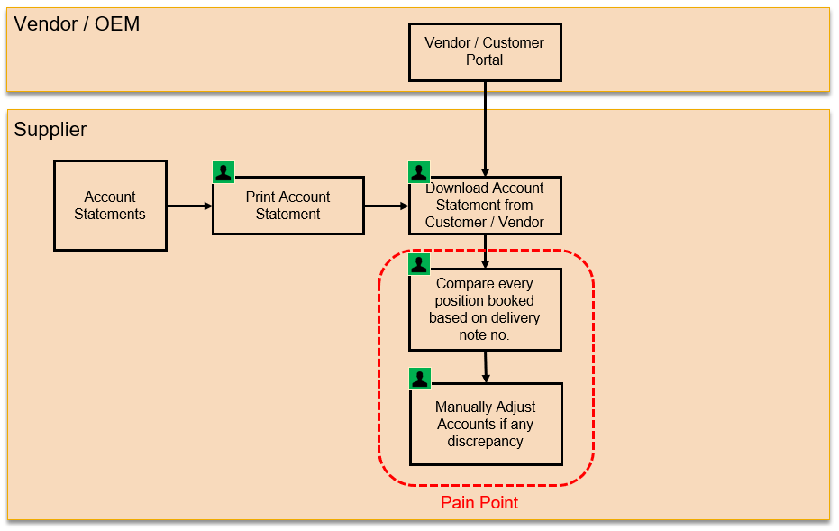

**Requirement:**

Supplier should be able to do the account statement matching with vendor/OEM statements automatically by electronically comparing their statements with the supplier accounts.

Intelligent Returnable Packaging solution should be able to be integrated with vendor/OEM portal, so that suppliers can match the vendor/OEM statements with supplier accounts automatically.

### Serialization of Returnable

### Planning & Forecasting

**Current Process:**

Currently customers plan based on the fixed order quantity based on their experience.

**Requirement:**

Suppliers should be able to plan and forecast the returnable containers required to fulfill the demand for a defined horizon for e.g. next (n) days or next (n) weeks or next (n) months.

The below process flow explains the various attributes or parameters that needs to be considered to plan and forecast the required containers for the define horizon.

The following parameters needs to be considered for forecast planning:

* Delivery Schedule
* Packaging Instruction
* Historic Demand Data
* Empty Storage containers

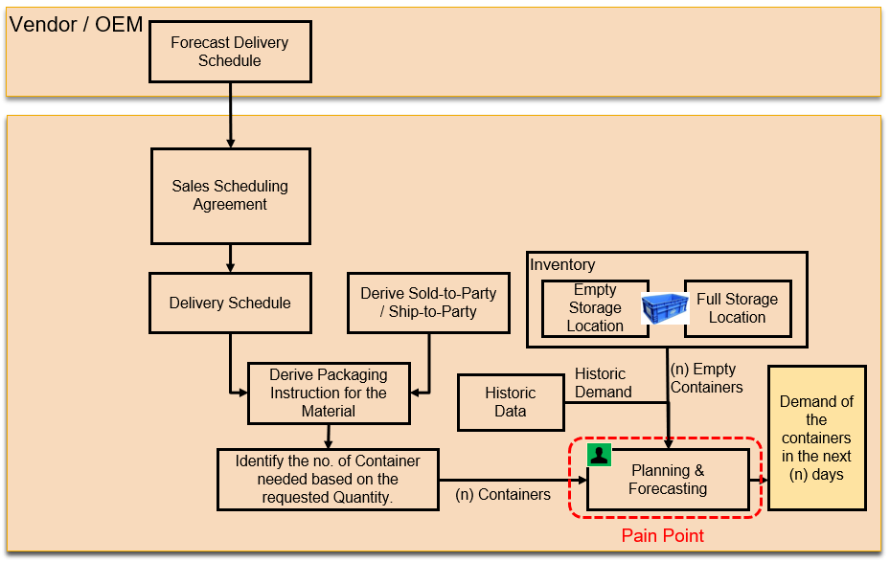

### View & Perform activities on a mobile device

Packaging Manager should be able to track and perform activities related to packaging material on a mobile device.

### ERP Integration

Default standard integration of Intelligent Returnable Packaging solution with S/4hana cloud and on-premise should be provided for S/4 Hana customers, so that a relevant goods issue or goods receipts done on the returnable packaging material in S/4hana system should update the accounts in the Intelligent Returnable Packaging on SAP Cloud Platform.

### Integration to Vendor Portal

Intelligent Returnable Packaging solution should be able to be integrated with vendor/OEM portal, so that suppliers can match the vendor/OEM statements with supplier accounts automatically.

The relevant OData API’s should be published for customers and suppliers to integrate Intelligent Returnable Packaging solution with OEM/Vendor portals

### Output management

Intelligent Returnable packaging solution should be able to generate pdf forms for account posting (both inbound & outbound) for sending the statements to vendor/OEM’s

The packaging manager should be able to print account statements for a specific or multiple vendors accounts.

### Alert / Reminder Framework

Packaging Manager should get an alert or reminder if a container is on the premise for more than (n) days and the no. of days should be configurable for a customer.

### Rental and payments

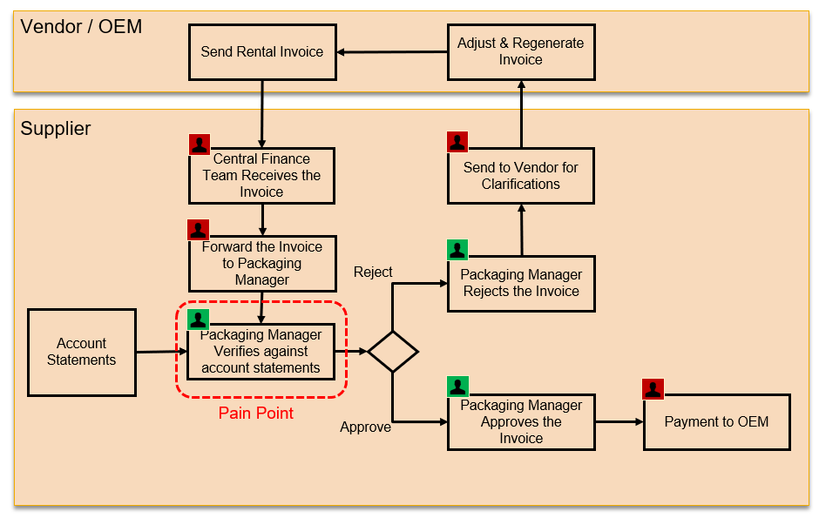

* Supplier must pay rental if the container is on the site for more than 5(n) days.
* Rental Charges are based on the customer/vendor and not on the container.
* Time between GR and GI use to calculate the rentals for a container.

**Requirement:**

Supplier (Packaging Manager) should be able to view all the container which are on-premise for more than n days i.e. for which the rent needs to be paid for.

Supplier (Packaging Manager) should be able to validate the rental invoice from customer or vendor

## Analytical Reports

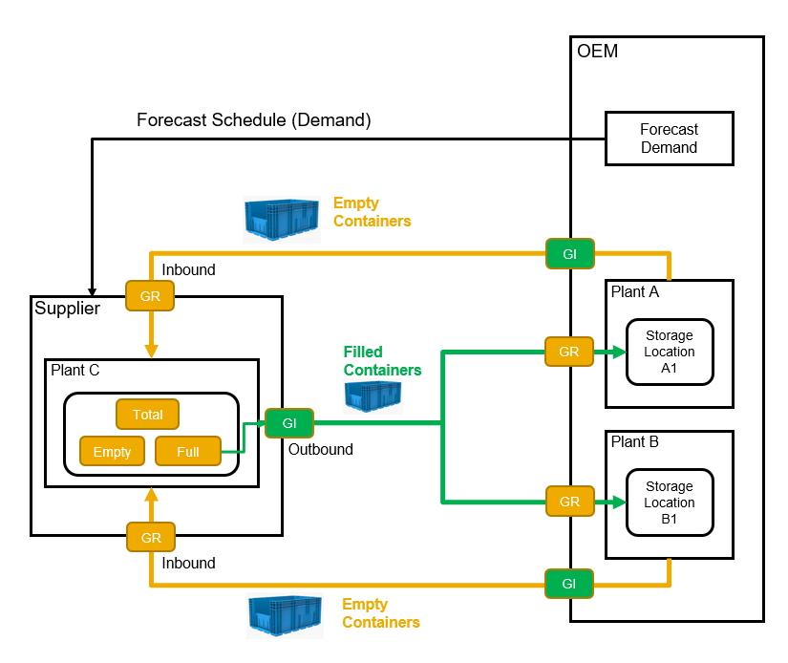

**Inventory Report on Accounts**

* **View Accounts Inbound Posting** of Returnable Packaging Grouped by a returnable packaging(s), or plant
* (s), or for a customer(s)/Vendor(s) consolidated across plant, or Exchange Partner, or Document Reference Number, or Account posting document number, or for a specific period.
* **View Accounts Outbound Posting** of Returnable Packaging Grouped by a returnable packaging(s) or plant(s), or for a customer(s)/Vendor(s) consolidated across plant, or Exchange Partner, or Document Reference Number, or Account posting document number, or for a specific period.
* **View Balance Stock** of Returnable Packaging for a specific returnable packaging(s), plant(s), or for a customer(s)/Vendor(s) consolidated across plant, or Exchange Partner, or Document Reference Number, or Account posting document number.

**Returnable Packaging Replenishment Dashboard**

* How many Returnable packaging are in the **stock**?
* What is the **expected stock** from Customer/Vendor?
* What is the **demand**?
* What is the **required no. of returnable(s)** based on the **demand**?
* (Planning & Forecasting of Returnable Packaging.)

**Empty Vs Full Containers**

* View the no of containers in stock which are **empty**
* View the no. of containers in stock which are **filled**

**Scraping Analysis & Prediction Report**

* View Returnable Packaging material which needs to be scrapped based on:
  + Usage (Life Cycle)
  + Damages
  + Change in Specification by Customer/Vendor

**Returnable Packaging Material Damage Report**

* View No of Returnable packaging which are damaged
* Who owns the damage i.e. Supplier/Customer/Vendor?

**Returnable Packaging Account Matching Report**

* Account Matching Wizard – Internal Stock Matching i.e. how many returnable packaging came in and how many went out for a specific Customer/Vendor or for a multiple Customers/vendors
* Account Matching Wizard – External Stock Matching i.e. how many returnable packaging were sent to customer/vendor and how many were received by customer/vendor.

**Control of Renting Report**

* Actual Rental Cost
* Penalties
* Requested too many returnable from Customer/Vendor

**Single Container Tracking using IOT**

* Serialized Tracking of Returnable packaging

**Tracking on Google Maps**

* Quantity Tracking of Returnable packaging on a Google map

**Report to Verify the Invoice from Customer/Vendor**

**Packaging planning**

* How a company decides to go in with a vendor for returnable or to own the returnable
* When will the company breakeven if they own the returnable?
* What will be the maintenance cost if a company own the returnable?
* Is the returnable required for prototype or mass production

**Sustainability Reports**

## Software Requirements

|  |  |  |  |
| --- | --- | --- | --- |
| User Stories | Reference BLI No. | SW Requirement Description | Release |
| As a Packaging Manager, I want to be able to create Accounts for posting returnable packaging |  |  |  |
|  |  | Packaging Manager Should be able to View the existing Returnable Packaging Account of a Vendor / OEM |  |
|  |  | Packaging Manager Should be able to Create a new Returnable Packaging Account for a Vendor / OEM |  |
|  |  | Packaging Manager Should be able to Change a Returnable Packaging Account of a Vendor / OEM |  |
|  |  | Packaging Manager Should be able to Delete the Returnable Packaging Account of a Vendor / OEM |  |
| As a Packaging Manager, I want to be able to post and send accounts for outgoing returnable to suppliers/OEM knowing the ownership. |  |  |  |
|  |  | Packaging Manager should be able to manually post an incoming or outing returnable material with a proper goods movement for a specific account. |  |
|  |  | Packaging Manager should be able to re-post incoming or outgoing receipt for a returnable account, if in case of any issues |  |
|  |  | Packaging Manager should be able to delete an incoming or an outgoing posting for a returnable account. |  |
|  |  | Packaging Manager should be able to adjust/Change already posted accounts manually for a returnable account. |  |
| As a Packaging Manager, I want to be able to track the accounts on a Monthly / Weekly / Day basis knowing the ownership. |  |  |  |
|  |  | Packaging Manager should be able to view the account statements for a returnable account for a specific day or weeks or months. |  |
|  |  | Packaging Manager should be able to download the account statements for a returnable account for a specific day or weeks or months in an excel format or as a PDF document. |  |
|  |  | Packaging Manager should be able to print the accounts statement manually for a returnable account. |  |
|  |  | Packaging Manager should be able to send the account statements to the OEM / Vendor via EDI. |  |
|  |  | Packaging Manager should be able to send the account statements to the OEM / Vendor in a PDF Document. |  |
| As a Packaging Manager, I want to be able to receive and match the account statement with supplier knowing the ownership |  |  |  |
|  |  | As a Packaging Manager, I want to be able to receive and match the account statement with supplier knowing the ownership |  |
| As a Shipping Specialist, I want to be able to perform Goods Issue or Goods Receipt on the Returnable Packaging Material |  |  |  |
|  |  | When a Shipping Specialist performs the Goods Issue on the Returnable Packaging Material in S/4Hana Cloud system, corresponding outbound accounting posting should be triggered/ recorded/logged in the Intelligent Returnable packaging solution on SCP. |  |
|  |  | When a Shipping Specialist performs the Goods Receipt on the Returnable Packaging Material in S/4Hana Cloud system, corresponding inbound accounting posting should be triggered/ recorded/logged in the Intelligent Returnable packaging solution on SCP. |  |
| ODATA API to create Accounts |  |  |  |
|  |  | Customers should be able to Create a returnable packaging account using OData API. |  |
|  |  | Customers should be able to Change a returnable packaging account using OData API. |  |
|  |  | Customers should be able to Read a returnable packaging account using OData API. |  |
|  |  | Customers should be able to Delete a returnable packaging account using OData API. |  |
| ODATA API to post Accounts |  |  |  |
|  |  | Customer should be able to Post inbound account in Intelligent Returnable Packaging solution using OData API. |  |
|  |  | Customer should be able to Post the outbound account in Intelligent Returnable Packaging solution using OData API. |  |
| ODATA API to Import Master Data from the ERP system |  |  |  |
|  |  | Customer should be able to import Plant master data information from any ERP system to Intelligent Returnable Packaging solution on SCP using OData API. |  |
|  |  | Customer should be able to import Business partner information from any ERP system to Intelligent Returnable Packaging solution on SCP using OData API. |  |
|  |  | Customer should be able to import Vendor information from any ERP system to Intelligent Returnable Packaging solution on SCP using OData API. |  |
|  |  | Customer should be able to import Company ode Master Data information from any ERP system to Intelligent Returnable Packaging solution on SCP using OData API. |  |
| As a Packaging manager, I would like to track the returnable packaging real time - Real time Returnable Packaging monitor |  |  |  |
| Identification of Empty / Full Containers |  |  |  |
| Serial no. tracking of Inbound / Outbound Containers |  |  |  |
| Vendor Integration |  |  |  |
| Rental / Payment for the returnable packaging |  |  |  |
| IOT/GPS based Single Container Tracking |  |  |  |
| Alerting Framework |  |  |  |
| Planning & Forecasting |  |  |  |
|  |  |  |  |

## Software Delivery

Describe the general factors affecting the software project and its requirements. This section should not tell specific requirements. Instead, it supplies a background of those requirements, which are defined in the chapter “Detailed Software Requirements,” and makes them easier to understand.

It is planned to deliver the functionality in the following cloud releases:

|  |  |  |
| --- | --- | --- |
|  | **S/4hana Cloud Planned Release** | **Comment (optional)** |
|  |  |  |
|  |  |  |
|  |  |  |
|  |  |  |

## Out of Scope

Specify here:

the features which may be expected, but not fulfilled or not covered by this document/project.

the features or topics which were included in assigned Requirements, but are no longer planned to be developed by this project

List requirements assigned to this project/SRS, but not specified.

## References

### SAP-Internal References

Provide a complete list of all documents referenced within this SRS.

| **ID**  <doc ID> and/or Link | **Name**  e.g. <SRS from other work areas | **Date**  Document date mm/dd/yyyy | **Version**  document version | **Comments**  Examples: Publishing organization, Sources of the reference's owner> |
| --- | --- | --- | --- | --- |
|  |  |  |  |  |
|  |  |  |  |  |
|  |  |  |  |  |
|  |  |  |  |  |
|  |  |  |  |  |
|  |  |  |  |  |

### Project Documents SCDP Co-Innovation EWM in S/4HANA 2020

| **ID**  <doc ID> and/or Link | **Name**  e.g. <SRS from other work areas | **Date**  Document date mm/dd/yyyy | **Version**  document version | **Comments**  Examples: Publishing organization, Sources of the reference's owner> |
| --- | --- | --- | --- | --- |
|  |  |  |  |  |
|  |  |  |  |  |
|  |  |  |  |  |
|  |  |  |  |  |

Provide a complete list of all documents referenced within this SRS.

## Integration in the application environment

Optional: Describe the integration of the specified software in the context of the whole solution/application environment.

## Reuse of existing components

No re-uses of software components, re-use components, engines, services intended which have not been used in EWM before. Actual re-use of central (S/4) services will be evaluated in design phase.

From an external point of view (customers) or from a business point of view list the parts of other software/ components/ functions/ modules/ products which are planned to be reused (e.g. re-usable engines, common services …).

## Deviations and constraints

No deviations from product standards or guidelines.

Describe here from a business/solution’s point of view

* any known deviations and constraints
* functionality which cannot be developed in complete scope or expected scope by the market/customers or further restrictions for the functionality (e.g. platform dependent)

## Miscellaneous/Comments

List, for example other topics and/or comments, if existing.

# Organization

Enter all persons who work on this document:

| **Name** | **Organization** | **Project Role(s)/Comments** |
| --- | --- | --- |
| Bernd Goldfuss | SAP SE | [Scenario Owner / Author] |
| Rohan Dalawai | SAP IN | [Product Manager / Author] |
|  |  | [Software Developer] |
|  |  | [Solution Management Expert] |
|  |  | [Quality Management Contact] / [Test Coordination Expert] |
|  |  | [Knowledge Management] |

# Glossary

Use known expressions and those technical terms that are defined in the terminology database of SAP.

Enter all terms with significant importance for this document/development.

| **English Term** | **German Term** | **Definition** | **Entry** enter whether it is **new** or **existing** in SAP term |
| --- | --- | --- | --- |
|  |  |  |  |
|  |  |  |  |
|  |  |  |  |
|  |  |  |  |
|  |  |  |  |
|  |  |  |  |
|  |  |  |  |
|  |  |  |  |
|  |  |  |  |
|  |  |  |  |
|  |  |  |  |

# Detailed Software Requirements

This section contains all business and solution related software requirements on a detailed level which is enough to serve as a basis for the later design work, and for tests verifying that the system fulfills its requirements.

At a minimum, these software requirements should include a description of every input into the system, of every output from the system, and of all functions performed by the system in response to an input or in support of an output.

## Overview of Software Requirements

Intelligent Returnable Packaging will be a SCP based application to manage returnable packaging master data, inventory, account statements, manual account postings. Returnable packaging (RP) accounts reproduce the exchange status of returnable packaging between two business partners. The goods movement of empty or full returnable packaging is tracked in these accounts. The exchange balance per business partner can be monitored at any time by means of the account balance. This solution will integrate with suppliers and other business partners to increase trust and transparency in returnable packaging Supply-chain. This solution will also help organizations optimize direct and indirect cost of returnable packaging’s. FIORI based solution will enable secure access to this application from mobile devices and internet.

This product focuses on the following:

* Bringing more transparency in the supply chain process for returnable packaging.
* Forecast and Planning of Returnable packaging using machine learning
* Returnable Vendor/customer Integration
* Renting of Returnable packaging
* Real Time Tracking using IOT/GPS
* Serialization of Returnable for individual returnable tracking

Shortly describe here how the following defined detailed business/solution requirements are organized (e.g. business and/or solution related dependencies, relationship of requirements to the overall solution/processes/scenarios).

Following functionalities will be in scope for the IRP solution for 2008 release:

1. Import Org. Structure
2. Import Material Master
3. Import Customer-Vendor data
4. Create Returnable Account
5. Manual Returnable Account Posting
6. Automatic Returnable Account Posting
7. Standard Integration with S/4hana
8. Update Account Statement on SCP on GI/GR in ERP/S4Hana System
9. Define Number Ranges
10. Manage Account Posting Types
11. OData API to maintain Posting Type to Movement Type assignments
12. ~~Print / View of the Account Statements~~
13. ~~Receive Account Statements from Customer (OEM)~~
14. ~~Sending account statements to Vendor (Low priority)~~
15. ~~Matching of Account Statement~~
16. ~~Inventory Management~~

### List of planned IRP Applications

Following applications are planned for 2008 release

1. Manage Returnable Packaging Accounts
2. Manage Posting Documents
3. Define Number Ranges
4. Manage Account Posting Types
5. Stock Overview – Returnable Packaging Materials
6. ~~Assign Posting Type to Movement Type~~

## Logical data model

Architecture and design details are available in [ACD](https://sap.sharepoint.com/:w:/r/teams/EWM-JITJISIntegration/Shared%20Documents/S4HANA%202009%20EWM-JITJIS%20Integration/04_Design/Copies%20of%20files%20for%20ACD%20review%20(to%20be%20deleted%20after%20review)/ACD_OP2020_Integration_of_JIT_Calls_into_EWM_after_review.docx?d=w3c0fd9b84307449d8b2ff2454c6967bf&csf=1&e=JKgIpJ) and SDD.

**Data creation sequence:**

Organizational data should be created before creation of master data.

### Common Data Models

#### Address Table

Common ‘Address’ table will be used for maintaining address of Company Code, Plant and Business Partner (Vendor and Customer). Address number ID will link address to relevant data object.

Following data fields should be available in address entity:



Validations while uploading the data:

* Length validation is required
* Validate format of Country Key, Mobile, telephone, email, fax number is valid

Validations for data deletion:

* Hard delete.
* Do not delete if address is associated with other entity

### Organizational Data Models

Following Organizational Data is required for managing Returnable Packaging account:

#### Company code

The company code is the central organizational unit of external accounting within the SAP System. Company code data will be imported from ERP system. Customer should be able to import Company code information to Intelligent Returnable Packaging solution on SCP using Standard File (csv) Based Integration. Customer should also be able to import Company code information from any S/4Hana system to the Intelligent Returnable Packaging solution on SCP using Standard CPI Integration Flow.

Company code should be uploaded as a prerequisite before uploading other organizational data and master data.

Following data fields should be available in Company Code entity:



#### Plant

The plant is an organizational unit serving to subdivide an enterprise according to production, procurement, maintenance, and materials planning aspects. It is a place where either material is produced, or goods and services provided. From returnable packaging’s perspective, plant is a location of the returnable packaging transaction being recorded. For example, in goods receipt the location is the recipient, in goods issue the sender. Customer should be able to import plant information to Intelligent Returnable Packaging solution on SCP using Standard File (csv) Based Integration. Customer should also be able to import plant information from any S/4Hana system to the Intelligent Returnable Packaging solution on SCP using Standard CPI Integration Flow.

Plant should be uploaded after company code data upload and before uploading storage location data and master data.

Following data fields should be available in plant entity:



#### Storage location

A storage location is an organizational unit that allows to differentiate between various types of stock in a site. Returnable packaging’s will be received or issued from specific storage location which is identified for packaging inventory management. Customer should be able to import storage location information to Intelligent Returnable Packaging solution on SCP using Standard File (csv) Based Integration. Customer should also be able to import storage location information from any S/4Hana system to the Intelligent Returnable Packaging solution on SCP using Standard CPI Integration Flow.

Storage location should be uploaded after plant data upload and before uploading master data.

*Not critical for first release.*

Following data fields should be available in storage location entity:



#### Sales Org

A sales organization is responsible for the sales and distribution of goods and services. It represents the selling unit as a legal entity. Customer should be able to import sales organization data to Intelligent Returnable Packaging solution on SCP using Standard File (csv) Based Integration. Customer should also be able to import sales organization information from any S/4Hana system to the Intelligent Returnable Packaging solution on SCP using Standard CPI Integration Flow.

Sales Organization should be uploaded after plant data upload and before uploading master data.

Following data fields should be available in sales organization entity:



#### Sales Division

Sales division is specific to sales organization and it represents product groups, i.e. divisions, can be defined for a wide-ranging spectrum of products.

For every division customer-specific agreement can be created with partial deliveries, pricing and terms of payment. Within a division statistical analyses can be carried, or marketing procedures can be set up.

Following data fields should be available in sales division entity:



#### Distribution Channel

The distribution channel is the channel through which saleable materials or services reach the customer. Distribution channels include selling to consumers through various types of retail outlet or via mail order.

Following data fields should be available in sales division entity:



### Master Data Models

Following Master Data will be required for managing Returnable Packaging account:

#### Material Master

The material master contains information on all the materials that a company procures or produces, stores, and sells. It is the company's central source for retrieving material-specific data. This information is stored in individual material master records. Material master will be used to represent Returnable packaging in IRP.

Following material master details should be imported for master creation in given sequence:

1. Material Master General Data

Following data fields should be available in material master general data entity:



1. Material Master Plant, Storage and Pricing Data

Following data fields should be available in material master plant data entity:



1. Material Master Sales Data

Following data fields should be available in material master sales data entity:



#### Business Partner (Customer)

Customer master data is the data required to conduct business relationships with your customers. It includes address data and currency, for example. Common data structure and upload program is planned for Customer and Vendor in release 1.

*In future release – we can consider inclusion of Incoterms, Payment Terms and Currency fields in business partner. Need to check if Sold to party/ Ship to party details are required to be maintained.*

Following details should be imported for customer master creation:

*Multiple address functionality is required.*

Following data fields should be available in business partner data entity:



#### Business Partner (Vendor)

The vendor master database contains information about the vendors that supply an enterprise. This information is stored in individual vendor master records. A vendor master record contains the vendor’s name and address, as well as data such as currency.

*In future release – we can consider inclusion of Incoterms, Payment Terms and Currency fields in business partner.*

Following data fields should be available in business partner data entity:



If required, from a requesting party’s point of view, specify the logical business/solution data model as used for the *functional software requirements* (e.g. relations between business data). Use class diagrams

Describe here the logical relations and the flow of data between actors or/and business/solution objects.  
Do not describe a database design.

## Roles and User Stories

### Business Role: Packaging Manager:

Packaging manager manages inventory of packaging and returnable packaging materials. He performs packaging planning and initiates replenishment of packaging materials by requisitioning, procurement or rental. He also keeps track of packaging costs and works on cost optimization.

Key activities performed by Packaging Manager are listed below:

* Enables definition of returnable packaging master data
* Defines returnable packaging accounts with different business partners
* Plans returnable packaging requirements
* Defines reorder planning levels of returnable packaging
* Monitors returnable packaging inventory
* Works on the optimization of the rental cost of returnable packaging
* Monitors inventory movements of returnable packaging
* Ensures on time the availability of returnable packaging materials
* Works on cost savings of indirect cost incurred due to the non-availability of returnable packaging material resulting in delay in shipments.
* Ensures that the necessary packaging materials are available for the production and delivery process to fulfill the market demand on time
* Generates returnable packaging account statements, monitors and resolves differences
* Verifies invoice of returnable packaging

### User Story – Import Organization Structure

As an Integration Expert, I want to be able to Import Organization Structure from S/4Hana OP/CL system to SCP Intelligent Returnable Packaging Solution to create a Returnable Account.

* Following ORG data should be imported in SCP:
  + Company Code
  + Plant
  + Storage Location
  + Sales Org
  + Distribution Channel
  + Division

**Company Code Data Upload:**

* Develop OData API to Import Company Code Information to Intelligent Returnable Packaging. *(Check existing OData API availability).*
* Customer should be able to import Company code information to Intelligent Returnable Packaging solution on SCP using Standard File (csv) Based Integration. Refer ‘Logical data model’ for data template to be used for upload.
* Customer should be able to import Company code information from any S/4Hana system to Intelligent Returnable Packaging solution on SCP using Standard CPI Integration Flow. *Define filters – priority 2.*
* Develop new Fiori App to view company code data (To be developed in subsequent release).

Validations while uploading the data:

* Length validation is required
* Check if Country key, Address id, Currency Key is valid

Validations for data deletion:

* Hard Delete.
* Do not delete if active account exists.
* Do not allow to activate account if company code is deleted. Hence new postings will not be allowed
* Existing account, posting documents should be viewable even if company code is deleted.

**Plant Data Upload:**

* Develop OData API to Import Plant Information to Intelligent Returnable Packaging.
* Customer should be able to import Plant information to Intelligent Returnable Packaging solution on SCP using Standard File (csv) Based Integration. Refer ‘Logical data model’ for data template to be used for upload.
* Customer should be able to import Plant information from any S/4Hana system to Intelligent Returnable Packaging solution on SCP using Standard CPI Integration Flow.
* Develop new Fiori App to view company code data (To be developed in subsequent release)

Validations while uploading the data:

* Length validation is required
* Check if Company Code, Address id is valid

Validations for data deletion:

* Hard delete.
* Deletion not allowed if material master is linked to the plant

**Storage Location Data upload**

* Develop OData API to Import Storage Location information to Intelligent Returnable Packaging.
* Customer should be able to import Storage Location information to Intelligent Returnable Packaging solution on SCP using Standard File (csv) Based Integration. Refer ‘Logical data model’ for data template to be used for upload.
* Customer should be able to import Storage Location information from any S/4Hana system to Intelligent Returnable Packaging solution on SCP using Standard CPI Integration Flow.
* Develop new Fiori App to view storage location data (To be developed in subsequent release)

Validations while uploading the data:

* Length validation is required
* Check if ‘Plant’ is valid

Validations for data deletion:

* Hard delete.
* Deletion not allowed if material master is linked to the plant

**Sales Organization Data Upload**

* Develop OData API to Import Sales Organization information to Intelligent Returnable Packaging.
* Customer should be able to import Sales Organization information to Intelligent Returnable Packaging solution on SCP using Standard File (csv) Based Integration. Refer ‘Logical data model’ for data template to be used for upload.
* Customer should be able to import Sales Organization information from any S/4Hana system to Intelligent Returnable Packaging solution on SCP using Standard CPI Integration Flow.

Validations while uploading the data:

* Length validation is required
* Check if ‘Company Code’ is valid

Validations for data deletion:

* Hard delete
* Do not delete if active account exists.
* Do not allow to activate account if sales organization is deleted. Hence new postings will not be allowed
* Existing account, posting documents should be viewable even if sales organization is deleted

**Distribution Channel Data Upload**

* Develop OData API to Import Distribution Channel information to Intelligent Returnable Packaging.
* Customer should be able to import Distribution Channel information to Intelligent Returnable Packaging solution on SCP using Standard File (csv) Based Integration. Refer ‘Logical data model’ for data template to be used for upload.
* Customer should be able to import Distribution Channel information from any S/4Hana system to Intelligent Returnable Packaging solution on SCP using Standard CPI Integration Flow.

Validations while uploading the data:

* Length validation is required
* Check if ‘Sales Organization’ is valid

Validations for data deletion:

* Hard delete
* Do not delete if active account exists.
* Do not allow to activate account if distribution channel is deleted. Hence new postings will not be allowed
* Existing account, posting documents should be viewable even if distribution is deleted

**Sales Division Data Upload**

* OData API to Import Division information to Intelligent Returnable Packaging.
* Customer should be able to import Division information to Intelligent Returnable Packaging solution on SCP using Standard File (csv) Based Integration. Refer ‘Logical data model’ for data template to be used for upload.
* Customer should be able to import Division information from any S/4Hana system to Intelligent Returnable Packaging solution on SCP using Standard CPI Integration Flow.
* Develop FIORI app to view Sales Area Master Data imported into Intelligent Returnable packaging SCP solution (To be developed in subsequent release)

Validations while uploading the data:

* Length validation is required
* Check if ‘Sales Organization’ is valid

Validations for data deletion:

* Hard delete

### User Story – Import Material Master

As an Integration Expert, I want to be able to Import Material Master from S/4Hana OP/CL system to SCP Intelligent Returnable Packaging Solution to create a Returnable Account.

* Develop OData API to Import Material Master information to Intelligent Returnable Packaging.
* Customer should be able to import Material Master information to Intelligent Returnable Packaging solution on SCP using Standard File (csv) Based Integration. Refer ‘Logical data model’ for data template to be used for upload.
* Customer should be able to import Material Master information from any S/4Hana system to Intelligent Returnable Packaging solution on SCP using Standard CPI Integration Flow.
* Develop new Fiori App to view Material Master List. (To be developed in subsequent release) – *High priority*

Material master will be uploaded with following details

#### Material Master General Data

This data will include general attributes of material like Material Code, Material Type, Unit of Measure, weights etc.

Refer section 4.2.3.1 for material master data model.



Validations while uploading the data:

* Length validation is required
* Base Unit Of Measure should be existing,
* Valid From should be date format,

Validations for data deletion:

* Hard Delete.
* Do not delete if active account exists.
* Do not allow to activate account if Material Master is deleted. Hence new postings will not be allowed
* Existing account, posting documents should be viewable even if material master is deleted.
* If Material Master General data table is deleted, associated tables of material master should be deleted

#### Material Master Plant Data

Material master plant specific attributes will be captured in material master plant data.



Validations while uploading the data:

* Length validation is required
* Base Unit Of Measure should be existing,
* Valid From should be date format,

Validations for data deletion:

* Hard Delete.
* Do not delete if active account exists.
* Do not allow to activate account if Material Master is deleted. Hence new postings will not be allowed
* Existing account, posting documents should be viewable even if material master is deleted.
* If Material Master General data table is deleted, associated tables of material master should be deleted

#### Material Master Sales Data

Sales organization specific attributes of material master will be captured as part of material master sales data.



Validations while uploading the data:

* Length validation is required
* Sales Organization, Distribution Channel should be existing,

Validations for data deletion:

* Hard Delete.
* Do not delete if active account exists.
* Do not allow to activate account if Material Master is deleted. Hence new postings will not be allowed
* Existing account, posting documents should be viewable even if material master is deleted.
* If Material Master General data table is deleted, associated tables of material master should be deleted

### User Story –Import Business Partner

As an Integration Expert, I want to be able to Import Supplier/Customer/Vendor from S/4Hana OP/CL system to SCP Intelligent Returnable Packaging Solution to create a Returnable Account.

* Develop OData API to Import Supplier/Customer/Vendor (Business partner) information to Intelligent Returnable Packaging.
* Customer should be able to import Supplier/Customer/Vendor (Business partner) information to Intelligent Returnable Packaging solution on SCP using Standard File (csv) Based Integration. Refer ‘Logical data model’ for data template to be used for upload.
* Customer should be able to import Supplier/Customer/Vendor (Business partner) information from any S/4Hana system to Intelligent Returnable Packaging solution on SCP using Standard CPI Integration Flow.
* Develop new FIORI app to View Supplier/Customer/Vendor imported into Intelligent Returnable packaging SCP solution. (To be developed in subsequent release) ….*Prioritize- Capability to view should be available.*

Following template should be used for vendor master creation:



Validations while uploading the data:

* Length validation is required
* Valid country key, Company code, Address id is required

Validations for data deletion:

* Hard Delete.
* Do not delete if active account exists for this business partner.
* Do not allow to activate account if BP is deleted. Hence new postings will not be allowed
* Existing account, posting documents should be viewable even if partner is deleted

### User Story – Manage Returnable Packaging Account

As a Packaging Manager, I want to be able to Manage Returnable Packaging Accounts for posting returnable packaging

* Perform CURD operations on Returnable Packaging Account in Intelligent Returnable Packaging solution on SCP.
* Packaging Manager Should be able to View existing Returnable Packaging Account of a Vendor / OEM
* Packaging Manager Should be able to Create a new Returnable Packaging Account for a Vendor / OEM
* Packaging Manager Should be able to Change a Returnable Packaging Account of a Vendor / OEM
* Packaging Manager Should be able to Delete Returnable Packaging Account of a Vendor / OEM
* Packaging Manager should be able to securely log in to ‘IRP’ application with his ‘Username’ and ‘Password’.
* New FIORI Tile ‘Manage Account’ should be developed with ‘Active’ and ‘Inactive’ account’s count display on the tile.

#### Returnable packaging account:

Returnable packaging accounts form the basis of the exchange relationships for returnable packaging materials between business partners. Returnable packaging account will be used for tracking account balance in IRP application.

Packaging manager will create a new returnable packaging account if he wants to onboard specific item of returnable packaging and partner relationship, consisting of a location and an exchange partner in form of returnable packaging account. This will enable him to post transactions on the account and monitor account specific packaging inventory.

#### FIORI application for ‘Manage Returnable Packaging Account’

New FIORI application will be developed as part of Intelligent Returnable Packaging solution. With this application, a packaging manager can:​

* View the existing Returnable Packaging Account of a Vendor / Customer​
* Create a new Returnable Packaging Account for a Vendor / Customer​
* Change a Returnable Packaging Account of a Vendor / Customer​
* Delete Returnable Packaging Account of a Vendor / Customer​
* Copy and create new account
* Activate and deactivate returnable account
* Delete returnable account
* Search and generate list of returnable accounts
* Export returnable accounts list to excel
* Navigate to other IRP applications like Manage Returnable Documents

#### Prerequisites for creating returnable packaging account:

Relevant organization structure like Company Code, Plant, Storage Location and Sales area should be imported in IRP Solution.

Relevant master data like Returnable Packaging's (material masters) and Business Partners ( Customers, Vendors) is already created and imported in IRP application

#### FIORI tile for ‘Manage Returnable Packaging Account’ application

Packaging manager should be able to create Returnable Packaging Account using this application.

FIORI tile for launching ‘Manage Returnable Packaging Account’ should have following details:

1. Name of application: Manage Returnable Packaging Account
2. Number of Accounts below reorder point

After clicking on the FIORI tile for ‘Manage Returnable Packaging Account’, list of Accounts and filters to filter the accounts should be displayed.

#### Filters for returnable accounts list page

Following filters should be available for filtering list of returnable accounts.

|  |  |  |  |
| --- | --- | --- | --- |
| Order | Field/Component | Default Display/Adapt Filters | Comment |
| 1 | Returnable Packaging Account/ F4 | Default Display | Should only be one of the existing returnable packaging accounts. Suggestive text required to assist data entry along with F4 help |
| 2 | Returnable Packaging Material/F4 | Default Display | Should only be one of the existing returnable packaging materials. Suggestive text required to assist data entry along with F4 help |
| 3 | Company Code/F4 | Default Display | Should only be one of the existing company codes. Suggestive text required to assist data entry along with F4 help |
| 4 | Location Partner Type/List | Adapt Filters | Only 3 values are allowed: Plant, Customer & Vendor. Suggestive text required to assist data entry |
| 5 | Location Partner/F4 | Default Display | Should only be one of the existing locations. Suggestive text required to assist data entry along with F4 help |
| 6 | Exchange Partner Type/List | Adapt Filters | Only 3 values are allowed: Plant, Customer & Vendor. Suggestive text required to assist data entry |
| 7 | Exchange Partner/F4 | Default Display | Should only be one of the existing exchange partners. Suggestive text required to assist data entry along with F4 help. |
| 8 | Processor/F4 | Default Display | Should only be one of the existing processors. Suggestive text required to assist data entry along with F4 help. |
| 9 | Account status/List | Default Display | Only following values are allowed: Active, Inactive, Blocked, Marked for Deletion. Suggestive text required to assist data entry along with dropdown list. |
| 10 | Partner Material No | Default Display | Only text, No special characters* |
| 11 | Account Created By/ F4 | Adapt Filters | Should only be one of the existing processors. Suggestive text required to assist data entry along with F4 help. |
| ~~12~~ | ~~Ownership Type/ List~~ | ~~Adapt Filters~~ | ~~List - Customer, Vendor and Self~~ |
| ~~13~~ | ~~Owner/ F4~~ | ~~Default Display~~ | ~~Should only be one of the existing exchange partners. Suggestive text required to assist data entry along with F4 help.~~ |

~~‘Go’ button is not required.~~ By default, list of 20 filtered records should be displayed on screen and remaining list should be loaded with lazy loading.

Example of UX mockup is given below for reference. Latest mockup should be referred from [Teams](https://teams.microsoft.com/_#/files/Requirements%20and%20Use%20Cases?threadId=19%3Aacc16c4a49fa4b26aa17c2436c593114%40thread.skype&ctx=channel&context=MockUp&rootfolder=%252Fteams%252FReturnablePackagingDevelopment%252FShared%2520Documents%252FRequirements%2520and%2520Use%2520Cases%252FMockUp).

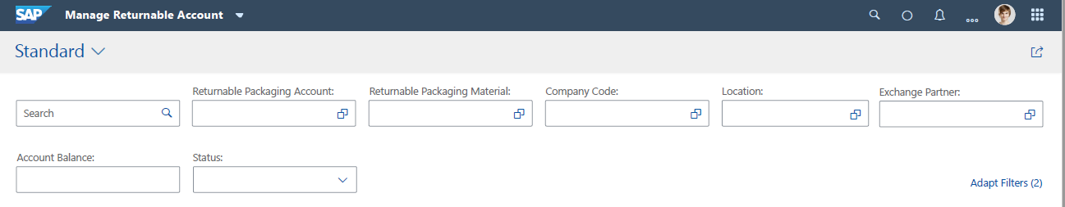

Provision should be available to adopt list of filters as per user requirement.

#### Returnable accounts list page

Following columns should be displayed in the list of returnable accounts:

|  |  |  |  |  |  |  |  |  |
| --- | --- | --- | --- | --- | --- | --- | --- | --- |
| Order | Field/Component | Default Display/Settings | Data Type | Length | Comment | Sortable | Filterable | Group By |
| 1 | Returnable Packaging Account | Default Display | CHAR | 12 | RLACCTSEL-ACCTNO | Yes | Yes | Yes |
| 2 | Returnable Packaging Material | Default Display | CHAR | 40 | Material description with material no in bracket | Yes | Yes | Yes |
| 3 | Company Code | Default Display | CHAR | 4 | Company Code Description with Company code in bracket | Yes | Yes | Yes |
| 4 | Location Partner Type | Optional | CHAR | 10 | Plant/ Customer/ Vendor | Yes | Yes | Yes |
| 5 | Location Partner | Default Display | CHAR | 10 | Location with location key | Yes | Yes | Yes |
| 6 | Exchange Partner Type | Optional | CHAR | 10 | Plant/ Customer/ Vendor | Yes | Yes | Yes |
| 5 | Exchange Partner | Default Display | CHAR | 10 | To be displayed in bracket after exchange partner name | Yes | Yes | Yes |
| 6 | Exchange Partner Name | Default Display | CHAR | 40 |  | Yes | No | No |
| 7 | Partner Material Code | Settings | CHAR | 40 |  | Yes | No | No |
| 8 | Account Balance | Default Display | Quantity Field in BCD Format | 13 | Graphical display to showcase Account balance in comparison with reorder point | Yes | No | No |
| 9 | Base Unit of Measure | Default Display | CHAR | 3 | Field to be clubbed with account balance on list display | Yes | Yes | Yes |
| 10 | Reorder Point Quantity | Settings | QUAN | 13 |  | Yes | No | No |
| 11 | Account Validity | Settings | Color indication | Red/ Green | Check validity for current date | Yes | No | No |
| 12 | Processor | Settings | CHAR | 12 |  | Yes | Yes | Yes |
| 13 | Status | Default Display | CHAR | 7 | Active/ Inactive | Yes | Yes | Yes |
| 14 | Account Created By | Settings | CHAR |  |  | Yes | Yes | Yes |
| ~~15~~ | ~~Ownership Type~~ | ~~Settings~~ | ~~CHAR~~ | ~~10~~ | ~~List - Customer, Vendor and Self~~ | ~~Yes~~ | ~~Yes~~ | ~~Yes~~ |
| ~~16~~ | ~~Owner~~ | ~~Default Display~~ | ~~CHAR~~ | ~~10~~ | ~~To be selected from existing list based on owner type selected~~ | ~~Yes~~ | ~~Yes~~ | ~~Yes~~ |
| ~~17~~ | ~~Quantity Owned~~ | ~~Settings~~ | ~~QUAN~~ | ~~13~~ | ~~Not planned for 2008 release~~ | ~~Yes~~ | ~~Yes~~ | ~~Yes~~ |

**Requirements in list view:**

* Latest account should be displayed on the top of the account list.
* List should be sorted in descending order of ‘Returnable packaging account numbers.
* Newly created accounts which are not viewed by user should be highlighted by blue color. E.g. 
* Once the account is viewed by user, the blue color highlight should be removed for that user.
* Account balance along with reorder point should be highlighted with bar chart in the list E.g.

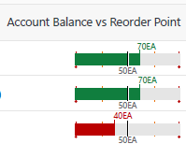

* If reorder point is not maintained, ‘Reorder point not maintained’ text should be displayed instead of graph.
* Provision should be available to add columns from provided options should be available as per user requirement.
* List export to excel functionality should be available
* Create button should be available on list page to navigate to ‘Create Account’ screen
* Copy Functionality: Refer section 4.3.5.7 for ‘Copy returnable packaging account’ functionality.

#### Navigation to other applications

Provision should be available to navigate to other applications of IRP solution should be available from list page of ‘Manage Returnable Packaging Accounts’ list page.

Navigation should be possible to following applications:

1. Manage Posting Documents
2. Manage Returnable Packaging Account statements

Example of UX mockup is given below for reference. Latest mockup should be referred from [Teams](https://teams.microsoft.com/_#/files/Requirements%20and%20Use%20Cases?threadId=19%3Aacc16c4a49fa4b26aa17c2436c593114%40thread.skype&ctx=channel&context=MockUp&rootfolder=%252Fteams%252FReturnablePackagingDevelopment%252FShared%2520Documents%252FRequirements%2520and%2520Use%2520Cases%252FMockUp).

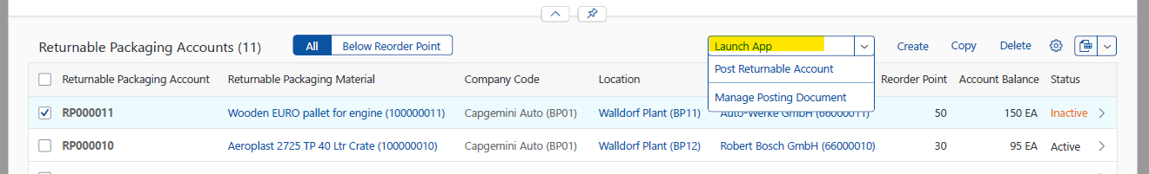

If returnable accounts are selected before navigating to another application, selected accounts should be passed on as filter criteria on the navigated application.

#### Returnable Packaging Account Creation

After clicking on ‘Create’ button from returnable packaging list page, ‘Returnable Packaging Account’ object page should be launched to enter account creation information.

Following tabs should be available on ‘Create Account’ page

|  |  |  |  |
| --- | --- | --- | --- |
| Order | Tab Name | Default Display | Comment |
| 1 | Main Relationship | Default Display |  |
| 2 | General Information | Default Display |  |
| 3 | Partner Relationships. To be renamed as ‘Additional Partner Relationships’ if main relationship cannot be added here by default in display only mode due to technical limitation. Reference technical JIRA No xxxxxx. | Default Display |  |
| ~~4~~ | ~~Account Matching (Not in scope for 2008 release)~~ | ~~Default Display~~ |  |
| ~~5~~ | ~~Purchase Order (Not in scope for 2008 release)~~ | ~~Default Display~~ |  |
| 6 | Change History | Default Display |  |
| 9 | Attachment | Default Display |  |

Following information should be available in header data:

|  |  |  |
| --- | --- | --- |
| Order | Field/Component | Default Display |
| 1 | Returnable Packaging Account No | Default Display |
| 2 | Returnable Packaging Material Description (Material Code) | Default Display |
| 3 | Product Image | Default Display |
| 4 | Exchange Partner (Code) | Default Display |
| 5 | Processor - Editable Field | Default Display |
| 6 | Status | Default Display |
| 7 | Account Balance: with Color-code (Red = Below reorder point, Green = above reorder point, Gray) ~~and Chart~~ | Default Display |
| 8 | Location Partner (Code) | Default Display |
| 9 | Edit/Delete/Share/Expand/Close Buttons | Default Display |

Following fields should be available on ‘Main Relationship’ Tab:

|  |  |  |  |
| --- | --- | --- | --- |
| Order | Field/Component | Mandatory/ Optional | Comment |
| 1 | Exchange Partner Type/ Dropdown | Mandatory | Only 3 values are allowed: Plant, Customer & Vendor. Suggestive text required to assist data entry |
| 2 | Exchange Partner/ F4 | Mandatory | Should only be one of the existing exchange partners. Suggestive text required to assist data entry along with F4 help. F4 help should be dynamically changed based on exchange partner type selected. Entry in exchange partner field should not be allowed unless ‘Exchange Partner Type’ is selected. |
| 3 | Location Partner Type/ Dropdown | Mandatory | Only 3 values are allowed: Plant, Customer & Vendor. Suggestive text required to assist data entry |
| 4 | Location Partner/ F4 | Mandatory | Should only be one of the existing locations. Suggestive text required to assist data entry along with F4 help. F4 help should be dynamically changed based on location type selected. Entry in location field should not be allowed unless ‘Location Type’ is selected. |
| 5 | Valid From/ F4 | Mandatory | Document creation date should be defaulted. Date should be editable in create and update mode. |
| 6 | Valid To/ F4 | Mandatory | 31/12/2050 date should be defaulted. Date should be editable in create and update mode. |

* Following information should be available on General Information tab:

|  |  |  |  |
| --- | --- | --- | --- |
| Order | Field/Component | Default Display | Comment |
| 1 | Returnable Packaging Account | Default Display | System generated number based on number generation logic maintained in ‘Define Number Ranges’ application. |
| 2 | Company Code/ F4 | Default Display | Should be one of the existing Company Codes. |
| 3 | Returnable Packaging Material/ F4 | Default Display | Should be one of the existing Returnable Packaging Material. |
| 4 | Created By | Default Display | Read only. First Name and Last Name of the user ID using which this account is created |
| 5 | Customer/ Vendor Material | Default Display | Manual entry. Special characters not allowed. |
| 6 | Created On | Default Display | Date and Time of document creation |
| 7 | Processor/ F4 | Default Display | Should be one of the existing Processor |
| 8 | Account Balance | Default Display | Not editable. Should be updated automatically after automatic or manual document posting. |
| 9 | Reorder Point Quantity | Default Display |  |

Following fields should be available on ‘Partner Relationship’ Tab.

To be renamed as ‘Additional Partner Relationships’ if main relationship cannot be added here by default in display only mode due to technical limitation. Reference technical JIRA No xxxxxx.

|  |  |  |  |
| --- | --- | --- | --- |
| Order | Field/Component | Mandatory/ Optional | Comment |
| 1 | Location Partner Type | Mandatory | Only 3 values are allowed: Plant, Customer & Vendor. Suggestive text required to assist data entry |
| 2 | Location Partner | Mandatory | Should only be one of the existing locations. Suggestive text required to assist data entry along with F4 help. F4 help should be dynamically changed based on location type selected. Entry in location field should not be allowed unless ‘Location Type’ is selected. |
| 3 | Exchange Partner Type | Mandatory | Only 3 values are allowed: Plant, Customer & Vendor. Suggestive text required to assist data entry |
| 4 | Exchange Partner | Mandatory | Should only be one of the existing exchange partners. Suggestive text required to assist data entry along with F4 help. F4 help should be dynamically changed based on exchange partner type selected. Entry in exchange partner field should not be allowed unless ‘Exchange Partner Type’ is selected. |
| 5 | Valid From/ F4 | Mandatory | Document creation date should be defaulted. Date should be editable in create and update mode. |
| 6 | Valid To/ F4 | Mandatory | 31/12/2050 date should be defaulted. Date should be editable in create and update mode. |
|  |  |  |  |

~~Following details should be available on account matching tab (Not planned for 2008 release) :~~

|  |  |  |  |  |
| --- | --- | --- | --- | --- |
| ~~Order~~ | ~~Field/Component~~ | ~~Default Display~~ | ~~Group~~ | ~~Comment~~ |
| ~~1~~ | ~~Role of location in statement/ List~~ | ~~Default Display~~ | ~~Account Matching~~ | ~~Dropdown List:~~   1. ~~Customer~~ 2. ~~Vendor~~ 3. ~~‘Blank’~~ |
| ~~2~~ | ~~Statement control/ List~~ | ~~Default Display~~ | ~~Account Matching~~ | ~~Dropdown List~~   1. ~~No Statements~~ 2. ~~Statements are received~~ 3. ~~Statements are sent~~ 4. ~~Invoices are created~~ |
| ~~3~~ | ~~Account Statement Create Control/ List~~ | ~~Default Display~~ | ~~Account Matching~~ | ~~Dropdown List (TBD)~~   1. ~~Creation and sending via SWP~~ 2. ~~Own creation, Sending and Matching via SWP~~ 3. ~~Creation by partner, no sending via SWP~~ 4. ~~Creation by partner, sending via SWP~~ 5. ~~Creation by partner, sending and matching via SWP~~ 6. ~~‘Blank’~~ |
| ~~4~~ | ~~Matching procedure/ List~~ | ~~Default Display~~ | ~~Account Matching~~ | ~~Dropdown List~~   1. ~~No matching~~ 2. ~~Matching without matching groups~~ 3. ~~Matching only with matching groups~~ 4. ~~Matching with or without matching groups~~ 5. ~~‘Blank’~~ |
| ~~5~~ | ~~Partner Type/F4~~ | ~~Default Display~~ | ~~Output Partner~~ | ~~TBD~~ |
| ~~6~~ | ~~Output partner/F4~~ | ~~Default Display~~ | ~~Output Partner~~ | ~~TBD~~ |
| ~~7~~ | ~~Sales Organization/F4~~ | ~~Default Display~~ | ~~Cust. Mat. Sales Org Data~~ |  |
| ~~8~~ | ~~Distribution Channel/F4~~ | ~~Default Display~~ | ~~Cust. Mat. Sales Org Data~~ |  |

~~Following fields should be available on ‘Purchase Order’ Tab. Not in scope for 2008 release.~~

|  |  |  |  |  |
| --- | --- | --- | --- | --- |
| ~~Order~~ | ~~Field/Component~~ | ~~Default Display~~ | ~~Group~~ | ~~Comment~~ |
| ~~1~~ | ~~Planning Type/ List~~ | ~~Default Display~~ | ~~Reorder point planning~~ | ~~Not planned for release 1~~ |
| ~~2~~ | ~~Outline agreement/ F4~~ | ~~Default Display~~ | ~~Reorder point planning~~ | ~~Not planned for release 1~~ |
| ~~3~~ | ~~Reorder Point Quantity/...../No~~ | ~~Default Display~~ | ~~Reorder point planning~~ |  |
| ~~4~~ | ~~Order Quantity/...../No~~ | ~~Default Display~~ | ~~Reorder point planning~~ | ~~Not planned for release 1~~ |
| ~~5~~ | ~~Current Account Balance~~ | ~~Default Display~~ | ~~Reorder point planning~~ | ~~Not planned for release 1~~ |
| ~~6~~ |  | ~~Default Display~~ |  |  |
| ~~7~~ |  | ~~Default Display~~ |  |  |
| ~~8~~ |  | ~~Default Display~~ |  |  |

* Save and Activate, Save and Cancel button should be available on create account page to perform Save or Cancel action. Save and Activate button should be highlighted if the document is in inactive statue.

Example of UX mockup is given below for reference. Latest mockup should be referred from [Teams](https://teams.microsoft.com/_#/files/Requirements%20and%20Use%20Cases?threadId=19%3Aacc16c4a49fa4b26aa17c2436c593114%40thread.skype&ctx=channel&context=MockUp&rootfolder=%252Fteams%252FReturnablePackagingDevelopment%252FShared%2520Documents%252FRequirements%2520and%2520Use%2520Cases%252FMockUp).



Save and Deactivate, Save and Cancel button should be available at the bottom of ‘Edit Account’ page to Save/ Cancel/ Activate the changes if account is in active status. Save button should be highlighted in this case.

Example of UX mockup is given below for reference. Latest mockup should be referred from [Teams](https://teams.microsoft.com/_#/files/Requirements%20and%20Use%20Cases?threadId=19%3Aacc16c4a49fa4b26aa17c2436c593114%40thread.skype&ctx=channel&context=MockUp&rootfolder=%252Fteams%252FReturnablePackagingDevelopment%252FShared%2520Documents%252FRequirements%2520and%2520Use%2520Cases%252FMockUp).



* Action: Display (Object Page): Account should be displayed with ‘Detail View’ after clicking on specific account number.

All the fields in returnable packaging account should be displayed in non-editable mode with two panel view.

#### Copy Account Functionality

Copy account functionality should be available on ‘Returnable Account’ list display screen as well as from object page. Reference account (One or Many) can be selected with checkbox and copied after click on ‘Copy’ button. Copied account will have ‘Inactive’ status by default.

* If no account is selected on list page, copy link should be disabled.

Example of UX mockup is given below for reference. Latest mockup should be referred from [Teams](https://teams.microsoft.com/_#/files/Requirements%20and%20Use%20Cases?threadId=19%3Aacc16c4a49fa4b26aa17c2436c593114%40thread.skype&ctx=channel&context=MockUp&rootfolder=%252Fteams%252FReturnablePackagingDevelopment%252FShared%2520Documents%252FRequirements%2520and%2520Use%2520Cases%252FMockUp).

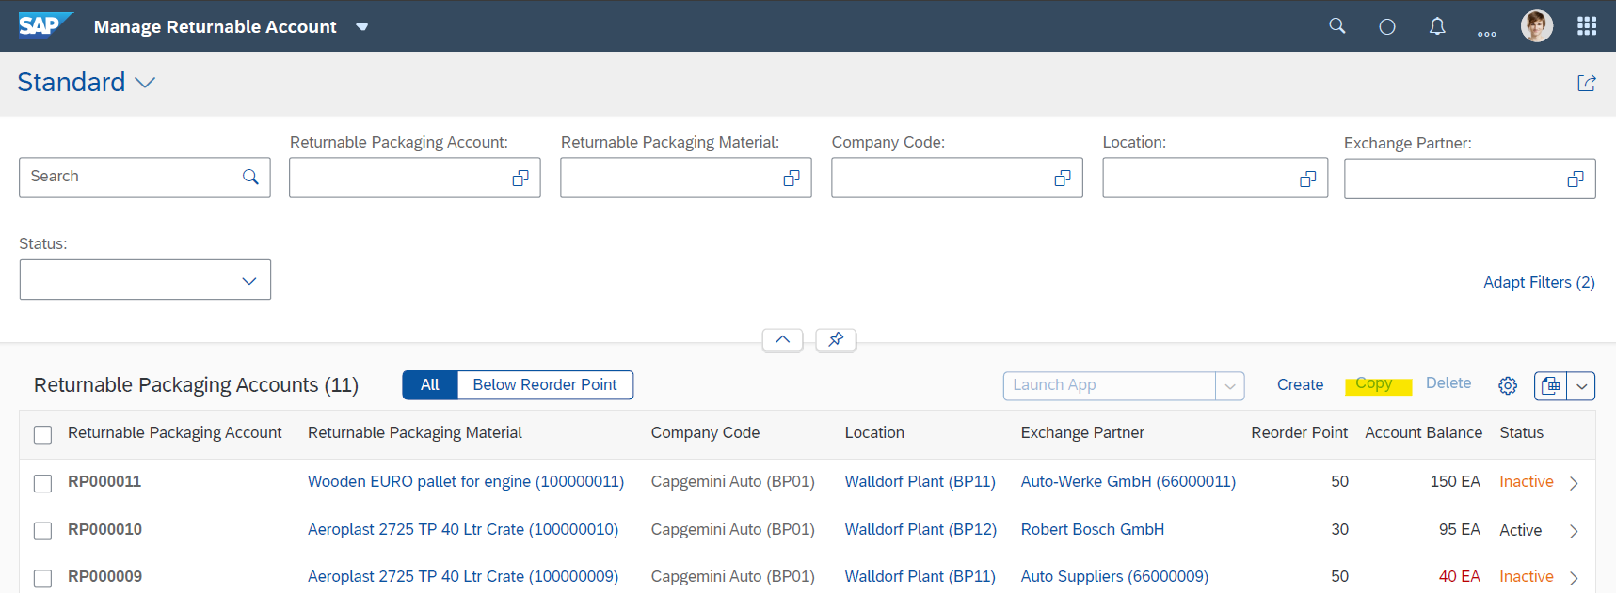

* When one or more accounts are selected, ‘Copy’ link should be enabled to copy one or more accounts to create new returnable account.

Example of UX mockup is given below for reference. Latest mockup should be referred from [Teams](https://teams.microsoft.com/_#/files/Requirements%20and%20Use%20Cases?threadId=19%3Aacc16c4a49fa4b26aa17c2436c593114%40thread.skype&ctx=channel&context=MockUp&rootfolder=%252Fteams%252FReturnablePackagingDevelopment%252FShared%2520Documents%252FRequirements%2520and%2520Use%2520Cases%252FMockUp).

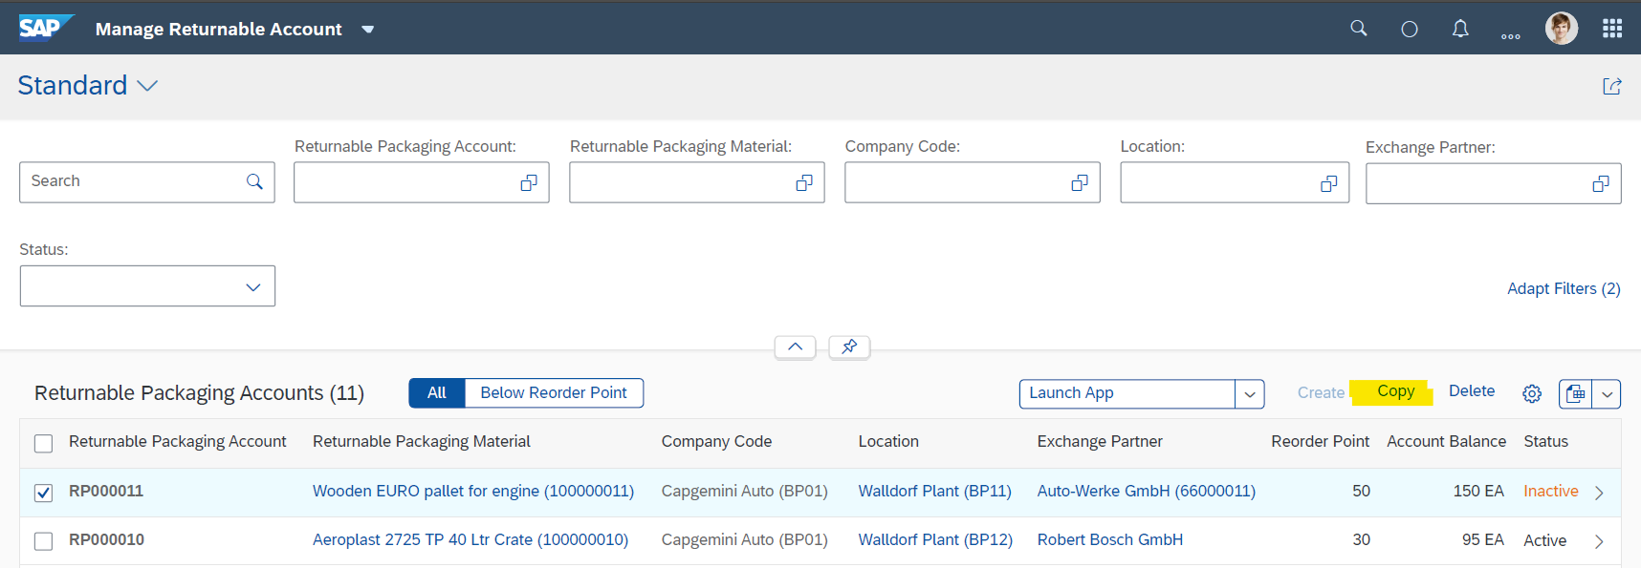

* ‘Copy’ functionality also should be available from object page of Returnable Packaging Account.

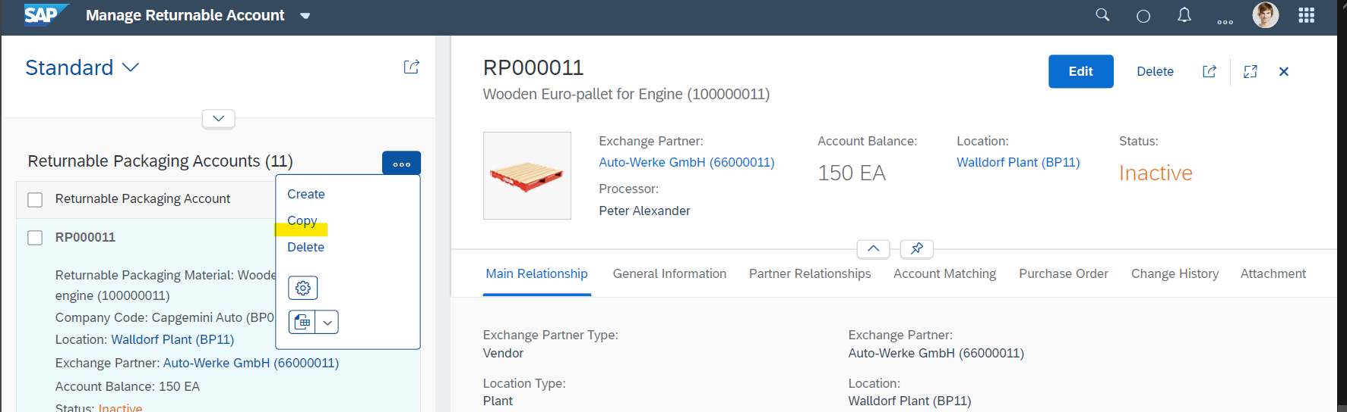

* After clicking on ‘Copy’ link, object page with flexi column layout should be opened for account creation on right side of flexi column layout. Following details should be copied in new account from the returnable account which is referred for copy.
  1. Exchange partner type
  2. Exchange partner
  3. Location partner type
  4. Location partner
  5. Company code
  6. Returnable packaging material
  7. Customer vendor material
  8. Processor
  9. Additional Partner Relationships
* Left side panel of flexi-column layout should show the returnable packaging accounts which were selected for copy function.
* Valid from date should be today’s date by default and should be modifiable while copying the account.
* Valid to date should be populated as *31/12/2050* by default.
* Packaging manager will add or modify required details in copied data and create new returnable packaging account.

#### F4 Help for Manage Account Application

Details of F4 help relevant fields, search filters for each field and required result list report for ‘Manage Returnable Packaging’ application is given below:

|  |  |  |  |
| --- | --- | --- | --- |
| F4 Help Field | Search Filters | Result List Report | Remarks |
| Returnable Packaging Account | Returnable Packaging Material | Returnable Packaging Account (Code) |  |
|  | Company Code | Returnable Packaging Material (Code) |  |
|  | Location Partner | Company Code (Code) |  |
|  | Exchange Partner | Location Partner (Code) |  |
|  | Account Status | Exchange Partner (Code) |  |
|  | Returnable Packaging Account | Account Status |  |
|  | Location Partner Type | Account Balance |  |
|  | Exchange Partner Type | Valid From |  |
|  |  | Valid To |  |
|  |  | Location Partner Type | Optional |
|  |  | Exchange Partner Type | Optional |
|  |  |  |  |
| Valid From | Date Picker | Date Picker |  |
|  |  |  |  |
| Valid To | Date Picker | Date Picker |  |
|  |  |  |  |
| Returnable Packaging Material | Returnable Packaging Material Description | Returnable Packaging Material (Code) |  |
|  | Returnable Packaging Material | Company Code (Code) |  |
|  | Company Code | Plant (Code) | *To be derived from linked plant |
|  | Plant |  |  |
|  |  |  |  |
| Company Code | Company Code | Company Code |  |
|  | Company Name | Company Name |  |
|  | City | City |  |
|  |  | Currency |  |
|  |  |  |  |
| Location Partner |  |  |  |
|  | Location Partner Type | Location Partner Type | Grayed out field / Info tab should be provided to guide user for inputs |
|  | Location Partner ID | Location Partner ID |  |
|  | Location Partner Name | Location Partner Name |  |
|  | City | City |  |
|  | Country | Country |  |
|  |  |  |  |
|  |  |  |  |
| Exchange Partner | Exchange Partner Type | Exchange Partner Type | Grayed out field / Info tab should be provided to guide user for inputs |
|  | Exchange Partner ID | Exchange Partner ID |  |
|  | Exchange Partner Name | Exchange Partner Name |  |
|  | City | City |  |
|  | Country | Country |  |
|  |  |  |  |
|  |  |  |  |
|  |  |  |  |
| Sales Organization | Sales Organization | Sales Organization |  |
|  | Sales Organization Name | Sales Organization Name |  |
|  | Distribution Channel | Distribution Channel |  |
|  | Distribution Channel Name | Distribution Channel Name |  |
|  |  |  |  |
| Distribution Channel | Sales Organization | Sales Organization |  |
|  | Sales Organization Name | Sales Organization Name |  |
|  | Distribution Channel | Distribution Channel |  |
|  | Distribution Channel Name | Distribution Channel Name |  |
|  |  |  |  |
| Processor | Processor ID | Processor ID | DDLB |
|  | Processor Name | Processor Name |  |
|  |  |  |  |
| Account Created By | Creator ID | Creator ID |  |
|  | Creator Name | Creator Name |  |
|  |  |  |  |

#### Statuses for returnable account

By default, returnable account should be created with ‘Inactive’ status.

Packaging manager can go to object page of returnable packaging account and change the status to ‘Active’

Packaging manager can change status of returnable packaging account to inactive by clicking on ‘Deactivate’ button on object page of active returnable packaging account.

Following notification toast message should be displayed after clicking ‘Activate’ button:

‘Returnable Packaging Account No RP000011 will be activated. Click ‘Save’ button to save changes’

Following notification toast message should be displayed after clicking ‘Deactivate’ button:

‘Returnable Packaging Account No RP000011 will be deactivated. Click ‘Save’ button to save changes’

**Business validations:**

* If account is not in validity period, it’s status should be changed to inactive.
* If account is not in active status, manual posting should not be allowed to the account
* If account is not in active status, Automatic posting should not be allowed to the account
* If the account is in ‘Inactive’ status, ‘Activate’ button should be enabled at the bottom of the object page in change mode for activating the account
* If the account is in ‘Active’ status, ‘Deactivate’ button should be enabled at the bottom of the object page in change mode to make the account inactive.
* Save button should be pressed to save the changes in account status.

#### Number range for returnable packaging account

Refer section ‘Define Number Ranges’ for details regarding number range definition and assignment of number range to Manage returnable packaging application.

Number range should be configurable for customer with numeric and alphanumeric sequential numbering options.

*~~Reuse service availability to be checked for number range maintenance.~~*

If the number range is not created and defined for ‘Manage Returnable Packaging’ application, returnable packaging account cannot be created.

#### ~~Ownership in returnable account (Not planned for 2008 release)~~

~~Each Account should have a input  Field at header level with option to select the owner .Values – Owned by Partner ,Self-Owned, Not specified  .Not Specified to be defaulted .~~

~~Assumptions/Scope for 2008 release~~

* ~~A material can have only one owner either Vendor ,Supplier or Customer .There are no technical restriction put in the application for the same. If a material is used in more than one account with different owners ,the data will be considered inconsistent .In SAC such data should not be used for reporting.~~
* ~~All the company code associated with the material to have the same currency in the first release .Material belonging to multiple Company Codes is supported but all the Company Codes should have the same currency .In case of different currencies it will not be considered a valid data and should not be used in the system .There will be no technical checks for this scenario.~~

#### Change History of Returnable account

Refer section ‘Change History Log’ for details regarding change history log.

Every change in returnable account should be captured in ‘Change History’ tab. Following details should be captured:

* Creation date, time, created by
* Change – Field, New Value, Old Value, Change Date, Change Time, Changed by

Example mockup is given below for reference

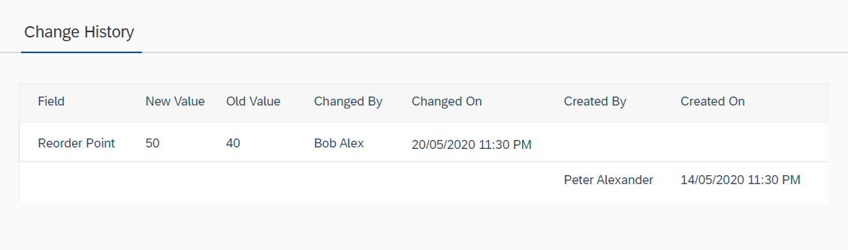

#### Update of Returnable Packaging Account

Returnable account can be edited by clicking on ‘Edit’ button on detail view page:

Following fields should be editable if returnable account is opened in Edit Mode

* Valid from
* Valid to
* Processor
* ~~Role of location in statement/ List~~
* ~~Statement control/ List~~
* ~~Account Statement Create Control/ List~~
* ~~Matching procedure/ List~~
* ~~Planning Type/ List~~
* ~~Outline agreement/ F4~~
* ~~Reorder Point Quantity/...../UOM~~
* ~~Order Quantity/...../UOM~~

Following buttons should be available in edit mode of returnable packaging account

* Add partner relationship
* Remove partner relationship

Save and Activate, Save and Cancel button should be available at the bottom of ‘Edit Account’ page to Save/ Cancel/ Activate the changes if account is in inactive status. ‘Save and Activate’ button should be highlighted in this case.

Example of UX mockup is given below for reference. Latest mockup should be referred from [Teams](https://teams.microsoft.com/_#/files/Requirements%20and%20Use%20Cases?threadId=19%3Aacc16c4a49fa4b26aa17c2436c593114%40thread.skype&ctx=channel&context=MockUp&rootfolder=%252Fteams%252FReturnablePackagingDevelopment%252FShared%2520Documents%252FRequirements%2520and%2520Use%2520Cases%252FMockUp).



Save and Deactivate, Save and Cancel button should be available at the bottom of ‘Edit Account’ page to Save/ Cancel/ Activate the changes if account is in active status. Save button should be highlighted in this case.

Example of UX mockup is given below for reference. Latest mockup should be referred from [Teams](https://teams.microsoft.com/_#/files/Requirements%20and%20Use%20Cases?threadId=19%3Aacc16c4a49fa4b26aa17c2436c593114%40thread.skype&ctx=channel&context=MockUp&rootfolder=%252Fteams%252FReturnablePackagingDevelopment%252FShared%2520Documents%252FRequirements%2520and%2520Use%2520Cases%252FMockUp).



#### View Returnable Packaging Account

Provision should be available to open returnable packaging account in display mode. Account can be opened in display mode by clicking on the account in filtered list. Account should be displayed in Flexi Column layout. All fields should be non-editable in display mode. Edit, Delete, Send and Expand buttons should be available in display mode.

Example of UX mockup is given below for reference. Latest mockup should be referred from [Teams](https://teams.microsoft.com/_#/files/Requirements%20and%20Use%20Cases?threadId=19%3Aacc16c4a49fa4b26aa17c2436c593114%40thread.skype&ctx=channel&context=MockUp&rootfolder=%252Fteams%252FReturnablePackagingDevelopment%252FShared%2520Documents%252FRequirements%2520and%2520Use%2520Cases%252FMockUp).

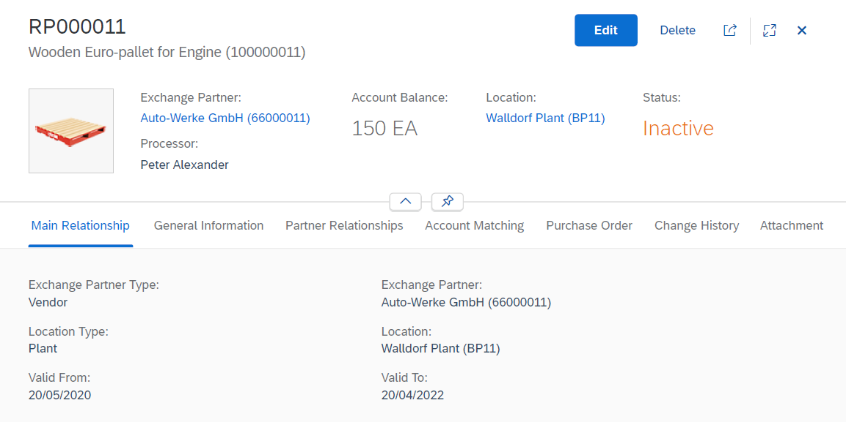

#### Deletion of Returnable Packaging Account

**Delete Functionality:** Checkbox for multiple selection and deletion of single or multiple returnable packaging accounts.

**Business Rule:** If account balance is not equal to zero, account deletion should not be allowed. System should give following error message while deleting.

**‘Account balance is not equal to zero, account cannot be deleted’**

#### Business validations

1. *Main partner relationship should be defaulted from General Information Tab (TBD after technical feasibility check)*
2. Once created, main relationship cannot be deleted for any account
3. Same relationship is not allowed in different accounts with overlapping validity date interval. Error message should be given if same relationship with overlapping validity interval already exists while creating and updating partner relationships.
4. Factors which constitute main relationship of an account are Returnable Packaging, Location, Exchange Partner, Company Code and Validity period,
5. If valid from date is not same as current date, system should give information message – ‘valid from date is not current date’.
6. If valid to date is prior to valid from date, system should give error message – ‘Valid from date cannot be prior to valid to date’.
7. **Exchange Partner** field details can only be entered if Exchange Partner Type is selected.
8. F4 value in Exchange partner should be dynamically changed based on selection of Exchange Partner Type field.
9. **Location Partner** field details can only be entered if Location Type is selected.
10. F4 value in Location should be dynamically changed based on selection of Location Partner Type field.
11. Account balance should be zero when new account is created. Account balance should be updated as per the logic given in ‘Account balance update’ section.
12. Account balance should not be manually editable.
13. Account balance can be updated only when account is in active status.
14. Account cannot be deleted, if account balance is not equal to zero.
15. ~~If account is not in validity period, it’s status should be changed to inactive.~~
16. ~~If new account is created with a period of validity that overlaps with that of an existing account with the same main relationship, then the valid-to date of the existing account is set to before the valid-from date of the new account. This is to ensure that a relationship is only used once. System should give a message before the action is carried out.~~
17. ~~If the new account fully overlaps the old one, the system sets the valid-to date of the old account further back than its valid-from date.~~
18. ~~Sales organization can be entered only if one of the main relationship partners has partner type "Customer".~~
19. ~~If sales organization is assigned for account, validate that this sales organization is assigned to returnable packaging material.~~

#### Account balance update in Returnable Packaging account

Following Logic should to be used to update account balance during manual postings:

1. Account balance should be zero when new account is created
2. System will check RP Posting type selected while manual posting
3. System will check RP Posting Table for the selected type
4. Based on +/ - sign maintained in account posting table, quantity should be added or subtracted from account balance.
5. Account balance can be updated only when account is in active status

### User Story – Manage Posting Documents

**User Story:** As a Packaging Manager, I want to be able to manage manually and automatically created posting documents for Inbound/ Outbound Transit of returnable packaging materials.

#### Posting documents

Posting document serves as an accounting record for a business transaction, for example, goods issue and goods receipt.

Returnable packaging account postings map the receipt and issue of returnable packaging in returnable packaging accounts. By posting movements to these accounts, packaging manager can establish exactly how much returnable packaging’s are borrowed from or lent to the business partner.

#### FIORI application for Posting documents

New FIORI application should be developed as part of IRP solution to Provision should be available for following functionalities for management of posting documents (Manual as well as automatic):

* View list of posted documents based on the filter
* Post document manually
* View posting document details
* Check errors details of posting documents with error
* Reprocess posting documents
* Cancel posting documents
* Download list of posting documents
* Print posting document *(Not planned for 2008 release)*

FIORI tile should have following details:

Name of application: Manage Posting Documents

Number of Documents in Error status

Following diagram shows different actions which can be performed using ‘Manage Posting Documents’ application.

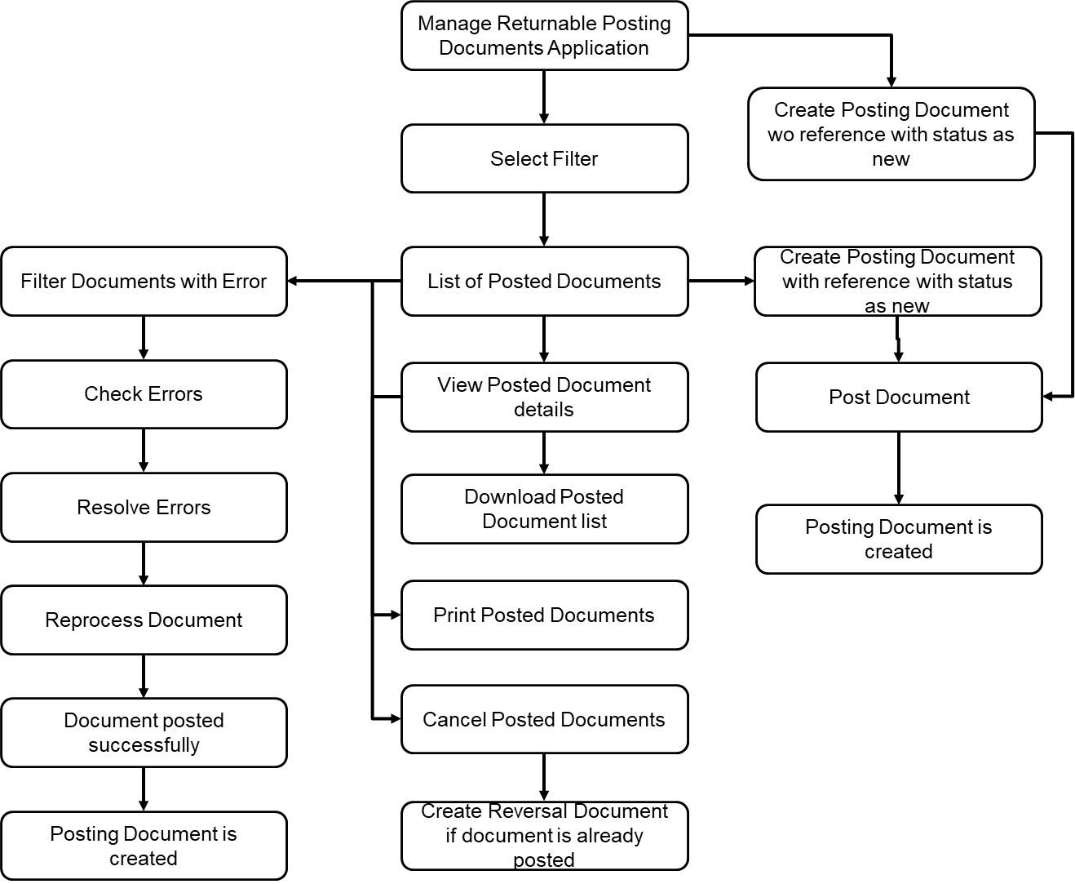

#### Filter criteria for posting documents

After opening ‘Manage Posting Documents’ application, list page of posted documents along with filter criterion should be opened.

Following filters should be available for generating posting documents list:

|  |  |  |
| --- | --- | --- |
| **No** | **Field** | **Remarks** |
| 1 | Posting Document Number | Entry aids like F4 and suggestive text are required |
| 2 | Packaging Material | Entry aids like F4 and suggestive text are required |
| 3 | Returnable Account | Entry aids like F4 and suggestive text are required |
| 4 | Exchange Partner | Entry aids like F4 and suggestive text are required |
| 5 | Inventory Reference | Entry aids like F4 and suggestive text are required |
| 6 | Posting Indicator | Dropdown list |
| 7 | Processor | Entry aids like F4 and suggestive text are required |
| 8 | Status | Dropdown list |
| 9 | Location | Entry aids like F4 and suggestive text are required |
| 10 | Posting Date | Only Date Format |
| 11 | Creation Date | Only Date Format |
| 12 | Created by | Entry aids like F4 and suggestive text are required |
| 13 | Posting Type | Should only be one of the existing posting types |
| 14 | Informing Partner | Entry aids like F4 and suggestive text are required |
| 15 | Sender | Entry aids like F4 and suggestive text are required |
| 16 | Recipient | Entry aids like F4 and suggestive text are required |
| 17 | Settlement Partner | Entry aids like F4 and suggestive text are required |
| 18 | Delivery Note | Only text, No special characters |
| 19 | Bill of Lading | Only text, No special characters |
| 20 | Posting year | Entry aids like F4 and suggestive text are required |
| 21 | Inventory Document Number | Entry aids like F4 and suggestive text are required |

~~Go button is not required.~~ By default, list of 20 filtered records should be displayed on screen and remaining list should be loaded with lazy loading.

Generated list report should have following fields:

|  |  |  |  |  |  |
| --- | --- | --- | --- | --- | --- |
| **No** | **Field** | **Default/ Optional** | **Sortable** | **Filterable** | **Group by** |
| 1 | Posting Document Number | Default | Yes | Yes | Yes |
| 2 | Posting Year | Optional | Yes | Yes | Yes |
| 3 | Packaging Material | Default | Yes | Yes | Yes |
| 4 | Returnable Account | Default | Yes | Yes | Yes |
| 5 | Location | Default | Yes | Yes | Yes |
| 6 | Exchange Partner | Default | Yes | Yes | Yes |
| 7 | Alert | Default | Yes | No | No |
| 8 | Status | Default | Yes | Yes | Yes |
| 9 | Posting Indicator | Default | Yes | Yes | Yes |
| 10 | Inventory Document Number | Optional | Yes | Yes | Yes |
| 11 | Inventory Document Item | Optional | Yes | Yes | Yes |
| 12 | Created by | Optional | Yes | Yes | Yes |
| 13 | Creation Date | Optional | Yes | Yes | Yes |
| 14 | Posting Date | Optional | Yes | Yes | Yes |
| 15 | Item no | Optional | Yes | Yes | Yes |
| 16 | Posting quantity | Default | Yes | No | No |
| 17 | Account posting Type | Optional | Yes | Yes | Yes |
| 18 | Reference Document | Optional | Yes | Yes | Yes |
| 19 | Informing Partner | Optional | Yes | Yes | Yes |
| 20 | Sender | Optional | Yes | Yes | Yes |
| 21 | Recipient | Optional | Yes | Yes | Yes |
| 22 | Settlement Partner | Optional | Yes | Yes | Yes |
| 23 | Delivery Note Item No | Optional | Yes | No | No |
| 24 | Delivery note quantity | Optional | Yes | No | No |
| 25 | Bill of Lading | Optional | Yes | No | No |

Checkbox should be available to select single or multiple documents on the list page and then take follow up action on the selected documents.

Packaging manager should be able to perform following activities from this page

* Create manual posting document by clicking on ‘Create New’ button
* Create manual posting document by selecting reference document
* Check error status and error details of documents by selecting documents in error status and
* Reprocess Document
* Generate list of posting documents based on the filter
* View posting document
* Cancel posting documents
* Download list of posting documents
* ~~Print posting document~~

**Business Validations on List Page:**

* ‘Check’ button should be enabled only when document with error status is selected.
* ‘Create’ button should be enabled when either none of the documents is selected or when documents with posted status are selected
* ‘Reprocess’ button should be enabled only when documents in ‘Error’ status are selected and the documents do not have any active errors
* ‘Cancel’ button should be enabled when documents with ‘Error’, ‘Posted’ or ‘New’ status are selected
* On a Posted Document if Cancel is pressed the Posted document should go in cancelled status and a reverse posted document should be created .This reverse posted document should have the posting type which is maintained in the Configure Posting Type App .Based on the credit/debit and other configuration of the reverse posting type ,Posting should be performed on the reverse posted document .If due to any reason reverse posting cannot be performed – example : Account not active ,BP is blocked ,Reverse posting type is not maintained ,the cancellation should fail with appropriate message.

#### Manual Posting

Packaging manager can post manually to returnable packaging accounts. For specific business scenarios such as cross-circulation since no goods movement takes place in plant stock.

Some of the examples when packaging manager can post manually are:

* Entering returnable packaging movements according to documents on paper (such as deliveries)
* Posting to a blocked account (automatic posting is not possible in this case)
* Reversing a manual posting
* Scrapping an item of returnable packaging
* Making an inventory difference posting
* Posting transfer of returnable packaging.

Packaging manager can also manually post transactions that take place outside the plant. In the case of cross-circulation with a sub-supplier, the sub-supplier delivers the goods in their returnable packaging directly to the customer, simply transmitting a message to the supplier. The physical stock does not change from the point of view of the supplier. However, the supplier must update the returnable packaging accounts.

The account posting types for the above movements are set for manual posting in Customizing.

*For release one: If manual posting is performed in IRP, it will not update inventory in ERP/ S4HANA system.*

##### Prerequisites for posting documents manually

* A returnable packaging account exists for the material to be posted
* Customizing table is maintained for account posting types. Refer section Account Posting Types for details.
* Manual posting is set for your account posting type in Customizing.

##### Account Posting Types

Refer section ‘Manage Account Posting Types’ for details.

Account posting type specifies the type of returnable packaging movement.

The account posting type is used to update the goods movement of a returnable packaging material to the associated returnable packaging account.

##### Manually Post Returnable Account process flow and detailed design

Following diagram highlights manual posting functionality as part of ‘Manage Posting Documents’ application

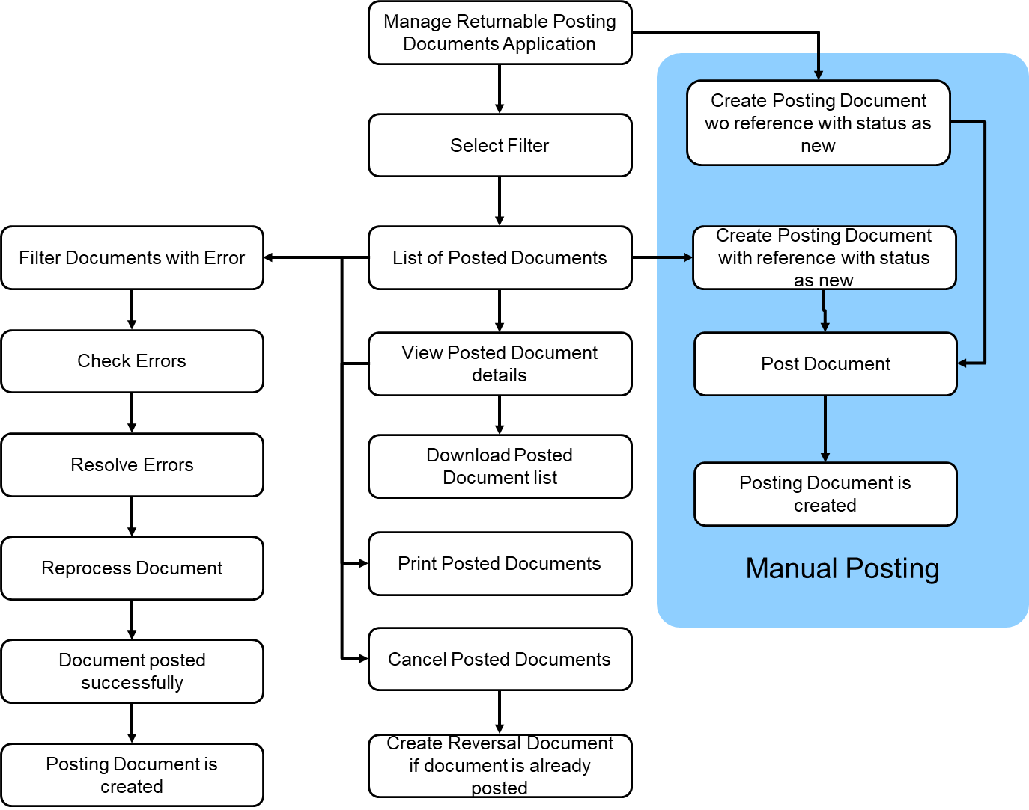

Manual document can be posted by navigating from list of posting documents. Following two types of navigation will be possible for creation of manual posting document

##### Navigation from Manage Posting Documents application for manual posting

With this app, a packaging manager should be able to manually post incoming or outing returnable material with a proper goods movement and inventory update for a specific account . ​

From landing page of Manage Posting Documents application following provisions should be available to create posting document manually

1. Create new manual posting document without reference
2. Create new manual posting document with reference to existing posting document

**Business Validations:**

In case of create new manual posting with reference, creation should be allowed only when referred document is in Posted status.

Create button should be available above posting documents list for creating manual posting document.

Following activities will be performed in Manual posting app:-

* Apply filter for returnable account selection for posting
* View filtered accounts
* Select account to be posted
* Pull details for manual posting by taking reference of selected account/ document
* Enter details in posting document and check for errors
* Resolve the errors
* Manually post the document
* Generate posting document number
* Update returnable packaging account balance
* *~~Change posted document – Not planned for release 1.~~*
* *~~Print returnable document – Not planned for release 1.~~*

#### Status network for posting document

Following statuses are allowed for posting documents as per the flow depicted in below diagram:

1. Posted: Documents will have status as posted if they are successfully posted without error. These are the valid documents which will be used for inventory updates and reporting.
2. Error: Automatically posted documents would be transferred to IRP via CPI integration. Documents will be transferred with status as ‘Error’ if the document has errors for posting.

For all automatically posted documents, document number will be automatically generated even if the document is saved with ‘Error’ status

List of possible errors is given below:

* Account does not exist in IRP
* Account is not active
* Account could not be determined -E.g. relationship not maintained
* Material does not exist in IRP
* Material is blocked
* Business partner does not exist in IRP
* Business Partner is blocked
* Movement type is not supported in IRP

1. Cancelled- Application should allow to cancel already posted document or the document with error. If posted document is cancelled, new reversal document should be created with reference to cancelled document. Both cancelled document and reversal document should have reference of each other document. With reference to reversal document, account balance should be reversed for the quantity of posted document. If the document which is in error or new status, the subsequent reversal document is not required after cancellation.
2. Reversed – If posted document is cancelled, new reversal document should be created with reference to cancelled document. Both cancelled document and reversal document should have reference of each other document. With reference to reversal document, account balance should be reversed for the quantity of posted document.
3. New – While creating document manually, if it gets created as draft, or if it is saved without posting, the document will have status as new.

**Status network for automatically posted documents**

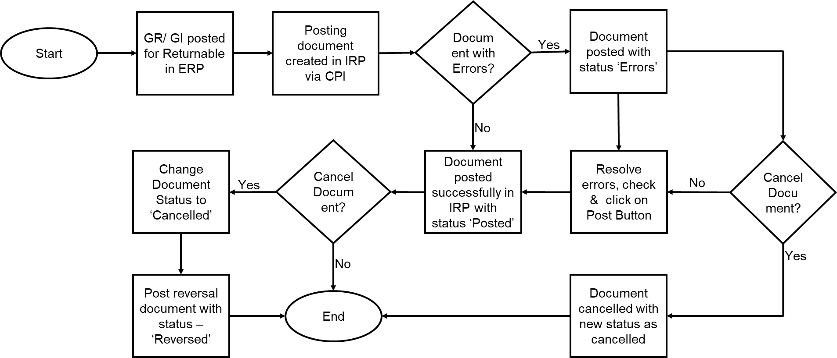

**Status network for Manually posted documents**

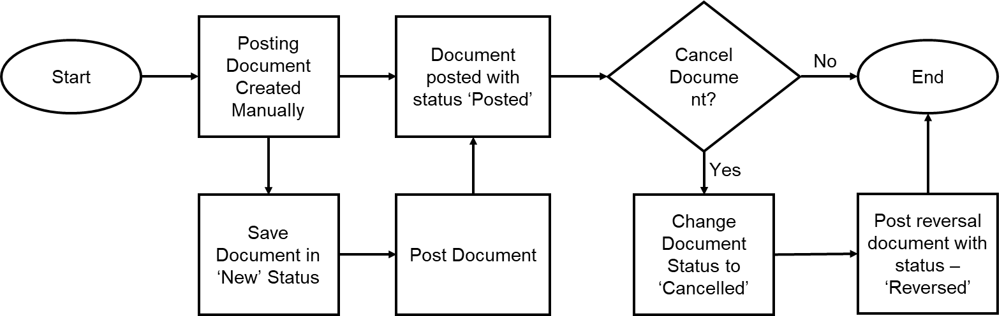

1. Creation of manual posting document without reference

Example of UX mockup is given below for reference. Latest mockup should be referred from [Teams](https://teams.microsoft.com/_#/files/Requirements%20and%20Use%20Cases?threadId=19%3Aacc16c4a49fa4b26aa17c2436c593114%40thread.skype&ctx=channel&context=MockUp&rootfolder=%252Fteams%252FReturnablePackagingDevelopment%252FShared%2520Documents%252FRequirements%2520and%2520Use%2520Cases%252FMockUp).

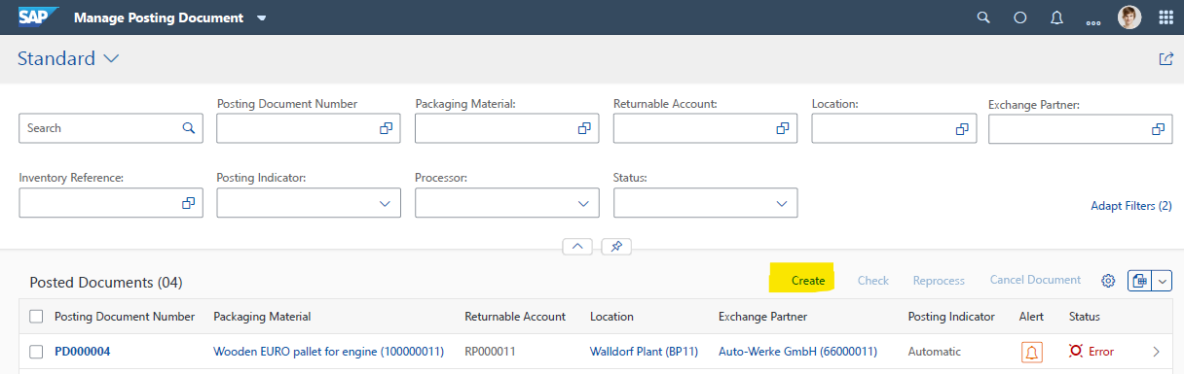

1. Creation of manual posting document with reference to posted document on list page. If the checkbox is selected, new posting document creation screen will be opened with selected documents as filter on the left side panel and reference for new document creation. The first document in the filter list would be selected by default for document creation.

Example of UX mockup is given below for reference. Latest mockup should be referred from Teams.

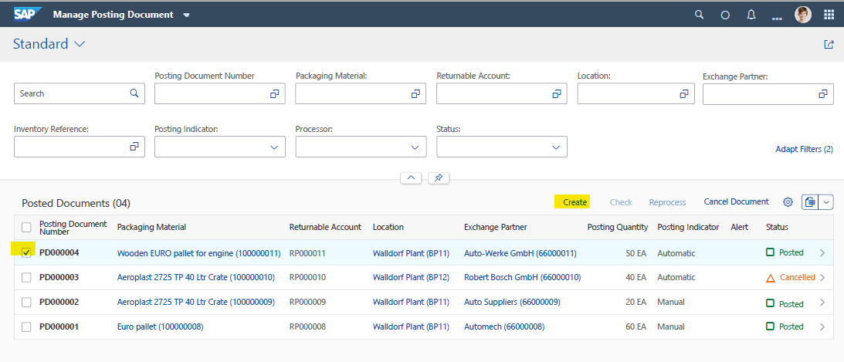

‘Two panel’ layout should be available on ‘Manual creation of posting document' screen. Left side panel should have filter functionality to filter required reference document for posting. Right side panel should have Posting Document Creation object page.

* Packaging manager should be able to filter posting document for reference based on ‘Posting Document Creation Object Creation’ page

Example of UX mockup of two panel layouts for ‘New Posting Document’ object page is given below for reference. Latest mockup should be referred from Teams.

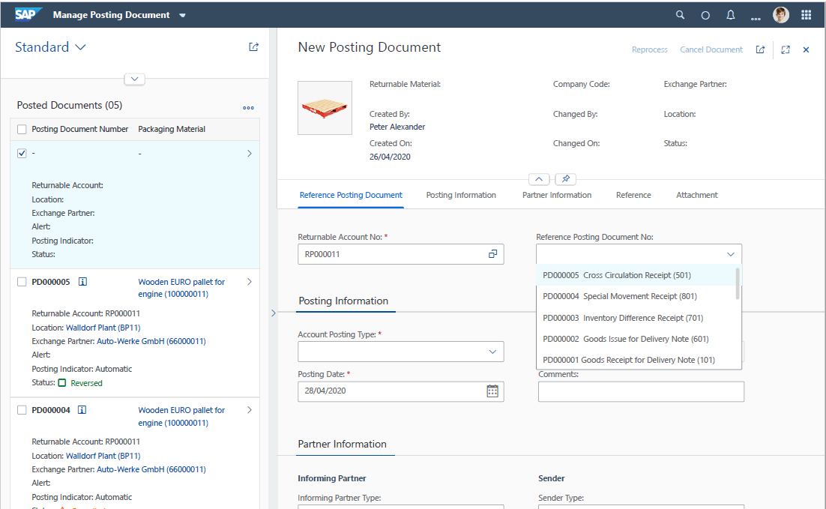

Following filters are required on ‘Posting document’ object page.

|  |  |  |  |
| --- | --- | --- | --- |
| Order | Field/Component | Default Display/Adapt Filters | Comment |
| 1 | Posting Document Number | Default Display | Suggestive text required to assist data entry apart from F4 help |
| 2 | Returnable Account/F4 | Default Display | Suggestive text required to assist data entry apart from F4 help |
| 3 | Returnable Packaging/F4 | Default Display | Suggestive text required to assist data entry apart from F4 help |
| 4 | Exchange Partner/F4 | Default Display | Suggestive text required to assist data entry apart from F4 help |
| 5 | Processor/F4 | Default Display | Suggestive text required to assist data entry apart from F4 help |
| 6 | Posting Indicator | Adopt filters | Suggestive text required to assist data entry apart from F4 help |
| 7 | Status | Adopt filters | Dropdown – Manual and Automatic |

Based on the applied filters, list of posted documents should be generated

The list report should have following fields.

|  |  |  |
| --- | --- | --- |
| Order | Field/Component | Comment |
| 1 | Posting Document Number |  |
| 2 | Returnable Account |  |
| 3 | Returnable Packaging |  |
| 4 | Location |  |
| 5 | Exchange Partner/F4 |  |
| 6 | Processor/F4 |  |
| 7 | Alert |  |
| 8 | Posting indicator |  |
| 9 | Status |  |

* The first document from the filtered list should be highlighted(Refer above image) and filtered by default for new manual document posting.
* Once the reference document is selected, account details and default details driven from the account should be transferred to object page.

Example of UX mockup is given below for reference. Latest mockup should be referred from [Teams](https://teams.microsoft.com/_#/files/Requirements%20and%20Use%20Cases?threadId=19%3Aacc16c4a49fa4b26aa17c2436c593114%40thread.skype&ctx=channel&context=MockUp&rootfolder=%252Fteams%252FReturnablePackagingDevelopment%252FShared%2520Documents%252FRequirements%2520and%2520Use%2520Cases%252FMockUp).

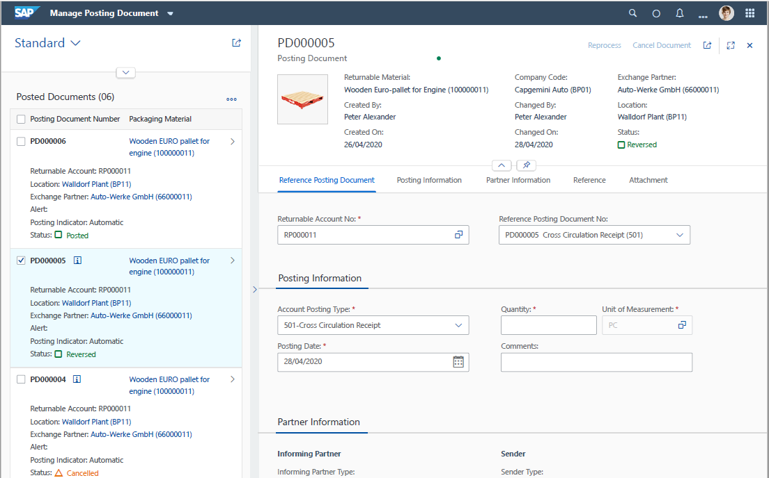

* Packaging manager should be able to select another document for posting reference if required.

Following fields should be available on the screen to post account manually. Validations mentioned in the validation column should be applied to the fields

| Sequence | Field/Component | Data Type | Length | Mandatory/ Optional | Validations/ Remarks |
| --- | --- | --- | --- | --- | --- |
| 1 | Created by | CHAR | 12 | Mandatory | System entry/ Not editable |
| 2 | Created on | DATE | 8 | Mandatory | System entry/ Not editable |
| 3 | Posting Date | CHAR | 8 | Mandatory | System entry, current date is taken as default. Only date formant allowed |
|  | Posting Year | NUM | 4 | Mandatory | System entry/ Not editable |
| 4 | Returnable Account | CHAR | 12 | Optional | Account should be existing and in active status. Suggestive text required to assist data entry apart from F4 help |
| 5 | Type of Informing Partner | CHAR | 2 | Optional | Only selection from dropdown list is allowed. Dropdown list:   1. Plant 2. Customer 3. Vendor |
| 6 | Informing Partner | CHAR | 10 | Optional | Should only be one of the existing plant/ customer/ Vendors. Selection should be driven based on type of informing partner selected in ‘Type of Informing Partner’ field. Suggestive text required to assist data entry apart from F4 help |
| 7 | Account posting type (Dropdown) | CHAR | 3 | Mandatory | Should only be one of the existing posting types |
| 8 | Returnable Packaging | CHAR | 40 | Mandatory | Should only be one of the existing returnable packaging materials. Suggestive text required to assist data entry apart from F4 help. |
| 9 | RP at partner | CHAR | 35 | Mandatory | Open text input field. Special characters are not allowed* |
| 10 | Quantity | QUAN | 13 | Mandatory | Only Numeric |
| 11 | UOM | CHAR | 3 | Mandatory | To be defaulted from returnable account. Read only field. |
| 12 | Ref. Document | CHAR | 35 | Optional | Open text input field. Special characters are not allowed* |
| 13 | Ref. Document Date | DATE | 8 | Optional | Date picker. If posting date is in future, then system should give error message |
| 14 | Company code | CHAR | 4 | Mandatory | To be defaulted from Returnable account |
|  | Sender Type | CHAR |  | Optional | Only selection from dropdown list is allowed. Dropdown list:   1. Plant 2. Customer 3. Vendor |
| 15 | Sender | CHAR | 10 | Optional | Should only be one of the existing plant/ customer/ Vendors. Selection should be driven based on type of informing partner selected in ‘Sender’ field. Suggestive text required to assist data entry apart from F4 help |
| 16 | Sender Name (External) | CHAR | 35 | Optional | Open text input field. Special characters are not allowed* |
|  | Recipient Type | CHAR |  | Optional | Only selection from dropdown list is allowed. Dropdown list:   1. Plant 2. Customer 3. Vendor |
| 17 | Recipient | CHAR | 10 | Optional | Should only be one of the existing plant/ customer/ Vendors. Selection should be driven based on type of informing partner selected in ‘Recipient’ field. Suggestive text required to assist data entry apart from F4 help |
| 18 | Recipient Name (External) | CHAR | 35 | Optional | Open text input field |
|  | Settlement Partner Type | CHAR |  | Optional | Only selection from dropdown list is allowed. Dropdown list:   1. Plant 2. Customer 3. Vendor |
| 19 | Settlement Partner | CHAR | 10 | Optional | Should only be one of the existing plant/ customer/ Vendors. Selection should be driven based on type of informing partner selected in ‘Settlement Partner’ field. Suggestive text required to assist data entry apart from F4 help |
| 20 | Settlement Partner Name (External) | CHAR | 35 | Optional | Open text input field. Special characters are not allowed* |
| 21 | Goods Movement Date | DATE | 8 | Optional | Date picker. If posting date is in future, then system should give error message |
|  | RP Location Type | CHAR | 1 | Optional | Only selection from dropdown list is allowed. Dropdown list:   1. Plant 2. Customer 3. Vendor |
| 22 | RP Location | CHAR | 10 | Optional | Should only be one of the existing plant/ customer/ Vendors. Selection should be driven based on type of informing partner selected in ‘RP Location’ field. Suggestive text required to assist data entry apart from F4 help |
| 23 | RP Location Name (External) | CHAR | 35 | Optional | Open text input field. Special characters are not allowed* |
|  | Exchange partner type | CHAR | 1 | Optional | Dropdown list:   1. Plant 2. Customer 3. Vendor |
| 24 | Exchange partner | CHAR | 10 | Optional | Should only be one of the existing plant/ customer/ Vendors. Selection should be driven based on type of informing partner selected in ‘RP Location’ field. Suggestive text required to assist data entry apart from F4 help |
| 25 | Exchange Partner Name (External) | CHAR | 35 | Optional | Open text input field. Special characters are not allowed* |
| 26 | Delivery Note | CHAR | 16 | Optional | Open text input field. Special characters are not allowed* |
| 27 | Delivery item no | NUMC | 6 | Optional | Open text input field. Special characters are not allowed* |
| 28 | Delivery note quantity | QUAN | 13 | Optional | Open text input field. Quantity/ Numeric |
| 29 | UOM From Delivery Note | UNIT | 3 | Optional | Should be defaulted from Returnable account. This should be editable field with F4 help. |
| 30 | Bill of lading | CHAR | 16 | Optional | Open text input field. Special characters are not allowed* |
| 31 | Reason for Reprocess | CHAR | 200 | Optional | Open text input field. Special characters are not allowed* |
| 32 | Comment | CHAR | 200 | Optional | Open text input field. Special characters are not allowed* |

* Based on selected reference account, key details will be pulled from the account for manual posting by taking reference of selected account/ document. Following details should be pulled from account when referred:

|  |  |
| --- | --- |
| **Field/Component** | **Remarks** |
| Returnable Account | Should be defaulted from returnable account |
| Returnable Packaging Material | Should be defaulted from returnable account |
| Exchange partner | Should be defaulted from returnable account |
| Location | Should be defaulted from returnable account |
| UOM | Should be defaulted from returnable account |
| Company code | Should be defaulted from returnable account |

* Following details should be pulled from reference document as a reference for new document creation:

|  |  |
| --- | --- |
| **Field/Component** | **Remarks** |
| Returnable Account | Should be defaulted from reference document |
| Returnable Packaging | Should be defaulted from reference document |
| RP at partner | Should be defaulted from reference document |
| UOM | Should be defaulted from reference document |
| Company code | Should be defaulted from reference document |
| Account posting type | Should be defaulted from reference document |
| Informing partner type | Should be defaulted from reference document |
| Informing partner | Should be defaulted from reference document |
| Sender type | Should be defaulted from reference document |
| Sender | Should be defaulted from reference document |
| External Description for Sender | Should be defaulted from reference document |
| Recipient Type | Should be defaulted from reference document |
| Recipient | Should be defaulted from reference document |
| External Description for Recipient | Should be defaulted from reference document |
| Settlement Partner Type | Should be defaulted from reference document |
| Settlement Partner | Should be defaulted from reference document |
| External Description for Settlement Partner | Should be defaulted from reference document |

* Following fields should be available on header section of posting document object page for manual posting

|  |
| --- |
| Top (read only) |
| Posting document number |
| ~~Posting document year~~ |
| ~~Returnable account no~~ |
| Returnable material (Code) |
| Company code (Code) |
| Location Partner |
| Exchange partner (Code) |
| Created by |
| Created on |
| Changed by |
| Changed on |
| Status |

Following Tabs should be available on top area of returnable packaging account object page for manual posting

|  |
| --- |
| Tabs for Post Document for Returnable Account object page |
| Reference Posting Document |
| Posting Information |
| Partner Information |
| Reference |
| Change History |
| Attachment |

Following fields should be available on ‘Reference Posting Documents’ tab-

|  |  |
| --- | --- |
| Reference Posting Document | Mandatory/ Optional |
| Returnable Account Number/F4 | Mandatory |
| Reference Posting Document No/ Dropdown | Optional |

Reference posting document should have dropdown in which last 10 documents should be displayed when clicked on dropdown button. This also should list ‘Account Posting Type’ and ‘Posting Type Description’ along with the document number.

* Following fields should be available on ‘Posting Information’ tab

|  |  |
| --- | --- |
| Posting Information | Mandatory/ Optional |
| Account Posting Type | Mandatory |
| Quantity (UOM) | Mandatory |
| Posting Date | Mandatory |
| Comments | Optional |
| Reason for cancellation | Optional |
| Reason for reprocessing | Optional |

* Following fields should be available on ‘Partner Information’ tab

|  |  |
| --- | --- |
| **Partner Information Tab** | **Mandatory/ Optional** |
| Informing Partner Type | Optional |
| Informing Partner | Optional |
| Sender Type | Optional |
| Sender | Optional |
| External description for sender | Optional |
| Recipient Type | Optional |
| Recipient | Optional |
| External description for receiver | Optional |
| Settlement Partner Type | Optional |
| Settlement partner | Optional |
| External description for settlement partner | Optional |

Following fields should be available on ‘Reference’ Tab

|  |  |
| --- | --- |
| Reference Tab | Mandatory/ Optional |
| Delivery Note | Optional |
| Delivery Note Item Number | Optional |
| Delivery Note Quantity | Optional |
| UOM | Optional |
| Reference Document | Optional |
| Reference Document Date | Optional |
| Bill of Lading | Optional |
|  |  |

#### Change History of Returnable account

Refer section ‘Change History Log’ for details regarding change history log.

Every change in returnable account should be captured in ‘Change History’ tab. Following details should be captured:

* Creation date, time, created by
* Change – Field, New Value, Old Value, Change Date, Change Time, Changed by

Example mockup is given below for reference

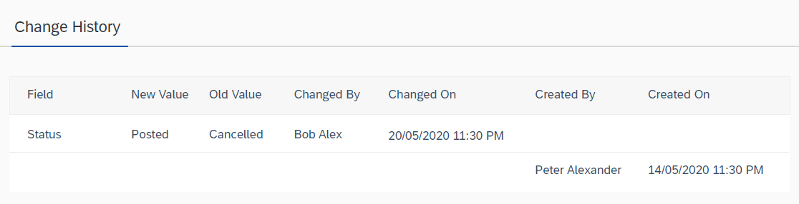

Attachment Tab should be available for attaching reference documents with ‘Drag and Drop’ functionality

* Posting date should be defaulted as current date when ‘Post Document for Returnable Account’ object page is opened. Posting date should be editable and packaging manager should be able to change posting date if required.

#### Number range for returnable packaging account

Refer section ‘Define Number Ranges’ for details regarding number range definition and assignment of number range to Manage returnable packaging application.

Number range should be configurable for customer with numeric and alphanumeric sequential numbering options.

Provision should be available to maintain two separate number ranges should be used for manual and automatically posted documents.

#### F4 Help for Manage Account Application

Details of F4 help relevant fields, search filters for each field and required result list report for ‘Manage Returnable Packaging’ application is given below:

|  |  |  |  |
| --- | --- | --- | --- |
| F4 Help Field | Search Filters | Result List Report | Remarks |
| Posting Document Number | Posting Document Number | Posting Document Number | * Only posted documents should be displayed in the list |
|  | Returnable Packaging Material | Returnable Packaging Material |  |
|  | Returnable Account | Returnable Account |  |
|  | Location Partner Type | Location Partner Type |  |
|  | Location Partner | Location Partner |  |
|  | Exchange Partner Type | Exchange Partner Type |  |
|  | Exchange Partner | Exchange Partner |  |
|  | Account Posting Type | Account Posting Type |  |
|  | Inventory Reference | Inventory Reference |  |
|  | Posting Indicator | Posting Indicator |  |
|  |  |  |  |
| Returnable Packaging Material | Same as in Manage Returnable Packaging Account | Same as in Manage Returnable Packaging Account |  |
|  |  |  |  |
| Returnable Packaging Account | Same as in Manage Returnable Packaging Account | Same as in Manage Returnable Packaging Account |  |
|  |  |  |  |
| Location Partner | Same as in Manage Returnable Packaging Account | Same as in Manage Returnable Packaging Account |  |
|  |  |  |  |
| Exchange Partner | Same as in Manage Returnable Packaging Account | Same as in Manage Returnable Packaging Account |  |
|  |  |  |  |
| Inventory Document Reference | Inventory Document No | Material Document No |  |
|  | Inventory Document Date | Item No |  |
|  | Material Description (Code) | Material Document Date |  |
|  | Movement Type | Material Description (Code) |  |
|  | Company Code | Movement Type |  |
|  |  | Company Code |  |
|  |  |  |  |
| Informing Partner | Same as in Manage Returnable Packaging Account | Same as in Manage Returnable Packaging Account |  |
|  |  |  |  |
| Sender | Sender Type | Sender Type | Grayed out field / Info TAB TO GUIDE USER FOR FIELD ENTRY |
|  | Sender ID | Sender ID |  |
|  | Sender Name | Sender Name |  |
|  | City | City |  |
|  | Country | Country |  |
|  |  |  |  |
| Recipient | Recipient Type | Recipient Type | Grayed out field / Info TAB TO GUIDE USER FOR FIELD ENTRY |
|  | Recipient ID | Recipient ID |  |
|  | Recipient Name | Recipient Name |  |
|  | City | City |  |
|  | Country | Country |  |
|  |  |  |  |
| Settlement Partner | Settlement Partner Type | Settlement Partner Type | Grayed out field / Info TAB TO GUIDE USER FOR FIELD ENTRY |
|  | Settlement Partner ID | Settlement Partner ID |  |
|  | Settlement Partner Name | Settlement Partner Name |  |
|  | City | City |  |
|  | Country | Country |  |
|  |  |  |  |
| Unit of Measure | Unit of Measure | Unit of Measure |  |
|  | Unit of Measure Text | Unit of Measure Text |  |
|  |  |  |  |

#### Business validations

* If posting date is not same as current date, system should give information message – ‘Posting date is not current date’.
* **Informing Partner** field details can only be entered if Informing Partner Type is selected.
* F4 value in Informing partner should be dynamically changed based on selection of Informing Partner Type field.
* **Sender** field details can only be entered if Sender Type is selected.
* F4 value in Sender should be dynamically changed based on selection of Sender Type field.
* **Recipient** field details can only be entered if Recipient Type is selected.
* F4 value in Sender should be dynamically changed based on selection of Recipient Type field.
* **Settlement Partner** field details can only be entered if Settlement Partner Type is selected.
* F4 value in Informing partner should be dynamically changed based on selection of Settlement Partner Type field.
* While creating posting document manually, if referred returnable account and the account number in referred document are not same, system should give error message
* After entering all the Mandatory Details and required optional details, packaging manager can click on ‘Post Document’ button to post the document or ‘Save’ to save the document in ‘New’ status.
* After manually posting/ saving the document, a document number should be generated for each posted document. This would be a sequential auto generated number.

Number range should be configurable for customer with numeric and alphanumeric sequential numbering options.

* After posting the document, returnable packaging account balance should be updated as per the quantity entered in the posting quantity field.
* If document is created manually in IRP application, then posting indicator ‘Manual’ should be updated against this document details.
* Reversed document should always be created with the posting indicator as ‘Manual’

Following Logic should to be used to update account balance during manual postings:

* System will check RP Posting type selected while manual posting
* System will check RP Posting Table for the selected type
* Based on +/ - sign maintained in account posting table, quantity should be added or subtracted from account balance.

*Hierarchical and multilevel postings need to be explored further.*

#### Automatic Posting

Refer user story ‘Automatic Posting’ for automatic posting process details.

If specific prerequisites are fulfilled, the system can automatically post the goods movement of returnable packaging to the appropriate returnable packaging account when the goods movement is posted in ERP system.

Refer user story ‘Automatic Posting’ for automatic posting process details.

#### Reprocessing of posted documents in errors

Reprocessing functionality

* Reprocessing functionality should be enabled only for the automatically posted documents in errors.
* Error message details would be shown for each document in error status on list page as well as object details page.
* Packaging manager should check and resolve the errors.
* After resolving the errors, packaging manager should use ‘**check’** functionality to ensure all errors are resolved.
* Documents in Error status will be allowed to be reprocessed so that document status will be changed to posted.
* After successful posting, account balance of returnable packaging’s will be updated successfully as per the document quantity.
* No communication message will be sent back to S4HANA system regarding status update

### User Story – Track Returnable Quantity

As a Packaging Manager, I want to be able to Track all the Returnable Packaging by Quantity.

### User Story- Send the Outbound/Inbound Account Statements

As a Packaging Manager, I want to be able to Send the Outbound/Inbound Accounts to OEM/Vendor.

* List of Filters
  + Returnable Packaging
  + Company Code
  + Returnable Packaging Account Number
  + Location Partner Type
  + Location Partner
  + Exchange Partner Type
  + Exchange Partner
  + Statement Number
  + Statement Date
  + Customer in statement
  + Vendor in account statement
  + Status
  + Statement Type: Inbound/ Outbound
* Adapt filters
  + Customer in returnable packaging account no
  + Returnable packaging number at vendor
* List grid column header names
  + Statement Number
  + Item no
  + Statement Date
  + Customer
  + Vendor
  + Returnable Packaging Account
  + Returnable packaging
  + New balance
  + Old balance
  + Old balance date
  + Transaction Quantity
  + Transaction Date
* grid column Setting
* Section Details
  + General Information
    - Statement Number
    - Status
  + Statement Data
    - Customer in account statement
    - Vendor in account statement
    - Returnable Packaging
    - Returnable Packaging Type
    - Unit of Measure
    - Customer Returnable Packaging Account No
    - RP Number at Vendor
    - Account Number at Sender
    - New Balance
    - Statement Date
    - Old account balance
    - Old statement date
  + Account Data
    - Returnable Packaging Account
    - Current Account Balance (UOM)
    - Company Code
    - Returnable Packaging
    - Location Partner Type and Location
    - Exchange partner type and Exchange partner
  + Account Statement Transacts.
    - Matching Status
    - Transaction Type for returnable statements
    - Transaction Quantity (UOM)
    - Posting Date
    - Document Number
    - Document Item
    - Document Date
    - Delivery Date
    - Customer in statement
    - Vendor in statement
    - Partner No
    - Reference Document
    - Reference Document Item
    - Reference Document Date
* Need Column orders
  + Same as above
* Need column data
  + Same as above

### User Story – Match the inbound / outbound account statement

As a Packaging Manager, I want to be able to Match the inbound / outbound account statement for a Customer(s) / Vendor(s) i.e. How many returnable packaging came in from a customer or vendor and how many returnable packaging went out to a customer or Vendor.

### User Story – Receive and Match the Returnable Account Statement

As a Packaging Manager, I want to be able to Receive and Match the Returnable Account Statement with OEM/Vendor Accounts

### User Story – Perform Goods Issue or Goods Receipt

As a Shipping Specialist, I want to be able to Perform Goods Issue or Goods Receipt on the Returnable Packaging Material

### User Story – Identify the Empty Containers vs the full containers

As a Packaging Manager, I want to identify the Empty Containers vs the full containers to plan the containers for future demand accordingly.

### User Story – Track the Returnable Packaging by Serial Numbers

As a Packaging Manager, I want to Track the Returnable Packaging by Serial Numbers.

### User Story – Track the exact location (IOT/GPS Enabled) of the Returnable packages.

As a Packaging Manager, I want to Track the exact location (IOT/GPS Enabled) of the Returnable packages.

### User Story- Manage Scrapping

As a Packaging Manager, I want to able to Manage Scrapping of Returnable Material due to Damages.

### User Story – Plan and Forecast the Packaging Material

As a Packaging manager, I want to be able to Plan and Forecast the Packaging Material to be ordered based on the demand and the historic information.

### User Story – Verify the Rental invoice

As a Packaging Manager, I want to be able to Verify the Rental invoice received from OEM/Vendor against the account statement.

### User Story – Returnable Packaging Material - Overview

As a Packaging manager, I want to view the Account Balance of Returnable Packaging for a specific returnable packaging, for a company code(s), returnable account(s) over a period. I want to view the account balance and stock overview with their current location.

Note: Screenshots are just for demonstration. Please refer to the requirement statements for development

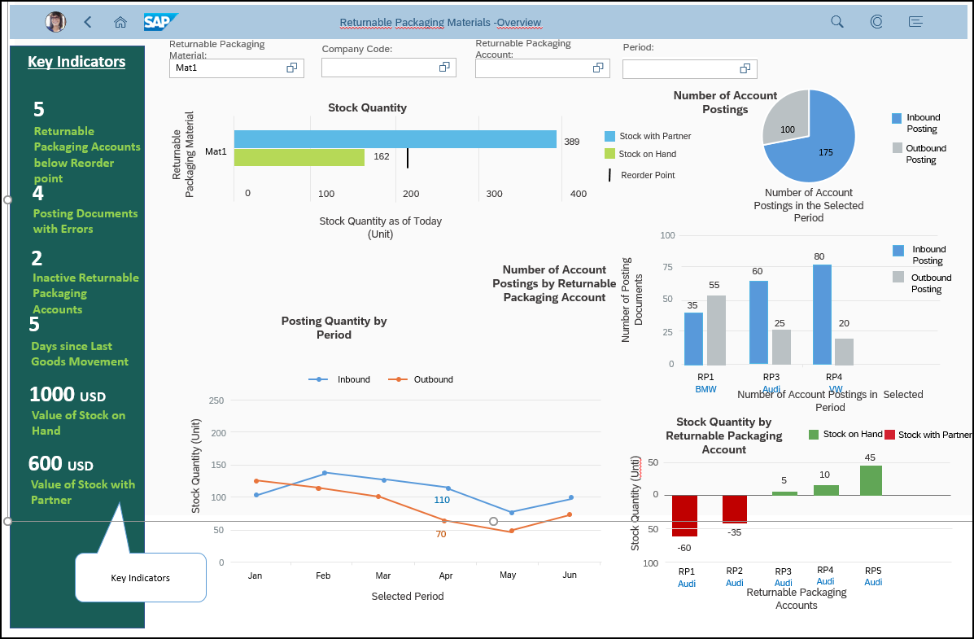

**(Below Chart not in Scope for First Release)**

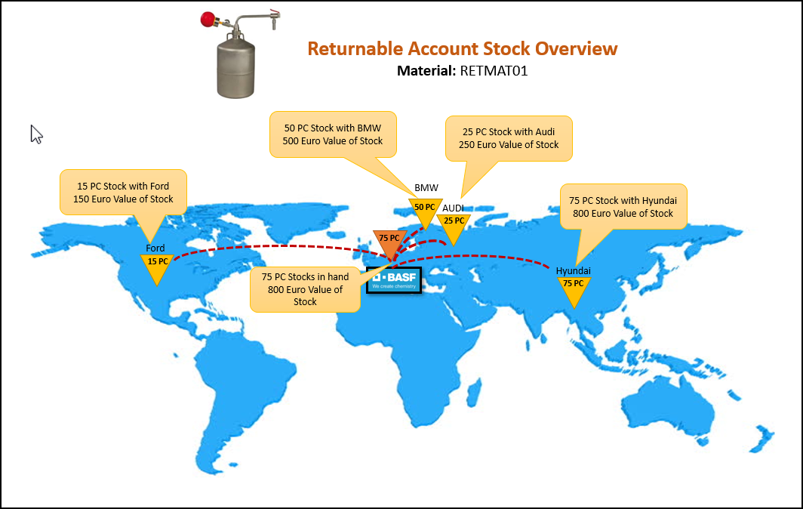

* + - 1. **View Stock Status for a Single Returnable Packaging**

Following Filters should be available for selection

|  |  |  |
| --- | --- | --- |
| Filter Name | Property | Displayed Attribute |
| Returnable Packaging Material | Single Select | Description (Mat. ID) |
| Company Code | Multi Select | Company Code Desc (ID) |
| Returnable Packaging Account | Multi Select | Account ID |
| Period | Period selection | Period |

**Chart 1: Stock Quantity**

* Based on the filter selection display the number of stocks consolidated across the accounts.
* Stock with Partner is sum of all Account with Positive Balance
* Partner Stock on Hand is Sum of all Accounts with Negative Balance
* This should include all Active and Inactive accounts
* Reorder Point at the material level should be shown here

**Chart 2: Stock Quantity by Returnable Packaging Account**

* Based on the filter selection display the Account Balance account wise
* Stock with Partner is all Account with Positive Balance
* Partner Stock on Hand is Accounts with Negative Balance
* This should include all Active and Inactive accounts
* Reorder Point at account level should be shown here
* Sorting should be based on account balance in ascending order

**Chart 3: Number of Account Postings**

* Based on the filter selection display the number of postings consolidated across selected accounts
* Inbound Posting: Sum of all the number of postings, manual and automatic with a credit action.
* Outbound Posting: Sum of all the number of postings, manual and automatic with a debit action.
* Active and Inactive accounts to be considered.

**Chart 4: Number of Account Postings by Returnable Packaging Account**

* Based on the filter selection display the number of postings in the selected accounts individually
* Inbound Posting: Sum of all the number of postings, manual and automatic with a credit action on the accounts.
* Outbound Posting: Sum of all the number of postings, manual and automatic with a debit action on the accounts.
* Active and Inactive accounts to be considered.
* Sorting to be done by Number of Postings in Descending order

**Chart 5: Posting Quantity by Period**

* Based on the filter selection display the Inbound and Outbound Stock quantity
* Inbound: Sum of all the Posting Quantity, manual and automatic with a credit action consolidated across accounts
* Outbound: Sum of all the Posting Quantity, manual and automatic with a debit action consolidated across accounts
* Active and Inactive accounts to be considered.

**Chart 6: Location Wise Account details (Not in Scope for first release)**

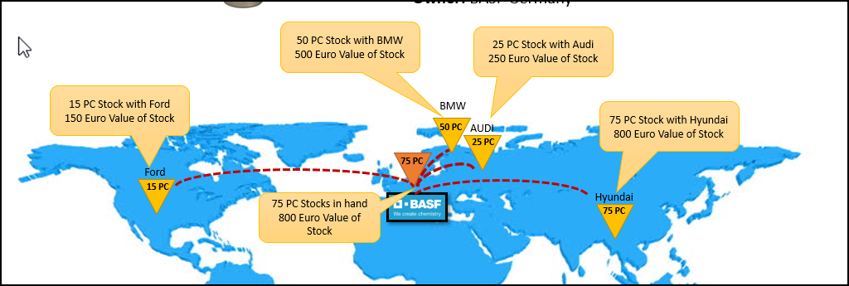

* Based on the filter selection display the Account Balance and Stock value location wise
* Location Partner type address to be considered for location .
* Active and Inactive accounts to be considered.

**Chart 7: Key Indicators**

Following key indicators to be shown

* Returnable Packaging Accounts below reorder point: Number of accounts with balance below reorder points
* Posting Documents with error: Number of documents in error state where this packaging material has been used.
* Inactive Returnable Packaging Account: Number of accounts in inactive state where this packaging material has been used.
* Days since last Goods movement: Number of days since the last posting done on the account where this material is involved
* Value of Partner Stock on Hand: No. of Partner Stock * Value of the Returnable packaging material
* Value of Stock with partner: Stock with Partner * Value of the returnable packaging material

### User Story – Real time Returnable Packaging monitor

As a Packaging manager, I would like to track the returnable packaging real time - Real time Returnable Packaging monitor

### User Story –Manage Account Posting Types

As a Packaging manager, I would like to change existing account posting types and/or define new account posting types.

In the Posting type configuration, I should be able to define if the Posting is a credit or debit type, role of the Location Partner and Exchange partner, corresponding reverse posting type and whether the posting type is relevant for a manual or automatic posting or both.

Packaging manager should be able to perform following activities

* Create a new Posting Type
* Update an existing Posting Type
* Delete an existing Posting Type
* Copy an existing Posting Type
* Search and View details for existing Posting Type
* Track the changes done in the application

Account Posting Type enables to reproduce goods movement of returnable packaging between two business partners.

* + - 1. **Create an Account Posting Type**

Packaging manager should be able to login to Configure Posting Type app and create a Posting type.

For creation of a posting type following information is required to be entered

|  |  |  |  |  |  |  |
| --- | --- | --- | --- | --- | --- | --- |
| **Field Label** | **Data Type** | **Field Length** |  |  | **Field Type** | **Technical Validations** |
| Account Posting Type* | CHAR | 3 |  |  | Input Text Box | Numeric Values allowed |
| Account Posting Type Description | CHAR | 50 |  |  | Input Text Box | Alpha numeric values |
| Transaction Type* | CHAR | 1 |  |  | Drop Down | Values -Debit and Credit |
| Account Posting Indicator* | CHAR | 1 |  |  | Drop Down | Values -Manual, Automatic or All |
| Reverse Account Posting Type | CHAR | 3 |  |  | Search Help | Values – Existing posting types |
| Subsequent Account Posting Type | CHAR | 3 |  |  | Search Help | Values – Existing posting types |
| Offsetting Account Posting Type | CHAR | 3 |  |  | Search Help | Values – Existing posting types |
| Location Partner Role | CHAR | 2 |  |  | Drop Down | Values - Sender, Recipient, Settlement Partner |
| Exchange Partner Role | CHAR | 2 |  |  | Drop Down | Values -Sender, Recipient, Settlement Partner |

* Mandatory field for creation

**Steps**

* Packaging manager should be able to login to the Manage Account Posting Types application and click on create button.
* A page with list of input fields should be displayed with Save and Cancel button
* Packaging manager should be able to enter the mandatory details and click on Save. An information message should be displayed.
* On click of cancel or navigating out of creation page a data loss pop-up should come up.
  + - 1. **Copy an existing Account Posting Type**

Packaging manager should be able to login to the app and copy a Posting type to create a new Posting type

**Steps**

* Packaging manager should be able to login to the Manage Account Posting Types application
* Packaging manager should be able to select one of the existing posting types from the result list and click on Copy button
* All the data from the Account Posting type should be copied and the details page should open up with copied data.
* Account Posting Type should not be copied to the new record
* Save and Cancel button should be enabled.
* Packaging manager should be able to change the existing fields and click on Save. An information message should be displayed. Mandatory fields should have values for save to happen.
* On click of cancel or navigating out of creation page a data loss pop-up should come up.
  + - 1. **Search and View details for an existing Account Posting Type**

Packaging manager should be able to login to Configure Posting Type app, Search for an existing Posting type and view its details.

Following filter parameters should be available for searching an existing Posting Type

|  |  |  |
| --- | --- | --- |
| **Field Label** | **Field Type** | **Display** |
| Search | Input Text Box | Default |
| Editing Status | Drop Down (Framework provided) | Default |
| Account Posting Type | Input Text Box with Search Help | Default |
| Account Posting Type Description | Input Text Box with Search Help | Default |
| Transaction Type | Drop Down | Default |
| Account Posting Indicator | Drop Down | Default |
| Reverse Account Posting Type | Drop Down | Optional |
| Location Partner Role | Drop Down | Default |
| Exchange Partner Role | Drop Down | Default |
| Subsequent Account Posting Type | Drop Down | Optional |
| Offsetting Account Posting Type | Drop Down | Optional |

Result list of Account Posting Types

|  |  |  |
| --- | --- | --- |
| **Field Label** | **Display** | **Sortable** |
| Account Posting Type | Default | Yes |
| Account Posting Type Description | Default | Yes |
| Transaction Type | Default | Yes |
| Account Posting Indicator | Default | Yes |
| Reverse Account Posting Type | Optional | Yes |
| Location Partner Role | Default | Yes |
| Exchange Partner Role | Default | Yes |
| Subsequent Account Posting Type | Optional | Yes |
| Offsetting Account Posting type | Optional | Yes |

**Steps**

* Packaging manager should be able to enter the search criteria in the search filter.
* On entering the search criteria, the result list should display the corresponding result list on press of Go .
* Packaging Manager should be able to select a single record and view its detail
  + - 1. **Update an existing Posting Type**

Packaging manager should be able to login to Manage Posting Type app, Search for an existing Account Posting type and view its details and should be able to update the field values

**Steps**

* Packaging manager should be able to enter the search criteria in the search filter.
* On entering the search criteria, the result list should display the corresponding result list.
* Packaging Manager should be able to select a single record and view its detail
* Non editable filed in the details should be changeable.
* Packaging manager should be able to change the editable fields and click on Save. An information message should be displayed. Mandatory fields should have values for save to happen.
* On click of cancel or navigating out of creation page a data loss pop-up should come up.

|  |  |
| --- | --- |
| **Field Label** | **Property on Edit** |
| Account Posting Type | Non-Editable |
| Account Posting Type Description | Editable |
| Transaction Type* | Editable |
| Account Posting Indicator* | Editable |
| Reverse Account Posting type | Editable |
| Subsequent Account Posting Type | Editable |
| Offsetting Account Posting Type | Editable |
| Location Partner Role | Editable |
| Exchange Partner Role | Editable |

*

* + - 1. **Delete an existing Posting Type**

Packaging manager should be able to login to Manage Posting Type app, Search for an existing Account Posting type and delete it .

**Steps**

* Packaging manager should be able to enter the search criteria in the search filter.
* On entering the search criteria, the result list should display the corresponding result list.
* Packaging Manager should be able to select a single record and Click on delete button/Alternatively Packaging manager should be able to view details and click on Delete button on object page.
* On click of delete a warning message should be displayed with below flow
* If the posting type has been used in any of the existing Posted documents, posting type should not be deleted
* If the posting type has not been used in any of the existing documents, posting type should be deleted from the system.
  + - 1. **Track the changes done in the application**

Packaging manager should be able track the changes happening in the application using the change log application .

**Business Validations**

* Account Posting Type is always unique in the system. No two-account posting type can have the same value. An error message should be displayed while creation if the posting type already exists.
* On click of delete If the posting type has been used in any of the existing Posted documents, posting type should not be deleted
* On Click of delete If the posting type has not been used in any of the existing documents, posting type should be deleted from the system.

### User Story – Assign Posting Type to Movement Type

As a packaging manager I want to assign the already defined Posting Type for the returnable packaging to appropriate Movement Types.

For the first release only odata API is in Scope

This assignment ensures that when goods movement of returnable packaging is posted in MM Inventory Management, the system carries out the corresponding returnable packaging account posting if the automatic returnable packaging account posting for the material type has been set.

Following actions should be allowed

* Create a new assignment of Movement Type to Posting Type
* Update an existing assignment of Movement Type to Posting Type
* Delete an existing assignment of Movement Type to Posting Type
* Copy an existing assignment of Movement Type to Posting Type
* Search and View details of an existing assignment of Movement Type to Posting Type
* Track the change History
  + - 1. **Create a new assignment of Movement Type to Posting Type**

Packaging manager should be able to login to Assign Posting Type to Movement Type app and create a mapping.

For creation of an entry following information is required to be entered

|  |  |  |  |
| --- | --- | --- | --- |
| **Order** | **Filed Name** | **Mandatory** | **Property** |
| 1 | Movement Type | Yes | Input Text Box |
| 2 | Movement Type Description | No | Input Text Box |
| 3 | Movement Indicator | Yes | Drop Down |
| 4 | Receipt Indicator | Yes | Drop Down |
| 5 | Debit/Credit Indicator | Yes | Drop Down |
| 6 | Posting Type | Yes | Drop Down |
| 7 | Posting Type Description | No | Input Box |
| 8 | Exchange Partner | Yes | Drop Down |

Following are the drop-down values for the fields

**Movement Indicator**

* Goods movement w/o reference
* Goods movement for purchase order
* Goods movement for production order
* Goods movement for delivery note
* Goods movement for Kanban requirement (WM - internal only)
* Subsequent adjustment of "material-provided" consumption
* Subsequent adjustment of proportion/product unit material

**Receipt Indicator**

* Normal receipt
* Stock transport order
* Tied empties

**Debit/Credit Indicator**

* Credit
* Debit

**Exchange partner for account posting type**

* Issuing/receiving plant
* Customer (sold-to party, special stock partner)
* Ship-to party
* Vendor
* Goods supplier
* Freight Forwarder

**Steps**

* Packaging manager should be able to login to the Assign Movement Type to Posting type app and click on create.
* A page with list of input fields should be displayed with Save and Cancel button
* Packaging manager should be able to enter the mandatory details and click on Save. An information message should be displayed on saving
* On click of cancel or navigating out of creation page a data loss pop-up should come up.
  + - 1. **Update a new assignment of Movement Type to Posting Type**

Packaging manager should be able to login to Assign Posting Type to Movement Type app and update an existing mapping.

Following fields should be editable once the entry is saved

|  |  |  |  |  |
| --- | --- | --- | --- | --- |
| **Order** | **Filed Name** | **Mandatory** | **Property** | **Editable after Save** |
| 1 | Movement Type | Yes | Input Text Box | No |
| 2 | Movement Type Description | No | Input Text Box | Yes |
| 3 | Movement Indicator | Yes | Drop Down | Yes |
| 4 | Receipt Indicator | Yes | Drop Down | Yes |
| 5 | Debit/Credit Indicator | Yes | Drop Down | Yes |
| 6 | Posting Type | Yes | Drop Down | Yes |
| 7 | Posting Type Description | No | Input Box | Yes |
| 8 | Exchange Partner | Yes | Drop Down | Yes |

**Steps**

* Packaging manager should be able to enter the search criteria in the search filter.
* On entering the search criteria, the result list should display the corresponding result list.
* Packaging Manager should be able to select a single record and view its detail
* Non editable filed in the details should be changeable.
* Packaging manager should be able to change the editable fields and click on Save. An information message should be displayed. Mandatory fields should have values for save to happen.
* On click of cancel or navigating out of creation page a data loss pop-up should come up.
  + - 1. **Delete an existing assignment of Movement Type to Posting Type**

Packaging manager should be able to login to Assign Posting Type to Movement Type app and delete an existing entry.

**Steps**

* Packaging manager should be able to enter the search criteria in the search filter.
* On entering the search criteria, the result list should display the corresponding result list.
* Packaging Manager should be able to select a single record and Click on delete button/Alternatively Packaging manager should be able to view details and click on Delete button on detail screen.
* On click of delete a warning message should be displayed asking for confirmation
* On Confirmation Entry should be deleted.
* A message toast informing user that the entry has been deleted should come.
  + - 1. **Copy an existing assignment of Movement Type to Posting Type**

Packaging manager should be able to login to Configure Posting Type app and copy an existing entry to create a new assignment of Movement Type to Posting Type**.**

**Steps**

* Packaging manager should be able to login to the Assign Movement Type to Posting Type application
* Packaging manager should be able to select one of the existing entries from the result list and click on Copy button
* All the data from the existing entries should be copied and the details page should open up with copied data.
* All fields should be editable in the Copy
* Save and Cancel button should be enabled.
* Packaging manager should be able to change the existing fields and click on Save. An information message should be displayed. Mandatory fields should have values for save to happen.
* On click of cancel or navigating out of creation page a data loss pop-up should come up.
  + - 1. **Search and View details of an existing assignment of Movement Type to Posting Type**

Packaging manager should be able to login to Configure Posting Type app, Search for an existing assignment and view its details.

Following fields should be available in search filter. Search Fields should have suggestive text option

|  |  |  |  |
| --- | --- | --- | --- |
| **Order** | **Filter Name** | **Property** | **Display** |
| 1 | Movement Type | Search Help | Default |
| 2 | Movement Type Description | Input Text Box | Default |
| 3 | Movement Indicator | Drop Down | Default |
| 4 | Receipt Indicator | Drop Down | Default |
| 5 | Debit/Credit Indicator | Drop Down | Default |
| 6 | Posting Type | Drop Down | Default |
| 7 | Exchange Partner for posting type | Drop Down | Optional |

Following are the drop-down values for the fields

**Movement Indicator**

* Goods movement w/o reference
* Goods movement for purchase order
* Goods movement for production order
* Goods movement for delivery note
* Goods movement for kanban requirement (WM - internal only)
* Subsequent adjustment of "material-provided" consumption
* Subsequent adjustment of proportion/product unit material

**Receipt Indicator**

* Normal receipt
* Stock transport order
* Tied empties

**Debit/Credit Indicator**

* Credit
* Debit

**Exchange partner for account posting type**

* Issuing/receiving plant
* Customer (sold-to party, special stock partner)
* Ship-to party
* Vendor
* Goods supplier
* Freight Forwarder

Following fields should be available in result list with the following property

|  |  |  |  |  |  |
| --- | --- | --- | --- | --- | --- |
| **Order** | **Filter Name** | **Display** | **Sortable** | **Filterable** | **Group By** |
| 1 | Movement Type | Default | Yes | Yes | Yes |
| 2 | Movement Type Description | Default | Yes | No | No |
| 3 | Movement Indicator | Default | Yes | Yes | Yes |
| 4 | Receipt Indicator | Default | Yes | Yes | Yes |
| 5 | Debit/Credit Indicator | Default | Yes | Yes | Yes |
| 6 | Posting Type | Default | Yes | Yes | Yes |
| 7 | Posting Type Description | Default | Yes | No | No |
| 8 | Exchange partner for account posting type | Optional | Yes | Yes | Yes |

**Steps**

* Packaging manager should be able to enter the search criteria in the search filter.
* On entering the search criteria, the result list should display the corresponding result list.
* An explicit button should not be required to trigger the search.
* Packaging Manager should be able to select a single record and view its detail
  + - 1. **Track Change History**

Packaging manager should be able to track the change history in the app.

### User Story – Automatic Posting

As a packaging manager I want to see returnable account balance updated and posting documents created in IRP application by automatic postings based on inventory movements posted in ERP system on returnable packaging materials.

#### Introduction

IRP system should automatically post the goods movement (automatic posting document) of returnable packaging to the appropriate returnable packaging account when the goods movement is posted in ERP system if specific prerequisites are fulfilled.

#### Prerequisites

* Material type of returnables (LEIH/ other custom material type) is defined as a filter to select material documents for automatic posting
* Assignment of an account posting type to the MM movement type is maintained. (Refer User Story – Assign Posting Type to Movement Type)
* Automatic posting is set for your account posting type in Customizing (Refer User Story – configure material type).

#### Schematic process flow for automatic postings

##### Automatic Posting Process flow

Process flow of automatic posting document creation for goods receipt is given below

1. Goods receipt/ Issue will be posted in SAP S4HANA system for returnable packaging
2. Set a frequency to read data from S4 Hana through scheduler
3. Read Material Masters from IRP system for defined Material Type (LEIH).
4. Read Goods receipt data for returnable materials (Materiald type LEIH) at predefined intervals using following existing ODATA Api’s
   1. API_MATERIAL_DOCUMENT - A_MaterialDocumentHeader
   2. API_MATERIAL_DOCUMENT - A_MaterialDocumentItem
5. Apply filter in CPI for material type, company code and plant to perform message transformation
6. CPI will convert and send the posting payload to IRP
7. Odata API will be used to read the payload and convert it into account posting document
8. IRP will perform account determination (Refer section: Logic for Account determination)
9. In case the document is generated with errors (e.g returnable account is not active), the document will be posted with error status
10. The document generated with errors will be reprocessed after resolving errors to posted status
11. In case of multiple line items, one separate account posting document should be posted for each line item.

#### Processes not covered as part of automatic posting

Automatic posting can be used for all returnable packaging movements that involve the inventory management module of customer’s own ERP system, for which a material document is created. Movements that take place outside the system must be updated in the system via manual account postings. Refer section: Manual Posting.

Automatic posting is not planned for cross-circulation, returnable packaging scrapping or inventory difference posting, as these do not involve any MM posting and are lacking the partner-information that enables the system to trigger automatic posting.

#### Additional fields requirement for Automatic posting document

* Inventory Document No
* Item No
* Posting Indicator

#### Field mapping

| No | Field in IRP Posting Document | Field in Material Document | Data Type | Length | Mandatory/ Optional | Validations/ Remarks |
| --- | --- | --- | --- | --- | --- | --- |
| 1 | Created by | NA | CHAR | 12 | Mandatory | System entry/ Not editable |
| 2 | Created on | NA | DATE | 8 | Mandatory | System entry/ Not editable |
| 3 | Posting Date | PostingDate  API_MATERIAL_DOCUMENT - A_MaterialDocumentHeader | CHAR | 8 | Mandatory | System entry, current date is taken as default. Only date formant allowed |
| 4 | Posting Year | PostingDate  API_MATERIAL_DOCUMENT - A_MaterialDocumentHeader | NUM | 4 | Mandatory | System entry, current year is taken as default. |
|  | Creation Indicator | NA | CHAR | 10 | Mandatory | Manual/ Automatic. Will always be set as ‘Automatic’ for CPI payload for Automatic Posting |
| 4 | Returnable Account | NA | CHAR | 12 | Optional | Account to be determined in IRP based on logic given in section ‘Logic for Automatic Material Document Posting’ |
| 5 | Type of Informing Partner | NA | CHAR | 2 | Optional |  |
| 6 | Informing Partner | NA | CHAR | 10 | Optional |  |
| 7 | Account posting type (Dropdown) | NA | CHAR | 3 | Mandatory | Get GoodsMovementType and convert it to Account Posting Type referring table ‘Assign posting type to movement type’ |
|  | NA | GoodsMovementType |  |  |  | Get GoodsMovementType and convert it to Account Posting Type referring table ‘Assign posting type to movement type’ |
| 8 | Returnable Packaging | Material | CHAR | 40 | Mandatory |  |
| 9 | RP at partner | NA | CHAR | 35 | Mandatory |  |
| 10 | Quantity | QuantityInBaseUnit | QUAN | 13 | Mandatory | Only Numeric |
| 11 | UOM | EntryUnit | CHAR | 3 | Mandatory |  |
| 12 | Ref. Document | MaterialDocument | CHAR | 35 | Optional |  |
| 13 | Ref. Document Date | DocumentDate | DATE | 8 | Optional |  |
| 14 | Company code | NA | CHAR | 4 | Mandatory | To be derived from plant code |
|  | NA | Plant | CHAR | 4 | Mandatory | To be used to derive Company code |
|  | Sender Type | NA | CHAR |  | Optional |  |
| 15 | Sender | NA | CHAR | 10 | Optional |  |
| 16 | Sender Name (External) | NA | CHAR | 35 | Optional |  |
|  | Recipient Type | NA | CHAR |  | Optional |  |
| 17 | Recipient | NA | CHAR | 10 | Optional |  |
| 18 | Recipient Name (External) | NA | CHAR | 35 | Optional |  |
|  | Settlement Partner Type | NA | CHAR |  | Optional |  |
| 19 | Settlement Partner | NA | CHAR | 10 | Optional |  |
| 20 | Settlement Partner Name (External) | NA | CHAR | 35 | Optional |  |
| 21 | Goods Movement Date | DocumentDate | DATE | 8 | Optional |  |
|  | RP Location Type | Plant | CHAR | 1 | Optional |  |
| 22 | RP Location | Plant | CHAR | 10 | Optional |  |
| 23 | RP Location Name (External) |  | CHAR | 35 | Optional |  |
|  | Exchange partner type | *Supplier if GR*  *Customer if GI* | CHAR | 1 | Optional | *Validation required* |
| 24 | Exchange partner | *Supplier if GR*  *Customer if GI* | CHAR | 10 | Optional | *Validation required* |
| 25 | Exchange Partner Name (External) | NA | CHAR | 35 | Optional |  |
| 26 | Delivery Note | NA | CHAR | 16 | Optional |  |
| 27 | Delivery item no | NA | NUMC | 6 | Optional |  |
| 28 | Delivery note quantity | NA | QUAN | 13 | Optional |  |
| 29 | UOM From Delivery Note | NA | UNIT | 3 | Optional |  |
| 30 | Bill of lading | NA | CHAR | 16 | Optional |  |
| 31 | Material Doc No | MaterialDocument | NUMC | 10 | Mandatory |  |
| 32 | Material Doc Item no | MaterialDocumentItem | NUMC | 4 | Mandatory |  |

#### Odata API to be used from SAP S4HANA system for automatic postings

Material Documents - Read, Create

URL - <https://help.sap.com/viewer/3f57e7df4a114edabffe8b2d581a59ed/2002.500/en-US/d4c919581bc30a02e10000000a44147b.html>

Technical Name:

API_MATERIAL_DOCUMENT

#### Odata API to transfer CPI payload to IRP

Odata API should be developed to transfer CPI payload for automatic posting documents to post IRP posting document.

Refer field mapping provided in ‘Field Mapping’ section to develop Odata API.

#### Logic for Automatic Material Document Posting

* Read Material Masters from IRP system for defined Material Type (LEIH).
* Read Goods receipt data for returnable materials (Materiald type LEIH) at predefined intervals using following existing ODATA Api’s
  + API_MATERIAL_DOCUMENT - A_MaterialDocumentHeader
  + API_MATERIAL_DOCUMENT - A_MaterialDocumentItem
* Apply following filters and select relevant documents for automatic posting
  + Material type
  + Company code
  + Plant
  + Date Interval
* Determine account posting type from material movement type referring configuration table ‘Assign Posting Type to Movement Type’
* Refer configuration table of Posting Type and check if ‘Automatic Posting’ or ‘Both Automatic and Manual Posting’ configuration is allowed to the determined posting type. If only manual posting is allowed, automatic posting document should not be posted.
* Determine company code from plant code (Refer table for ‘Plant’ to determine company code.
* Determine Returnable packaging (Material code in material document)
* Determine Location/ Exchange partner from Plant/ Customer/ Vendor. *(In case of goods receipt, the location will be plant, Exchange partner will be supplier. In case of goods issue, the Exchange partner will be customer and location will be plant.)*
* Check account validity and account status

Account matching procedure logic:

* Read material document to be posted
* Determine Returnable Packaging (Material Code)
* Determine Company Code (Derived from Plant)
* Determine Location and Exchange Partner
* Determine Account Posting Type
* Check if Automatic posting is allowed for Account
* If yes, pass Material, Location, Exchange Partner, Today’s Date and company code to Returnable account table and determine valid returnable account considering validity date
* Create posting document with ‘Posted’ status if the account is determined and it is in validity date
* Update account balance
* If account is not determined or if account is not active, post the document with error status.

List of fields to be considered for account matching:

|  |  |  |
| --- | --- | --- |
| **Material Document** | **IRP Account** | **Account Matching** |
| Material | Returnable Packaging | Required |
| Supplier | Location/ Exchange Partner | Required |
| Customer | Location/ Exchange Partner | Required |
| Plant | Location/ Exchange Partner | Required |
| Location | Location/ Exchange Partner | Required |
| Company Code | Company Code | Required |
| Movement Type | Account posting type | Required |
|  | Account Validity | Required |
|  | Account Status |  |

#### Account balance update in Returnable Packaging account

Following Logic should to be used to update account balance during manual postings:

1. Account balance should be zero when new account is created
2. System will check RP Posting type selected while manual posting
3. System will check RP Posting Table for the selected type
4. Based on +/ - sign maintained in account posting table, quantity should be added or subtracted from account balance.
5. Account balance can be updated only when account is in active status

#### Reprocessing of documents in error

Automatic postings that cannot be successfully posted due to errors go directly to reprocessing, where you can access them to manually reprocess. See also: Reprocessing of Account Postings.

Exception scenarios for reprocessing are listed below:

* Returnable account does not exist in IRP
* Returnable account is not active
* Returnable account cannot be determined (E.g. relationship not maintained)
* Material does not exist in IRP
* *Returnable packaging material is blocked*
* Business partner does not exist in IRP
* *Business Partner is blocked*
* Movement type is not supported in IRP

#### Automatic posting document number range

Refer section ‘Define Number Ranges’ for details of number range definition process. Different number range should be defined for manual and automatically posted documents.

List of error messages is given below.

* Returnable account does not exist
* Returnable account cannot be determined
* Returnable account is not active
* Material does not exist in IRP
* Business partner does not exist in IRP
* Movement type is not configured in IRP

#### Business validations

* Automatic posting cannot be carried out if account is not in active status
* Account posting can not be carried out if account is not in validity date
* If document is created automatically via CPI interface, ‘Automatic’ indicator should be set for the document
* If returnable packaging account does not exist in IPR or if account could not be determined, document should be posted with error.
* If the returnable packaging material does not exist in IRP, account determination cannot be carried out and document cannot be posted
* If the business partner does not exist in IRP, account determination cannot be carried out and document cannot be posted
* Movement type should be linked to account posting type and with automatic posting allowed configuration. Otherwise automatic posting cannot be carried out.
* Automatic postings will not be updated in case of scrapping
* Automatic postings will not be directly updated in case of inventory differences

### User Story –Define Number Ranges

As a packaging manager I should be able to Define the Number Range for the following application

* Manage Posting Documents
* Manage Returnable Packaging Accounts
* Account Statement **(not in scope for first release)**

Packaging manager should be able to perform following activities

* Create a new Number range
* Search and View details of a Number range
* Activate/Deactivate a new number range
* Track the changes in change history

Following status should be feasible in Number range

* New – When the number range is newly created
* Active- When the number range is activated to be used in applications
* Inactive- When the number range is defined but cannot be used in applications
* Consumed -When the number range has reached the upper limit .

Following Values should be present as drop-down values for these fields

|  |  |
| --- | --- |
| **Application Name** | **Application Sub Object Name** |
| Manage Returnable Packaging Accounts | * All |
| Manage Posting Documents | * All * Manual Posting * Automatic Posting |

#### Create a new Number Range

Packaging manager should be able to login to app and create a Number range.

For creation of a posting type following information is required to be entered

|  |  |  |  |
| --- | --- | --- | --- |
| **Field Name** | **Mandatory** | **Property** | **Technical Validations** |
| Application Name | Yes | DDLB | Only predefined Values |
| Application Subobject | No | DDLB | Only predefined Values |
| Number Range Prefix | No | Input Text box,  length 2 Characters | Only Characters allowed (A-Z, a-z) |
| Lower Limit | Yes | Input Text box,  Length 19 Characters | Only Numbers allowed (0-9) |
| Upper Limit | Yes | Input Text box,  Length 19 Characters | Only Numbers allowed (0-9) |

**Steps**

* Packaging manager should be able to login to the Configure Number Range application and click on create button.
* A page with list of input fields should be displayed with Save and Cancel button
* Packaging manager should be able to enter the mandatory details and click on Save. An success message should be displayed.
* On click of cancel or navigating out of creation page a data loss pop-up should come up if there is unsaved data.
* Number range will be created with Status New.
* Packaging manager should be able to activate the Number range once the number range is saved.
* Packaging Manager should also be able to deactivate an existing number range which is not in consumed status .

#### Search and View details of a Number range

Packaging manager should be able to login to Configure Number Range app, search for an existing Number range and view its details.

Following filter parameters should be available for searching an existing Number Range

|  |  |  |  |
| --- | --- | --- | --- |
| **Order** | **Filter Name** | **Property** | **Display** |
| 1 | Search | Input Search Box | Default |
| 2 | Editing Status | Drop Down | Default |
| 3 | C’ Application Name | Drop Down with type ahead | Default |
| 4 | Application Subobject | Drop Down with type ahead | Default |
| 5 | Number Range Status | Drop Down with type ahead | Default |
| 6 | Number Range Prefix | Search Help with type ahead | Optional |

Result list of Number Range

|  |  |  |
| --- | --- | --- |
| **Field Name** | **Display** | **Sortable** |
| Application Name | Default | Yes |
| Application Subobject | Default | Yes |
| Number Range Status | Default | Yes |
| Number Range Prefix | Default | Yes |
| Lower Limit | Default | Yes |
| Upper Limit | Default | Yes |
| Last Number Used | Default | Yes |

**Steps**

* Packaging manager should be able to enter the search criteria in the search filter.
* On entering the search criteria and pressing Go, the result list should display the corresponding result list.
* Packaging Manager should be able to select a single record and view its detail
* Fields should be in display mode
* The number currently consumed should be displayed at the header level

#### Activate and Deactivate

Packaging manager should be able to activate or deactivate a number range from the list page and the object page.

Activate /Deactivate should be possible with single select from the list page and object page

#### Track change history

Packaging manager should be able to track the change history in the Number range configuration app.

#### Business Validations

* Once the number range has reached the upper limit, a suitable visual indicator and message should be shown in the application
* If a number range already exists for the combination of Application Name and Application Sub-Object and is active no new number range can be activated
* Upper limit should be greater than the lower limit
* Last Number Used should show the current number consumed.
* In the consumed status the number range will be in read only mode with no further changes feasible.
* Export to excel is not required
* Only Valid Application Name and Application Sub object name from the drop down should be allowed else an error message should be thrown.
* Following is the lifecycle of the status
  + - New --> Active
    - Active --> Inactive
    - Inactive--> Active
    - Active --> Consumed

### User Story – Change history log

As a packaging manager I want to have audit trail (change history log) of all master data and transactional data for create and change operations.

#### Introduction

IRP application should generate change history log of all transactions for create and change operations. This is also a requirement from security perspective.

#### Prerequisites

NA.

#### Applications for maintaining Change log

Change log should be captured and displayed for all IRP applications. List of applications for which change log is required is given below:

* Manage Returnable Packaging Account
* Manage posting documents
* Manage account statements
* Configure number range
* Configure posting type
* Assign movement type to posting type

Every change in returnable account should be captured in ‘Change History’ tab. Following details should be captured:

|  |  |  |
| --- | --- | --- |
| **Field** | **Field attributes** | **Remarks** |
| Field | CHAR 60/ Max field length as per DB design | Label of field which was changed |
| Old Value | CHAR 60/ Max field length as per DB design | Old value in the field |
| New Value | CHAR 60/ Max field length as per DB design | New value in the field |
| Changed by | CHAR 12 | User ID of user who modified and saved the changes |
| Changed on | DATE and TIME | Date and TIME of updating the field |
| Created by | CHAR 12 | User ID of user who created the object |
| Created on | DATE and TIME | Date and TIME of creating the object |

Example mockup is given below for reference



A use case is a **definition of use**, from the **end-user's perspective**, for accomplishing a specific goal within a system. An individual use case describes a set of steps -- a sequence of user interactions -- to successfully accomplish the goal. (A use case also shows alternative paths to success, failures, and associated data used in the interactions.) A set of use cases defines all user interaction for an entire product.

Based on the use cases it is possible to specify the detailed functional requirements.

For each use case variant, a test case shall be available.

## S/4HANA CE

This section is relevant if your development is planned for the Cloud.

Development relevant for SCP based IRP Solution.

### Scope Items

Describe if there are new scope items planned. This should be discussed with the best practice colleagues.

Following functionalities will be in scope for the IRP solution:

1.Import Org. Structure

2.Import Material Master

3.Import Customer-Vendor data

4.View Imported Master Data on SCP

5.Create Returnable Account

6.Manual Inbound/Outbound Account Posting

7.Print / View of the Account Statements

8.Send Account Statements to OEM/Vendor (TBD further)

9.Matching of Account Statement

10.Update Account Statement on SCP on GI/GR in ERP/S4Hana System

11.Standard Integration with S/4hana (TBD)

12.Inventory Management

### Best Practice Content

Describe what is planned and shall be delivered as best practice content

TBD

### Planned IRP UIs

Describe what is planned and shall be delivered as SSC UIs.

Not applicable

### Planned Transactions/Apps

Describe what UIs (settings or processing) are planned to be delivered as cloud scope. In the case of offering existing non-Fiori Apps, exceptions must be requested. Make sure that new apps in cloud scope (could as well be old SAP GUI transactions) are flagged as tablet enabled and tablet test requirements are mandatory

Following Apps are planned for IRP

1. Manage Returnable Packaging Account
2. Post returnable packaging account
3. View returnable packaging account statements
4. Track returnable packaging quantity (Overview)
5. Receive and Match Account Statements
6. View Company Code
7. View Plant
8. View Storage Locations
9. View Sales Area
10. View Material Master
11. View Business Partner

### Identity and Access Management (IAM)

Describe in terms of catalogs, roles and groups what shall be created anew or needs to be enhanced.

*Authorization and Roles*.

### Feature Toggling

Describe if/how it is possible to switch off the release of the feature if it is not finalized or has no green FIT test plan at Dev-Close. The preferred tool is the Feature Toggle framework as it is also enabled for UA (documentation), Best Practice content, SSCUIs (planned), business role templates and business catalogues. Mention if such objects also need to be toggled for your development.

Not applicable.

## User Interfaces

Describe all user interfaces to be realized in this project (In case there is no user interface, state this explicitly in this chapter).

In any case provide details necessary for implementation

## Software Requirements for technical Interfaces

## Non-Functional Requirements

### System Landscape and Deployment Options

The targeted deployment for this development is EWM embedded in S/4HANA On Premise.

The fact that JIT Supply to Production and EWM are running in the same system instance should allow seamless integration. Synchronization issues that are usually observable in distributed application environment should not occur.

Although EWM and JIT/JIS are two separate components, the process flow in the embedded system should act as one application.

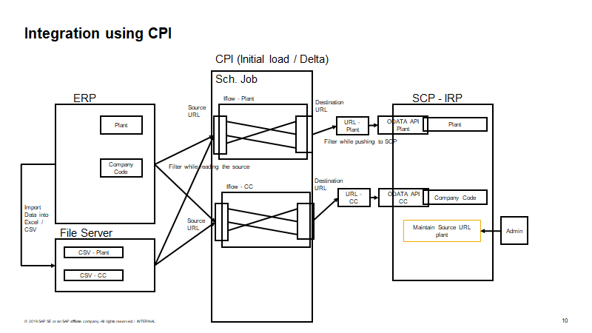

### Performance

### Extensibility

### Authorization and Roles

|  |  |  |  |
| --- | --- | --- | --- |
| **FIORI APP** | **Role** | **Authorization Check** | **Actions performed** |
| Manage Returnable Packaging Account | Packaging Manager | Org level objects:  Company code, Sales Org and Plant  Activities:  Create, Change, Display, Activate/ Deactivate and Delete | With this app, a packaging manager can:​   * View the existing Returnable Packaging Account of a Vendor / Customer​ * Create a new Returnable Packaging Account for a Vendor / Customer​ * Change a Returnable Packaging Account of a Vendor / Customer​ * Delete Returnable Packaging Account of a Vendor / Customer |
| *Manage Returnable Packaging Account* | *Business Partner (TBD- Not planned for 2008 release)* | *Object:*  *Returnable Packaging Account*  *Activities:*  *Display* | *With this app, a customer can:​*   * *View the existing Returnable Packaging Account for which he is authorized​* |
| Post returnable packaging account | Packaging Manager | Org level objects:  Company code, Sales Org and Plant  Activities:  Post, Reprocess, Edit, Display, Cancel and Delete | With this app, a packaging manager can:​   * Manually post incoming or outing returnable material with a proper goods movement for a specific account . ​ * Re-post incoming or outgoing receipt for returnable account, if in the case of any issues​ * Delete incoming or outgoing posting for a returnable account.​ * Adjust/Change already posted accounts manually for a returnable account.​ * Update Inventory in S/4 Hana (OP/CL) on Manual Posting Returnable Account. |
| View returnable packaging account statements | Packaging Manager |  |  |
| Track returnable packaging quantity (Overview) | Packaging Manager |  |  |
| Receive and Match Account Statements |  |  |  |
| View Company Code |  |  |  |
| View Plant |  |  |  |
| View Storage Locations |  |  |  |
| View Sales Area |  |  |  |
| View Material Master |  |  |  |
| View Business Partner |  |  |  |

### Processing Status, Application Logs, Change Documents

### Documentation

## Test Requirements

### Test Landscape and Setup

### Test Strategy

During the development phase, new functionality in EWM should be covered with manual and automatic tests in accordance with test strategy for S/4HANA[1].

**Mandatory Tests**

1. FIT and SAT (mandatory, see details of test cases below)
2. Automatic Tests for EWM backend logic (if possible and reasonable), development objects should be covered by Unit Tests according to S/4HANA coverage goals.

**All implemented software requirements shall be covered by manual test cases**. Each requirement should occur in at least one test case.

A test case may contain multiple requirements if process chain should be tested.

**Regression Tests** for Wave Management, Distribution Equipment, Storage-Control – scope will be decided during design/implementation

**Additional Test Cases (list not exhaustive)**

There shall be at least one process test case which tests the complete end-to-end scenario from JIT call creation, via picking, and final confirmation into PSA bin. Preferably, one test case with single step, one test case with distribution equipment.

Process Tests

1. Simple Pick Warehouse Process Type, destination of the pick is PSA
2. Storage Control: Pick, Pack, Stage to PSA
3. Process Test – Distribution Equipment

## Business validations

List of business validations and unique identifier for each validation is given below-

| Sr No (Identifier) | Validation | Reference FIORI application | Remarks |
| --- | --- | --- | --- |
| 1 | Returnable Account is not in validity date | Manage Posting Documents | Validation and Error message |
| 2 | Returnable Account is not active | Manage Posting Documents | Validation and Error message |
| 3 | Material does not exist in plant XXXX | Manage Returnable Packaging Account  Manage Posting Documents | Validation and Error message |
| 4 | Material is not blocked | Manage Returnable Packaging Account  Manage Posting Documents | Validation and Error message |
| 5 | BP does not exist in IRP | Manage Returnable Packaging Account  Manage Posting Documents | Validation and Error message |
| 6 | BP no XXXX is blocked | Manage Returnable Packaging Account  Manage Posting Documents | Validation and Error message |
| 7 | Posting document no XXXX does not have status as ‘Posted’ | Manage Posting Documents | Validation and Error message |
| 8 | Returnable account does not exist in IRP | Manage Returnable Packaging Account  Manage Posting Documents | Validation and Error message |
| 9 | Returnable account cannot be determined | Manage Posting Documents | Validation and Error message |
| 10 | Movement type is not supported in IRP | Manage Posting Documents | Validation and Error message |
| 11 | Posting date is not current date | Manage Posting Documents | Validation and Information message |
| 12 | Reference Posting Document and Reference Account Number do not match | Manage Posting Documents | Validation and Error message |
| 13 | Special characters are not allowed for input fields. List of special characters which are not allowed: "..|>|;|<" |  |  |

## Exception Handling

### Error handling for integration scenario’s

High level integration architecture is depicted in below diagram. CPI will be used as a middleware for ERP integration or for CSV file uploads from file server.



For 2008 release, direct ERP (SAP S4HANA) integration will not be in scope. CSV file integration will be in scope for 2008 release.

Following objects will be in scope for integration

1. Company code
2. Plant
3. Storage Location
4. Sales organization
5. Distribution Channel
6. Division
7. Material Master
8. Customer
9. Vendor
10. Material Documents

#### Filters to be maintained for CPI Integration

|  |  |  |
| --- | --- | --- |
| **Object** | **Filters** | **Remarks** |
| Company code | Company Code | Creation, update and delete functionality is required |
| Plant | Company Code, Plant | Creation, update and delete functionality is required |
| Storage Location | Company Code, Plant, Storage Location | Creation, update and delete functionality is required |
| Sales organization | Company Code, Sales Organization | Creation, update and delete functionality is required |
| Distribution Channel | Company Code, Sales Organization, Distribution Channel | Creation, update and delete functionality is required |
| Division | Company Code, Sales Organization, Division | Creation, update and delete functionality is required |
| Material Master | Material, Plant | Creation, update and delete functionality is required |
| Customer | Company Code, Sales Org, Customer | Creation, update and delete functionality is required |
| Vendor | Company Code, Purchase Org, Vendor | Creation, update and delete functionality is required |
| Material Documents | Company Code, Plant, Creation Date, Material, *Material Type,* | Creation, update and delete functionality is required |

#### Externalization parameters to be maintained for CPI integration

* Receiver – Mail_exception
* Adapter Type- Mail
* Address- email address
* Credential name – mail_cred
* From – email ID
* To – email ID of recipient
* Subject: File Based Load - XXXXX executed successfully
* Email body: refer below section
* Hi – Hi,
* Exception content- refer below section
* Regards – Regards,
* Sender Name – IRP system

#### Validations before file upload

* File should be in CSV format only
* Special characters like  "..|>|;|<" are not allowed in the file
* Any scripts are not allowed in the file to be uploaded

#### Data attributes validation

* Validate data length and send exception if it is not as per specification
* Validate data type and send exception if it is not as per specification

#### Data validation for dates

* Data should be in date format
* ‘Valid To’ date should be equal to or more than ‘Valid From’ date

#### Error handling after file upload

##### Upload Success

Upon successful upload of the data, system should trigger email to responsible person with following details:

Email subject: File Based Load - XXXXX executed successfully

Email Body:

Hi,

The integration process 'File Based Load - XXXXX' was executed successfully without errors.

Regards,

IRP System



##### Upload Failure

If the upload is failed, system should trigger email to responsible person with following details:

Email subject: File Based Load - XXXXXX failed

Email Body:

Hi,

The execution of the integration process 'File Based Load-ApprovedManufacturerList' failed due to below exception.

Reason for failure: No of fields in row are not matching

Error status Code: 401

Exception: 403

Regards,

IRP System



##### Upload with errors

If the upload is executed with errors, system should trigger email to responsible person with following details-

Email subject: File Based Load - XXXXXX executed with errors

Email Body:

Hi,

The integration process 'File Based Load-XXXXXXX' was executed with errors. Please find the error log attached.



Regards,

IRP System



##### Rules for master data and organization data deletion

Following rules will be applicable for master data and organization data deletion.

|  |  |
| --- | --- |
| **Entity** | **Deletion rules** |
| Business Partner | 1. Hard Delete.  2. Do not delete if active account exists for this business partner. 3. Do not allow to activate account if BP is deleted. Hence new postings will not be allowed 4. Existing account, Posting documents should be viewable even if partner is deleted |
| Material Master General Data | 1. Hard Delete.  2. Do not delete if active account exists. 3. Do not allow to activate account if Material Master is deleted. Hence new postings will not be allowed 4. Existing account, Posting documents should be viewable even if material master is deleted.  5. If Material Master General data table is deleted, associated tables of material master should be deleted |
| Material Master Plant Data | 1. Hard Delete. Do not delete if active account exists. 2. Do not allow to activate account if Material Master is deleted. Hence new postings will not be allowed 3. Existing account, Posting documents should be viewable even if material master is deleted.  4. If Material Master General data table is deleted, associated tables of material master should be deleted |
| Material Master Sales Data | 1. Hard Delete.  2. Do not delete if active account exists. 3. Do not allow to activate account if Material Master is deleted. Hence new postings will not be allowed 4. Existing account, Posting documents should be viewable even if material master is deleted.  5. If Material Master General data table is deleted, associated tables of material master should be deleted |
| Company Code | 1. Hard Delete.  2. Do not delete if active account exists. 3. Do not allow to activate account if company code is deleted. Hence new postings will not be allowed 4. Existing account, Posting documents should be viewable even if company code is deleted. |
| Plant | 1. Hard delete.  2. Cannot be deleted if material master is linked to the plant |
| Address | 1. Hard delete.  2. Do not delete if address is associated with other entity |
| Sales Organization | 1. Hard delete 2. Do not delete if active account exists. 3. Do not allow to activate account if sales organization is deleted. Hence new postings will not be allowed 4. Existing account, Posting documents should be viewable even if sales organization is deleted |
| Storage Location | 1. Hard delete |
| Distribution Channel | 1. Hard delete 2. Do not delete if active account exists. 3. Do not allow to activate account if distribution channel is deleted. Hence new postings will not be allowed 4. Existing account, Posting documents should be viewable even if distribution is deleted |
| Division | Hard delete |

From a development point of view describe what should be tested and how. From a test system landscape perspective describe what kind of test systems are needed to be ready for FIT and SAT testing. Keep in mind what is needed for Cloud and/or for on Premise.

# Appendices

The appendices are not always considered part of the current SRS and are not always necessary. They may include

Sample input/output formats

Results of user surveys

Supporting or background information that can help the readers of the SRS

The included appendices shall not any requirements which are not already included in the chapters of this SRS.

1. <https://wiki.wdf.sap.corp/wiki/display/SimplSuite/Quality+Engineering>